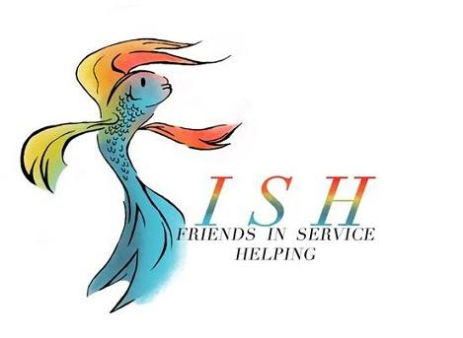
Business Meeting Minutes
January 14, 2020

- Meeting called to order at 12:03 pm by President Carol White followed by Altrusa grace and the Pledge of Allegiance.

- Introduction of guests – there were two guests in attendance who were introduced individually by their Altrusan friends.

- Accent – Debbie Mabry presented the accent on membership retention. The Temple Altrusa Club has made retention a priority and plans have been made and are being executed to ensure that members feel valued and involved. The next mixer will be January 30, 5:30 pm, at the CAC.

- Old Business
Minutes from the December business meeting were presented and approved as written.

- New Business
  - Debra Hicks presented the Treasurer’s Report reflecting an administrative account balance of $10,052.83 and a project budget balance of $12,660.71. Treasurer’s report will be filed for audit.
  - Marsha Oliver presented the Correspondence Report for the month of December. A $10,000 donation was made to the Altrusa Foundation from an anonymous donor. Report will be filed.

- New member, Jill McAfee, was installed by Jennifer Adams.

- Nominating Committee
  - Nominating Committee guidelines were presented by Linda Moore, Parliamentarian
  - President Carol White accepted nominations for the 2020/2021 Nominating Committee from the membership.
  - Five Altrusans were nominated: Kathy Folley, Dorothy Granfor, Hope LeGrone, Mary Black-Pearson and Kelli Alsup. After a vote by paper ballot, the results are:
    - Hope LeGrone, Chair
    - Dorothy Granfor
    - Mary Black-Pearson

- Committee Reports / Announcements

  - Kelly Nix announced that the 2019 Taste of the Holidays raised $66,000, including $20,000 raised for scholarships through the raffle.
  - Susan Cory announced that Days for Girls Workshop will be held Saturday, January 18, at First United Methodist Church from 9 am – 5 pm.
  - Debbie Mabry encouraged members to support the Caring Ball which raises 50% of the annual budget for the Temple Community Clinic.
  - Teresa Bowen-Bechtel made several ASTRA announcements
    - Belton High School has new t-shirts
    - Valentines for Vets workshop on Thursday, January 16
    - Teresa’s husband, Don, won a volunteer award through his workplace $500 for Days for Girls.

- Brags

- Following the benediction, the meeting was adjourned by President Carol White at 12:57 pm.
Minutes submitted by Lori Luppino, 2019-2020, Recording Secretary.

