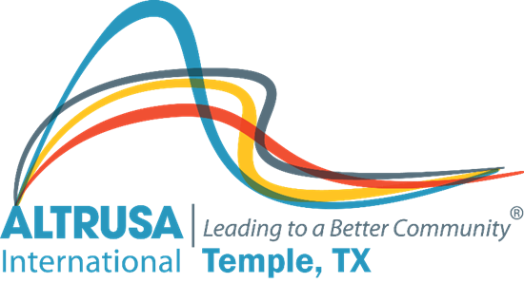
Business Meeting Agenda
June 8, 2021

I. Welcome and Call meeting to order
Altrusa Grace
For this food before us spread,
For our steps in safety led,
For thy favor on our way,
Lord, accept our thanks today.

II. Introduction of guests – Dana Riegel
III. Accent – Susan Cory - World Environmental Day
IV. Review minutes from May business meeting – Jennifer Adams
V. Corresponding Secretary - Sharon Schmidt
VI. Treasurer’s report – Donna Wright
VII. New business –
- Proposed administration budget for 2021-2022 – Michelle DiGaetano
- Proposed projects – Brenda Hill
- Club 21 and Club Lamplighter
- Signature Project Part 1
- Project Appletree

- Club meeting space. Ad hoc committee working on details.

VIII. Committee Reports
IX. Announcements
- Requested project funds from Foundation - $30,400.00.
- Scholarship recipients will be attending the June 22nd program meeting.
- July Program meeting is now on July 20th (3rd Tuesday) 5:30 pm at CAC
- Altrusa International Convention July 28th – 31st, 2021
- Altrusa International Conference – April 29th – 30th, 2022
X. Brags

XI. Benediction
May we go forth with high ideals,
To greet our fellow man,
Be true to all Altrusa aims,
Until we meet again.

