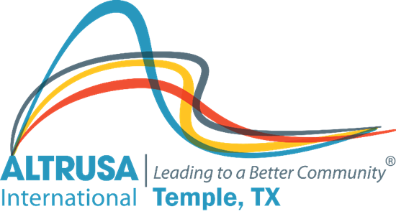
Business Meeting Agenda
July 13, 2021

I. Welcome and Call meeting to order
Altrusa Grace
For this food before us spread,
For our steps in safety led,
For thy favor on our way,
Lord, accept our thanks today.

II. Introduction of guests – Patsy Sulak
III. Accent – Project Appletree – Debbie Mabry
IV. Review minutes from June business and program meeting – Jennifer Adams
V. Corresponding Secretary - Sharon Schmidt
VI. Treasurer’s report – Donna Wright
VII. New business –
- Proposed projects – Brenda Hill
- Ronald McDonald House
- Closet of Hope – Men’s clothing drive. Socks and Underwear drive.
- Days for Girls
- New Member application – Brenda Hill
- Taste of the Holiday 2021 Proposed budget
- Club Meeting space August 2021
- Club Meeting space September 2021-May 2022

VIII. Committee Reports
IX. Announcements
- TOH Menu Brainstorming meeting - July 13th 5:30 – Patillo Brown and Hill
- TOH Committee meeting – July 15th 5:30 – Temple Community Clinic
- July Program meeting is on July 20th (3rd Tuesday) 5:30 pm – 7:00 pmat CAC
- Altrusa International Convention July 28th – 31st, 2021
- Orchestra selections have been finalized and are listed on ClubRunner.
- Greeter and Accent volunteers are needed. Please contact Dana Riegel or Patsy Sulak for your opportunity to serve!
X. Brags

XI. Benediction
May we go forth with high ideals,
To greet our fellow man,
Be true to all Altrusa aims,
Until we meet again.

