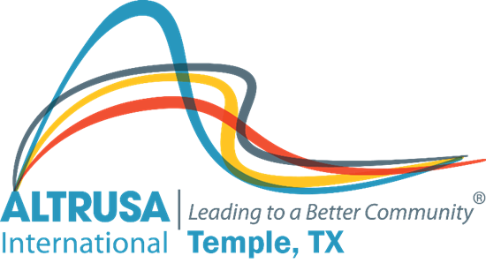
Program Meeting Agenda
October 26, 2021

I. Welcome and Call meeting to order.
Altrusa Grace
For this food before us spread,
For our steps in safety led,
For thy favor on our way,
Lord, accept our thanks today.

Pledge of Allegiance

II. Introduction of guests/guests on Zoom – Dana Riegel
III. Accent –Jennifer Adams
IV. Program – Brenda Hill – Kami Diaz – Central Texas Youth Services Bureau
V. Committee Reports
- Membership
- Communications
- Service
- ASTRA
- Taste of the Holidays
VI. Announcements-
VII. Brags
VIII. Benediction
May we go forth with high ideals,
To greet our fellow man,
Be true to all Altrusa aims,
Until we meet again.

