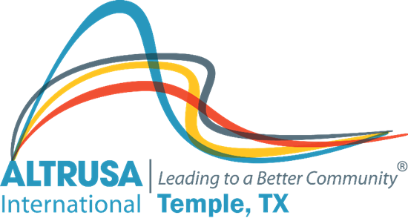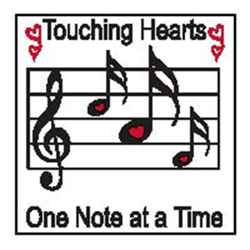
Program Meeting Minutes
October 26, 2021

I. Welcome and Call meeting to order at 12--- followed by Altrusa Grace and Pledge
II. Introduction of guests/guests
III. Accent –Topic UN Day
IV. Program Kami Diaz – Central Texas Youth Services Bureau
V. Committee Reports
- Service- CommiteeMeeting this Thursday via zoom, the link will be emailed by Brenda Hill
- Taste of the Holidays- Received more funds for underwriting $25,000 so far
- Membership- -Care and Concerns-please reach out to Lynda Schumann if you have a need
VI. Announcements
-Early Christmas shopping Thursday and Friday Kendra Scott online shopping. 20% goes to charity. Please see Altrusa FB page for details. You may also contact Debbie Mabry with any questions
-One Book at a Time- We will collect 10,000 books over the next 2 years. 106 books so far and 1 hour of service time. If you donate books anywhere as an individual please report to Sarah Davidson, you must still report the club hours on the attendance sheet, Sarah will be tracking separately.
Meeting adjourned at 12:53pm

Minutes recorded by Jennifer Adams, Recording Secretary 2021-2022

