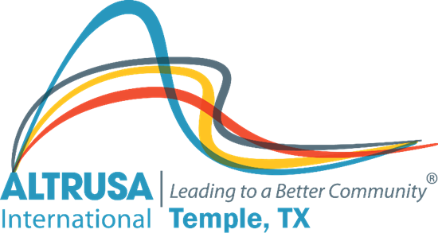
Program Meeting Minutes
November 23, 2021

- Meeting called to order at 12:03pm followed by Altrusa Grace and Pledge of Alleigance

II. Introduction of guests.
III. Accent: International Day to End Violence Against Women presented by Marlene King
IV. Program – Diana Zaremba – Chair – Taste of Holiday’s 2021- Preliminary results-Total of over $44,723 to date. Raffle raised over $19,000. $2,426 in expenses. Leaving over $24,000 for projects.
V. Committee Reports
Meeting adjourned at 1:03PM
Minutes recorded by Jennifer Adams, Recording Secretary 2021-2022

