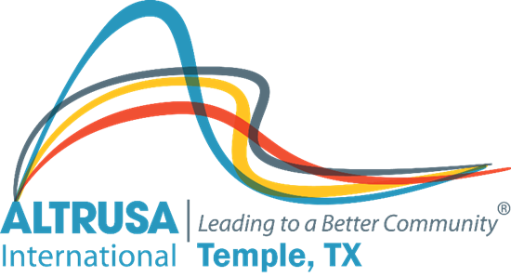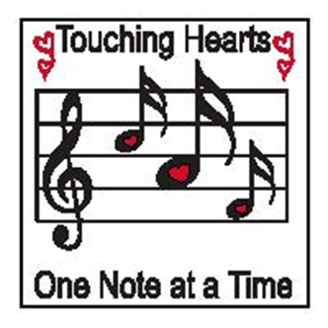
Altrusa Business Meeting Minutes
December 14, 2021

I. Call meeting to order at 12:05pm followed by Altrusa Grace and Pledge of Allegiance
II. Accent presented by Lisa Gingerich- Topic Human Rights Day

III. Review minutes from November business and program meeting. Accepted as written
IV. Treasurer’s Report – Admin $7,242.22 Project $22,850.63 Scholarship $1,246.31
V. Corresponding report presented by Sharon Schmidt
VI. New business –
- Proposed projects – Brenda Hill
- Volunteers for the 2022 Caring Ball. Motion carried.
- Temple High School Jazz Band fund. Motion carried.
- Christmas Love for Western Hills Nursing Home. Motion carried.
- Christmas Blessings for residents of Bell Oaks Apartments. Motion carried.
VII.
Committee announcements, followed by brags
Meeting adjourned at 1:05PM. Minutes recorded by Jennifer Adams Recording Secretary 2021-2022

