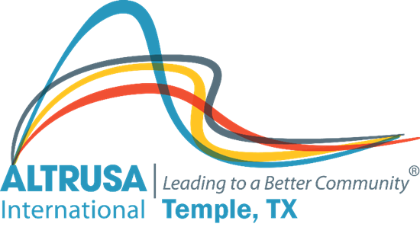
Altrusa Business Meeting Minutes
January 11, 2022

- Meeting called to order at 12:04PM followed by Altrusa Grace and Pledge of Allegiance

II. Patsy Sulak introduced guest
III. Patsy Sulak initiated new member- Joanna Slone – Sponsors are Hope LaGrone and Julie Ruiz
IV. Jordan Castillo presented the accent. Topic: Temple Community Clinic
V. Minutes from December business meeting was reviewed and accepted as written
VI. Treasurer’s Report- Reconciled bank balances: Admin $5,654.77 Project-$19,529.59 Scholarship $1,246.32. In January the funds raised for scholarship will be requested from foundation and be deposited into the scholarship fund
VII. Sharon Schmidt presented the correspondence report
VIII. Nominations and Vote for 2022-2023 Nominating Committee –online poll for members on Zoom. Vote results: Traci Squarcette (chair), Debra Hicks, Debbie Fendrick will serve as the nominating committee. Motion by Diana Zaremba, 2nd Cyndi Warren to accept results and destroy the ballots. Motion carried.
IX. New business –
- Proposed projects – Brenda Hill
- Camp Dreamcatcher 2022. Motion carried.
- Multifaceted Literacy for Bell County – Project A. Motion carried.
- January Passion Project Ronald McDonald House. 0 dollars. Motion by Dorothy Granfor, 2nd by Regina Phinney. Motion carried.
- Labels for books. Motion to approve up to $400 by Debbie Mabry, 2nd Traci Squarcette. Motion carried.
- Job Fair for young adults with disabilities. Motion to approve up to $500 by Sherri Woodard, 2nd Traci Squarcette. Motion carried
- Diana Zaremba – TOH results= 654 hours reported. $19,025.00 will be designated for scholarships, $28,916.35 for projects

X. Announcements -
A. January 25th Program meeting – District Nine 1st Vice Governor – Kimberly Kierce
B. Next month we will vote on delegates for District Nine conference April 29, 30 and May 1st.

Committee announcements
- Days for Girls preparation day this Saturday January 15th 9am-1pm at First United Methodist Church in Belton. On January 29th assembly day at Patsy Sulak’s home
- Reminder to take the Altrusa survey, the request has been emailed to all members
- Ronald McDonald house has been able to increase their budget from the tabs donations
- TOH 2022-Taryn Cox will chair, Julie Ruiz will co-chair. Theme: Comfort and Joy. Anyone who wants to continue to serve on committees reach out to Taryn
XI. Brags
Meeting adjourned at 1:05pm. Minutes recorded by Jennifer Adams, Recording Secretary 2021-2022

