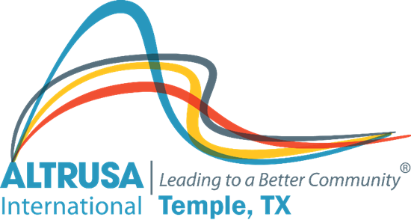
Program Meeting Minutes
January 25, 2022
I. Meeting called to order at 12:05pm followed by Altrusa grace and Pledge of Allegiance.
II. Dana Riegel introduced guest
III. Dana Riegel Initiated new member Diana Lane Cowen, Sponsors Sherry Woodard and Hope LaGrone.
IV. Brenda Hill presented the accent. Topic: International Day of Education
V. Program – Altrusa District Nine - 1st Vice Governor – Kimberly Kierce
Temple Community Clinic – Executive Director – Sherri Woytek

VI. Committee Reports
- Communications – Janna Janes – Please add the ClubRunner app. Update your information if anything has changed. Events-contact information for members are all available on CR. District events are also located in CR.
- Membership- Retention-if there is someone you haven’t seen lately please reach out to them.
- Service- committee meeting this Thursday at 5:30 via Zoom. Brenda Hill will send an email reminder with the Zoom link.
- Scholarship application is live online must be submitted by 3/31/22, please spread the word
VII. Announcements
- Book planning meeting 1/26/22 via Zoom email Debbie Mabry if you are interested in attending.
- Days for Girls meeting this Saturday at Patsy Sulak's home
Meeting adjourned at 1:05PM. Minutes recorded by Jennifer Adams, Recording Secretary 2021-2022

