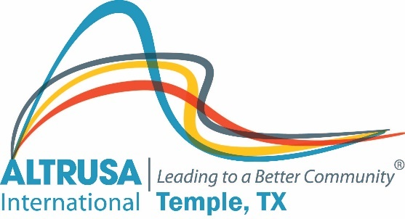

Program Meeting Minutes
February 22, 2022

- The meeting was called to order at 12:04 by President Michelle DiGaetano followed by the Altrusa Grace and the Pledge of Allegiance.
- Dana Riegel introduced guests.
- The accent, provided by Carol McDuffie, was on World Day of Social Justice, which was established in 2009. It promotes gender equality, rights of indigenous people, fair outcomes for everyone and much more. This year’s theme is closing the inequities gap to ensure social justice.
- The program was provided by the choir at Temple High School, directed by Cameron Roucloux and Megan Byrd.
- Committee Reports
  - Astra delivered cards and goodies to VA nursing home.
  - The literacy project has a zoom meeting tomorrow at noon. A book drive will be held during March meetings to donate to agencies needing books and the book exchange project.
  - The storage unit was cleaned out this past weekend. A sale of decorations and other miscellaneous items will be held on Sunday, March 6 from 2-3 at the storage unit.
- Announcements – there will be a hands-on service project at the end of the meeting to give cookies to the staff at Travis Science Academy and the Ralph Wilson Youth Club.
- Following the Benediction, the meeting was adjourned at 1:05 pm.

Minutes submitted by Brenda Hill for Jennifer Adams

