

Program Meeting Minutes April 25, 2023

Ralph Wilson Youth Club
Zoom Meeting
https://us02web.zoom.us/j/88176734603?pwd=WnhVbEEwTjk1Z0pXQjFmMEoxRWFiZz09
Meeting ID: 881 7673 4603
Passcode: 551402
One tap mobile
+13462487799,,88176734603#,,,,*551402# US (Houston)

- President Tara Stafford called the meeting to order at 12:03 pm. Quorum present.
Our heavenly Father,
Surrounded by blessings, may we learn to bless;
Reaping the fruits of patriotism, may we love our country more;
Members of a world-wide community, may we cherish our neighbors everywhere;
Grateful to Thee, may we show our gratitude by efficiency and service.

- Members stood for the Pledge of Allegiance.

- Debbie Fendrick introduced our guests.

- Linda Moore gave the accent: Special Event Altrusan of the Year. Nominated by current membership, this Award recognizes the outstanding contributions of one member during 2022-2023. The committee, chaired by the last year’s winner and consisting of past recipients of this award, collects nominations, select the winner, and plans the recognition luncheon. The name of the recipient is revealed at the luncheon.

- ALTRUSAN OF THE YEAR is Diana Zaremba. Diana is an outstanding member of a team serving so many in our community. She is a team player devoted to making our projects successful. She is organized and approaches each task with commitment and purpose. A friend to all, Diana in turn thanked everyone for their support, saying that “Altrusa gave her purpose at a time in her life when she needed it most.” Congratulations Diana!

- Tara Stafford covered Announcements/Upcoming Events
  - LAST service committee meeting – Thursday, April 27 at noon (virtual)
  - New Officer Installation – Tuesday May 23rd (NO PROGRAM MEETING at NOON). Everyone is invited to attend.
  - Upcoming Romance Book Club will be on 5TH Tuesday in May The Wife Who Risked Everything by Ellie Midwood.

- Committee Announcements
  - BHS Penguin Project: Tickets for the 2:00 pm Sunday performance of Annie.
  - ASTRA: Susan Corey invited members to the Chording Ceremony for the Salado club. Please see the calendar.

- Brags

- Benediction
May we go forth with high ideals,
To greet our fellow man,
Be true to all Altrusa aims,
Until we meet again.

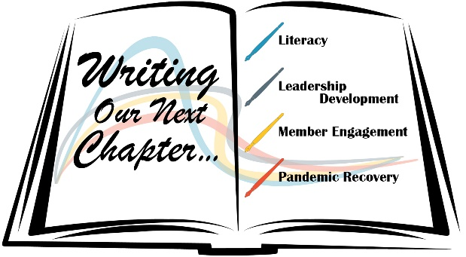
Meeting adjourned a 1:12 pm. Minutes recorded by Debbie Mead, Recording Secretary 2022-2023

