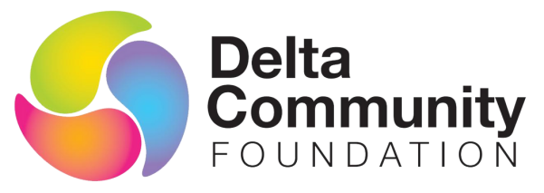

Do you love living in Delta? Want to give back?
Delta Community Foundation, Delta’s only community foundation or charity for charities, is seeking community leaders from North Delta to serve on our volunteer Board of Directors.
If you are motivated, inspired and committed to give back to the entire community of Delta in building long-term, sustainable funding of causes that improve the lives of Deltans you will be interested in this influential role. We support charities which deliver service to the many people in our community who need a hand up or who could enjoy more services in a stronger community.
You will be interested in this opportunity if you have a background in areas such as fundraising, administration, marketing and social media, technology, finance or event planning. You enjoy connecting people and bringing likeminded individuals together.
We administer grants directed through endowment funds and from the Foundation’s general funds to support local initiatives and give back to the community we live in. We are looking for a commitment of up to 10 hours per month and you will get to work with some of Delta’s dedicated leaders. We are one of 91 community foundations in a network across Canada, bringing national opportunities to Delta.
If this sounds like the opportunity you’ve been looking for, please visit our website at www.deltafoundation.org. To learn more, or to apply, please email Marion Janssen at marionchrp@gmail.com no later than March 25, 2022.

