Eco Toilets - A sustainable, ecological sanitation system providing dignity and food security

The Rotary Club of Oak Bay, Victoria, BC, Canada with matching funds from District 5020 and some financial support from the Project Unity Committee (PUC) is working together with a Rwandan partner, for 28 residential, composting toilets in rural Rwanda. During the last 18 months the partner has developed a safe, sanitary, dignified toilet for under $200. This document gives a brief description of the Eco Toilet and photographs of prototypes presently in use in Rwanda. The project leaders would like to share the design and production ideas with the Water and Sanitation Rotary Action Group (WASRAG) and any other interested Rotarians in hopes of establishing further improvements and use.

The Project and its objectives:
The project involves building 28 eco-toilets with hand washing stations for residential use as well as a system for hygienic extraction of waste for use as fertilizer. While 100% of rural population of Rwanda, including towns, uses basic latrines, the poor live with dangerous, squalid latrines that degrade the eco-system and offer no opportunity for practicing hygiene (such as hand washing after use). Once the toilet design is proven, the ultimate objective is that our partner organizations develop the skills and a business model that will support a sustainable, local enterprise demonstrating and distributing this much-needed technology.

The Eco Toilet
The rudimentary components of the Eco Toilet are shown in Figure 1. The foundation is made of cement covered rocks, imbedded 6-8 inches below the ground level. On top of the concrete foundation, a row of bricks with gaps for floor supports anchors structure to foundation. A row of wooden planks laid over the supports forms the floor over which a readily-manufactured plastic pan is inserted. A low floor level at rear of foundation allows for a solid waste bucket to be easily retrieved. The forward urine trap is formed as a funnel and feeds a hose that delivers urine into a 2 ½ gallon Gerry can placed in a deeper hole outside the toilet. An air vent provides for circulation from the waste pit which, in a finished toilet, is closed off by a hinged door adjacent to the waste bucket. After each use, the users cover the waste with ash and dry leaves. The solid waste is periodically emptied into a drying station and the collected urine is spread in the vegetable garden.

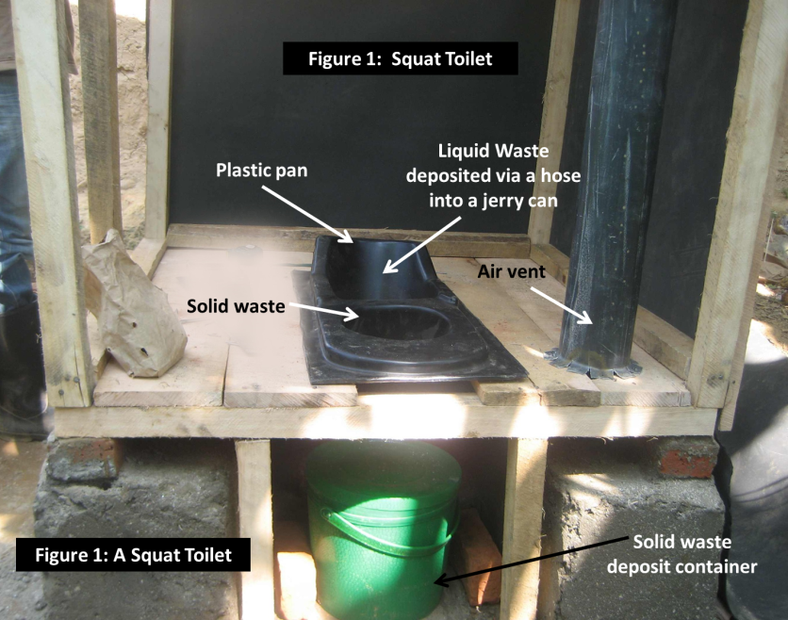
A photograph of a semi- finished toilet is shown in Figure 2.

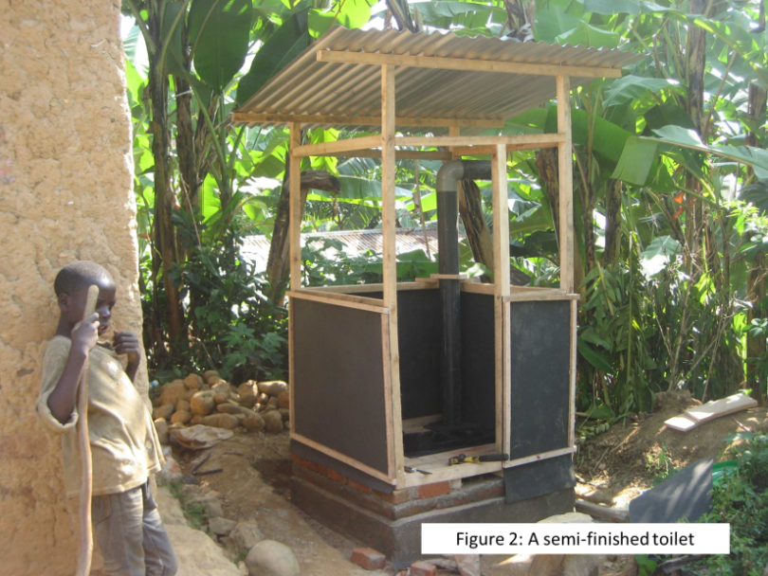
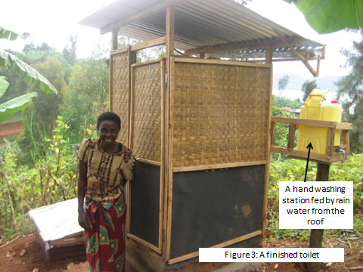

Figure 3 is a photograph of a finished toilet. The lower panels of the outer walls are made of a 1.5 cm thick, locally-available rubber material easy to cut with knife. This material is less expensive than wood. The upper panels are made from locally woven reed mats. The roof is the commonly used corrugated metal with life expectancy of 10-12 yrs. It has broad eaves to provide adequate surface for catching the rain water into a gutter which leads the harvested water into a plastic can which serves as a hand washing station.

Solid waste for family of 5 requires the solid waste container to be emptied every 5-7 days. A container of crushed leaves and ashes stands inside toilet and provides a scoop of material to be dropped on top of the waste after each use thus hastening drying, preventing access by insects and eliminating odor. Waste is dumped weekly into a two-compartment drying chamber (Figure 4) for period of 4 months after which time additional waste is deposited into the 2nd chamber for the next 4 months. During this period, sun and air completely dry 1st chamber, rendering it inert and available to be added to the compost pile. Urine which is sterile when it leaves the body is diluted with water at least by half before being poured directly around crops.
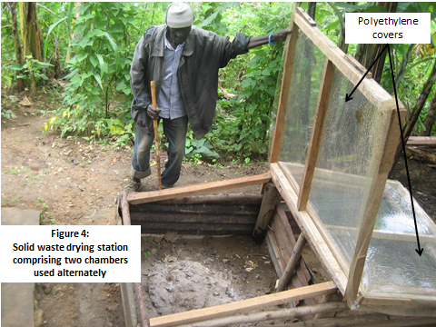

How the project benefits the community and improves the lives of beneficiaries?

The simple design of the Eco Toilet will alert government leaders and the general population to several new possibilities. The Eco Toilets are not only simple to construct, but they are also economic and hygienically recycle waste. The poor, for whom commercial and organic fertilizers are unaffordable, can have ready and free access to a useful source of fertilizer. Present users of Eco Toilets are proud of their sanitary, odorless, dignified toilets and they are astounded to report garden yield increases over 50%.

The challenge for Rotary development initiatives:

This is a sustainable, ecological sanitation system that provides dignity and food security. At $200 this toilet costs one third of government or commercial latrine-style toilets available in Rwanda but it is still beyond the capacity of the poor to afford. We are interested to learn more about what design improvements, production process or marketing approaches can make the toilets cheaper and more accessible for the poor.

For further information please contact:
Rotarian John Jordan – Rotary Club of Oak Bay
<jjordanafrica@gmail.com>

