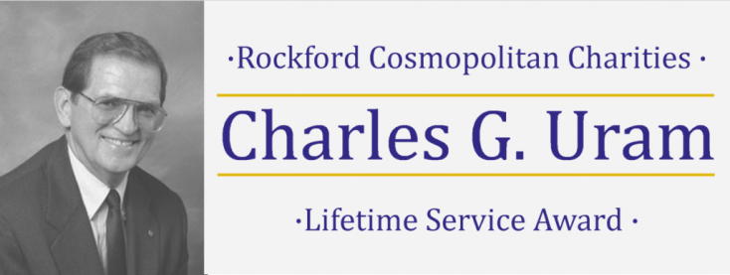

Nomination Form for 2020

The Rockford Cosmopolitan Club was saddened by the death of 40-year member Chuck Uram on December 24, 2004. He was a friend and mentor to many and demonstrated to us the true value that is derived from volunteering and donating to our community.
Chuck will always be remembered by the Rockford community and our Club as the person called upon to lead fund drives. Chuck was a fundraiser/volunteer for Crusader Clinic, Emmanuel Lutheran Church, Hunger Connection, Lifescape Community Services, Rockford Rescue Mission, Rosecrance Health Network, The MILL, United Way, Wesley Willows, YMCA, Community Foundation of Northern Illinois and others. He is credited with raising over $6 million for these organizations. His efforts earned him the Excalibur Award recognizing his charitable efforts that benefited so many Rockford organizations.
Although Chuck can no longer lead us in this life, his spirit will live on through this annual award created to recognize community leaders with Chuck’s style and record of lifetime achievement.

Purpose of Award:
This award recognizes and celebrates the achievements of a person who embodies Chuck’s values. Those who know Chuck best have described him using the following words:
“Worked behind the scenes” “a catalyst” “compassionate” “forgiving” “empowered others” “a doer” “positive” “loyal” “a man of great faith” “passionate” “did a lot of little things” “his actions had a cumulative effect” “gives strength” “sense of humor” “an understated man” “strong” “fundraiser” “ombudsman”
Eligibility: Rockford area non-profit organizations that qualify under Code Sec. 501(c)(3) are asked to nominate any living person, even if they are not affiliated with the nominating organization.

Two-Fold Benefit for the Recipient:
1. The individual selected for the award will be recognized for their efforts on April 23, 2020 at the Rockford Cosmopolitan Club’s Charities Awards Dinner at Prairie Street Brewing Co.
2. The nominating organization of the award winner will receive a $5,000 donation from the Rockford Cosmopolitan Charities.

……………………………..

PROCESS: Nominations will be accepted through March 15, 2020. The Rockford Cosmopolitan Club will select each year’s recipient.

Please return nomination form, essay and three letters of support to:

Rockford Cosmopolitan Club
420 Financial Court, Suite 124
Rockford, IL 61107

NOMINEE:
Name:
Address:
Phone: Email:
NOMINATING ORGANIZATION:
Organization Name:
Contact:
Address:
Phone: Email:

ESSAY: Nominating organizations should complete an essay of no longer than one typed page using the following questions as a guide:
• How has this individual impacted your organization over an extended period of time?
• How has this individual impacted the community at-large over an extended period of time?
• What is different in this community as a result of the efforts of this individual?
• In what community initiatives has this person played a key role?
• What other recognition and special awards has this individual earned?
• How has this individual displayed the values Chuck held dear?

LETTERS OF SUPPORT: In addition to the essay, nominating organizations should attach three letters of support for the nominated individual. Only one of the letters may be from a representative of the nominating organization.

Questions may be directed to: John LiCausi, President of the Rockford Cosmopolitan Club Charities Board for 2020, at RfdCosmoGrants@gmail.com.

