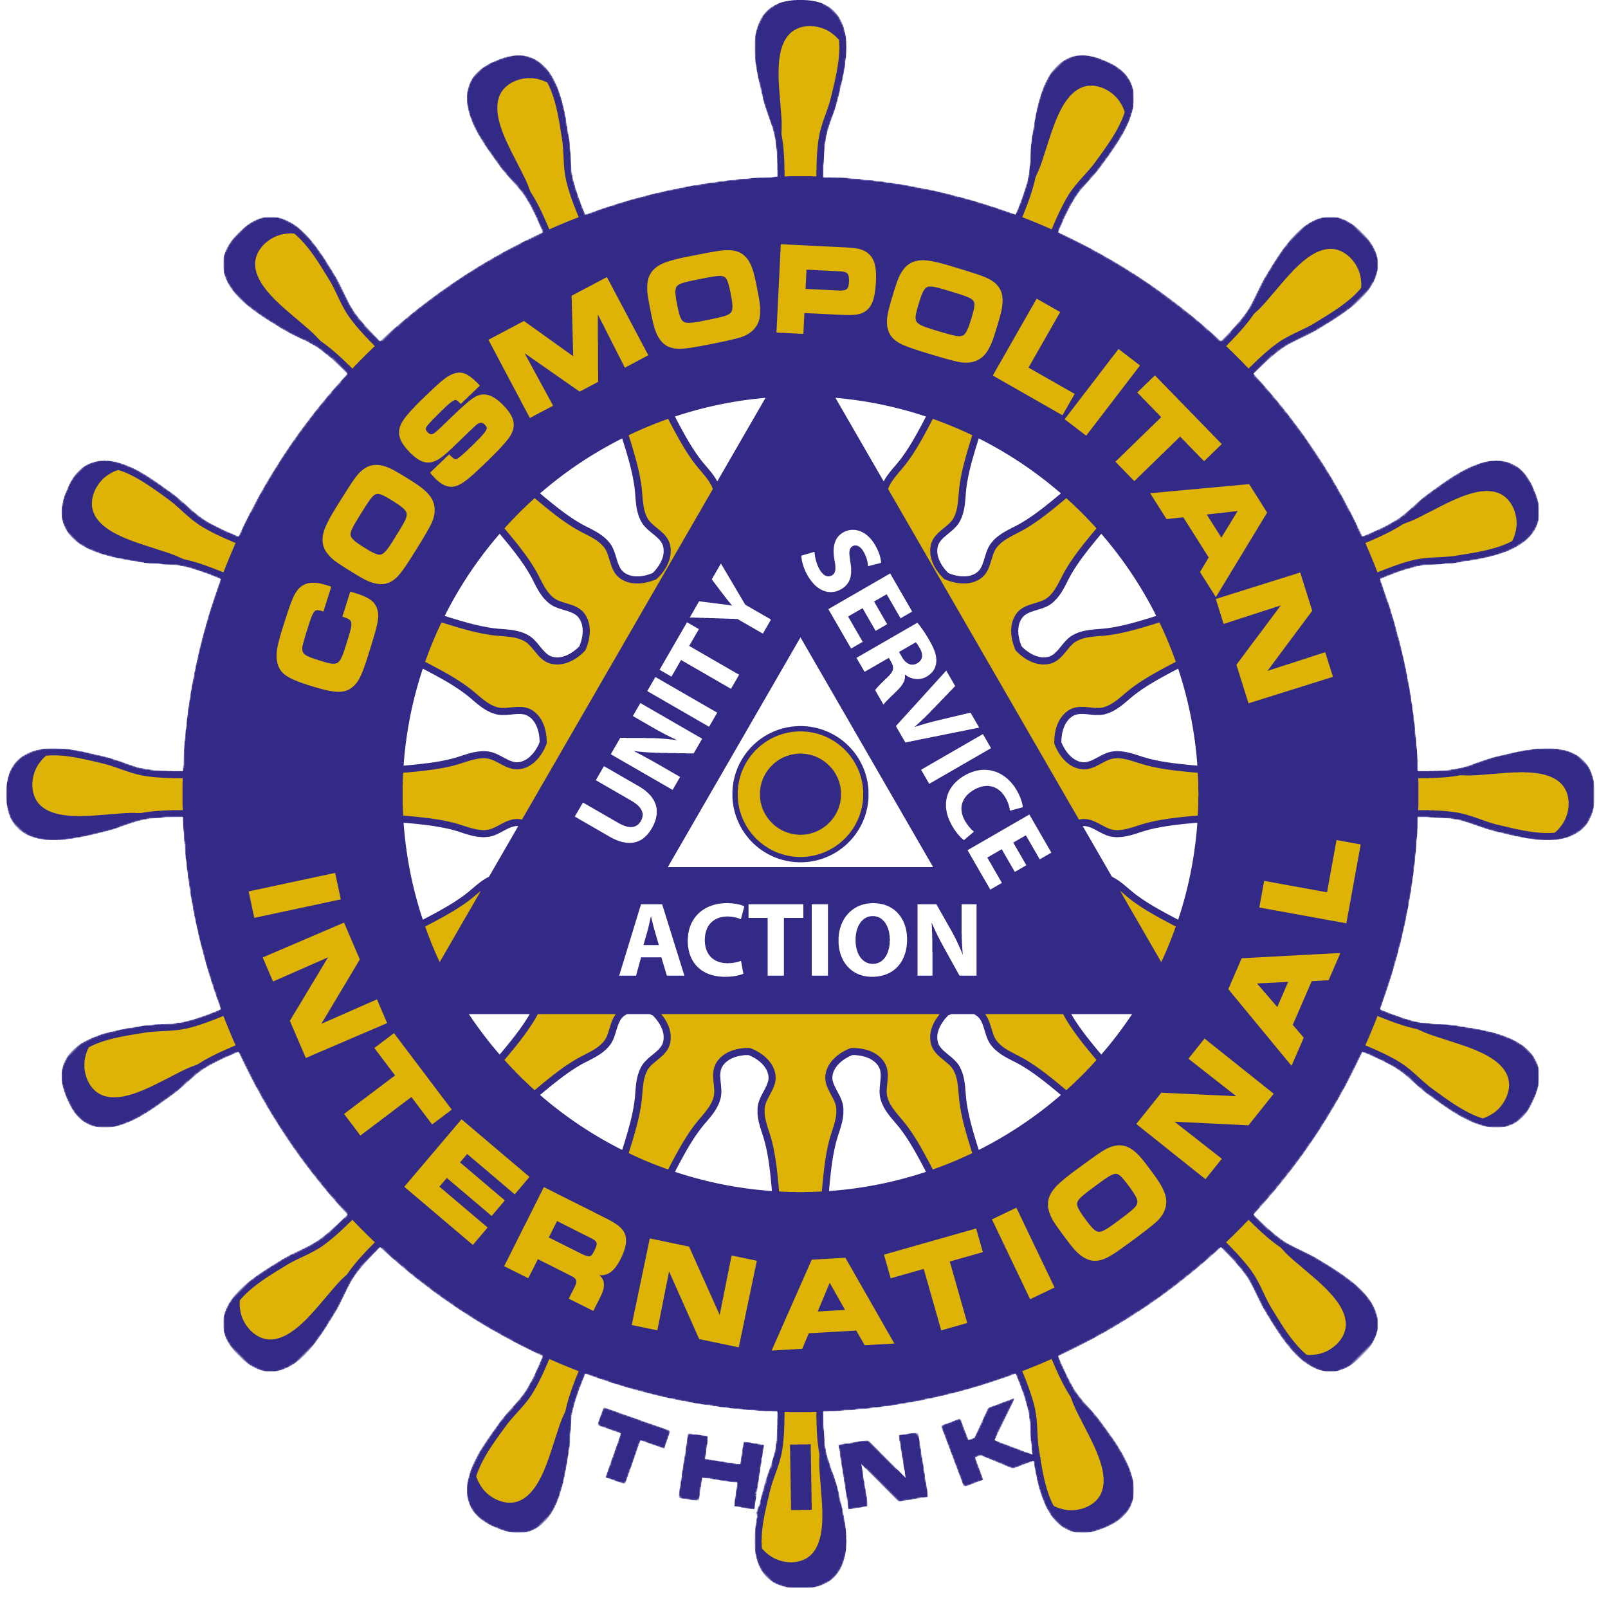

The new grant application for 2020 is an online form, and can be submitted by CLICKING HERE.

Thank you for your participation!

