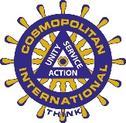
Cosmopolitan International Columbia Luncheon Club
1715 Burlington St.
Columbia, MO 65202
columbiacosmolunch@gmail.com

