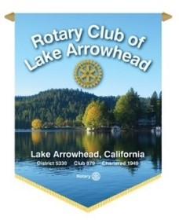
Lake Arrowhead PolaRotary Bear Plunge

Consider the PolaRotary Bear Plunge to raise money for your favorite charity!

Similar to a Walk-a-thon, participants, who pledge to “take the plunge”, solicit donations to support their favorite 501c3 charity organization.

The first $1000 raised is split 50/50 with the Lake Arrowhead Rotary Foundation; anything over $1000 goes to the jumper’s chosen charity. “Teams” jumping for the same charity, will be considered the same as an individual in respect to distribution of donations, although teams are limited to eight members. If your organization has more than eight who wish to participate you can have multiple teams with each team being subject to the 50/50 split. Participants must be at least 18years of age.
Please keep in mind this is a fund raiser.
Each individual jumper is expected to raise at least a minimum of $50.

Checks are to be made out to Lake Arrowhead Rotary Foundation. Please write the organization being supported and the jumper’s name on the memo line. After the event, a check reflecting the “split” will then be presented to the designated organization. Jumpers are responsible for collecting pledges (checks and cash) and bring them to the event where the funds are turned in as part of the Check-In process. Or, checks may be mailed to:
Lake Arrowhead Rotary, PO Box 686, Lake Arrowhead, Ca 92352.

Rules: No Wet Suits No Nudity Complete submersion (no time limit)

The Lake Arrowhead Resort & Spa again is our host.
Please respect the facility and acknowledge their much-appreciated support.

For more information VISIT OUR WEBSITE: http://www.polarotarybearplunge.com/

Please RSVP your commitment to jump or contact us with any questions. Patrick Rains, Chair arhdvet@hotmail.com or 909-337-4541

