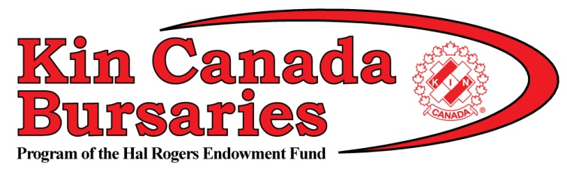

About Kin Canada Bursaries

Post-secondary education is expensive. Let us help!
in Canada Bursaries, a program of the Hal Rogers Endowment Fund (HREF), awarded 52 deserving students with a $1,000 bursary for their 2017-18 school year. Successful applicants were chosen based on their community and school involvement, knowledge of Kin Canada and financial need. Download the list of 2017 bursary recipients.
Since its inception in 1994, $978,000 has been awarded to 978 students across Canada. The amount disbursed in any one year depends on the balance of the Hal Rogers Endowment Fund and its governing laws.
Kin Canada Clubs play a vital role in the Kin Canada Bursaries program. They make donations to grow the fund, which affects how many bursaries are awarded each year.

Kin Canada Bursaries is a program of the Hal Rogers Endowment Fund, supported by Kinsmen, Kinette and Kin clubs, and public donations, across the country. Each year, $1,000 bursaries are awarded to successful Canadian applicants who are pursuing post-secondary education at a recognized university, community college, technical institute and other schools for advanced education.
Of the bursaries awarded, there are four named bursaries: The “Diana Lyn McKenna Memorial Bursary” to a student from Ontario in the Health/Sciences field, the Bob Pittman Bursary for a Business student, the Kevin Denbok Bursary for Music students and the Winnipeg Kinsmen Jackpot Bingo Bursary awarded to a District 2 student.
  - Apply
  - Application Form
  - Applications are due February 1st, 2018.
  - Kin Canada Bursary applications: English ; French
  - Submission
  - Completed application forms must be sent to the club closest to you.
  - Kinette Club of Stampede City
PO Box 1434 Stn. Main Calgary AB T2P 2L6

