2020-2021 President’s Worksheet
Bring this with you to MD PETS in Syracuse March 13 – March 14

Club Runner [www.rotary7190.org Member Area]
User Name
Password

MyRotary [www.rotary.org My Rotary]
User Name
Password

Club Officers – work with your club Secretary to enter in Club Runner for 2020-2021
(Your club may have more officers than listed below. That’s ok, but these seven are required in District 7190. If your club has not selected officers for 2020-2021, at least make sure you are listed as the President for the MD PETS training.)
Title | Club Member
President
President-Elect
Secretary
Treasurer
The Rotary Foundation Chair
Membership Chair
Public Relations Chair

Be prepared to enter Membership and Foundation Giving goals into MyRotary
Questions can be directed to Lisa Jackson at lisarmj33@gmail.com

MyRotary

- www.rotary.org choose My Rotary at the top of the page
- Sign in to My Rotary OR Register for an Account if you don’t have one yet. If you can, use the same email you use in your Club Runner profile.

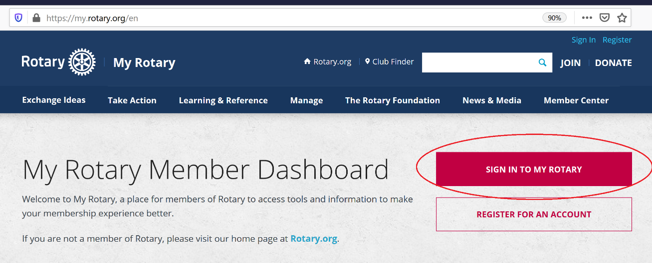

- Enter user name and password and SIGN IN
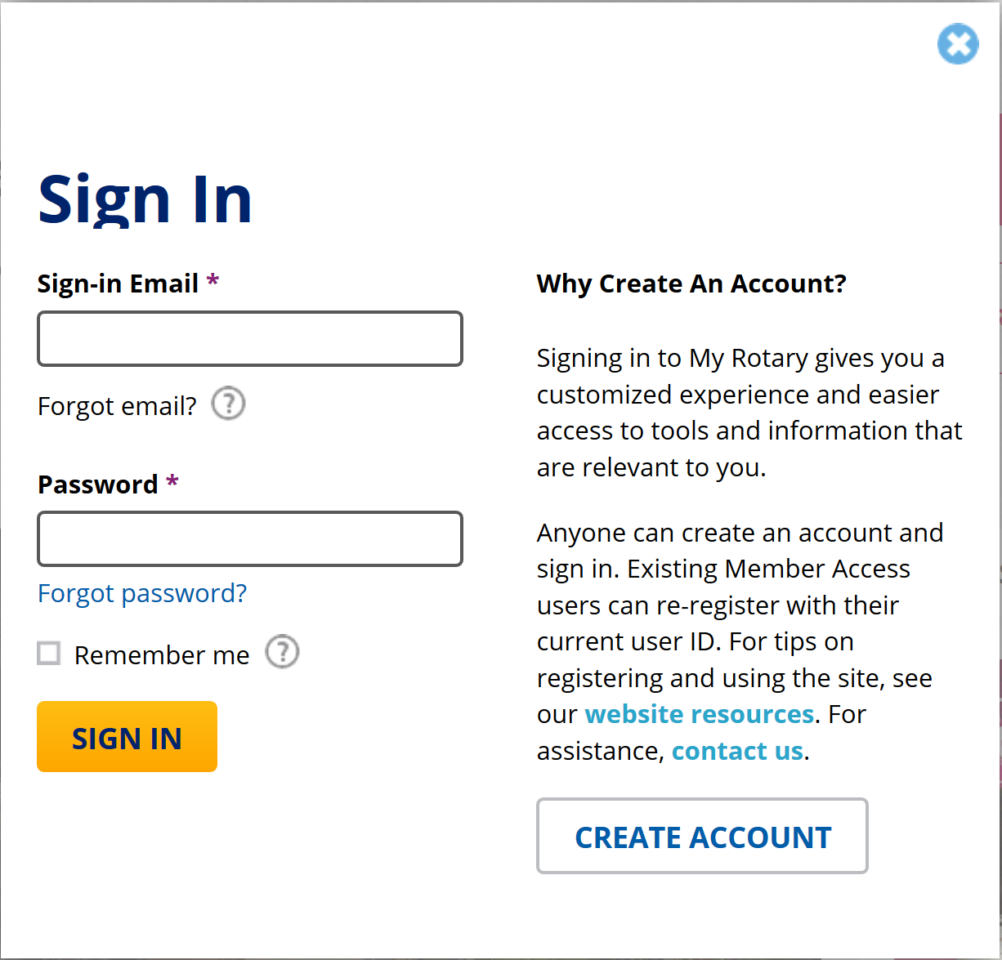

Club Goals
MyRotary Manage Club & District Administration Rotary Club Central
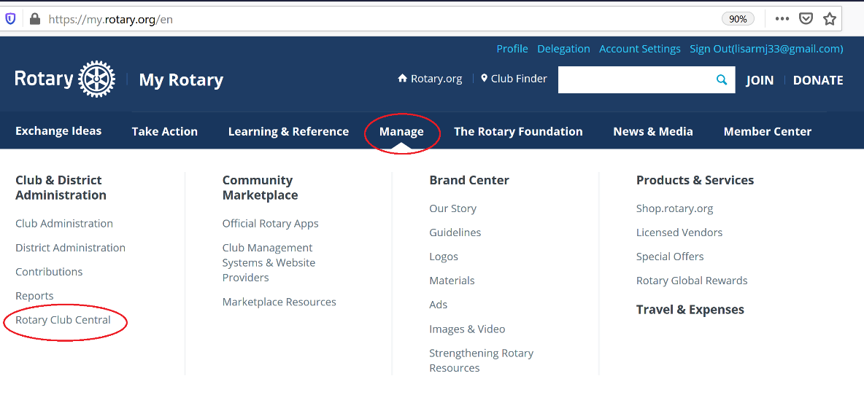
Choose Goal Center
