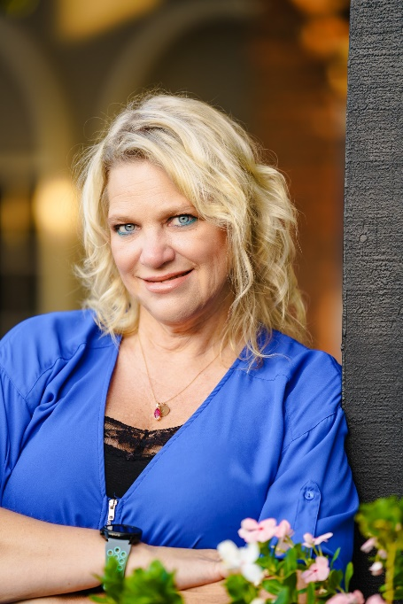

Hello, my name is Becky Goldberg I am a AVP Business Development Officer with First Savings Bank which allows me to develop relationships on many levels.
My Rotary background began in 2004 when I became a host mom and then asked to join the Lake Havasu City Rotary Club shortly after. I immediately became involved in the Youth Exchange program and hosted 2 other students and assisted with several more from our club.
Never one to shy away from being involved and helping I volunteered to on our board as Club administration and from there I held positions as Club Secretary and Foundation Chair. After being asked by a very valued Rotarian Chuck Denny I took the position of Vice President, President-Elect and finally Club President in 2020.
After completion of my Presidential year, I decided to serve as Assistant District Governor for the River Cities, Parker, and Poston from 2021-2023. Also, I agreed to serve as District 5495 Admin in 2022.
Being raised in a family that believed in giving back to the community where you live, I have been very involved in Lake Havasu City. I have served on the LHUSD Governing Board and was President for a year. My mother and myself co-founded the K-12Foundation for LHUSD. Over the years I have served on numerous boards: Go Lake Havasu, United Way, LHC Cares, LHHS Booster Club, Site Council for Nautilus Elementary School, Lake Havasu Area Chamber of Commerce Ambassador Committee, Chamber Foundation for Educational Leadership, CFEL Education Committee Co-Chair, LHUSD Discipline Hearing Officer, Women Council of Realtors, Lake Havasu Balloon Festival. I have received Chamber Volunteer of the year for 2021 and received the Whelan Leadership of the year award in 2022 from the Lake Havasu City Chamber of Commerce
I spent many years working in my family’s business and now as a Business Development Officer. I have 2 amazing children who I am so proud of Christopher who lives in Los Angles and is a film editor and my daughter Brittany and son-in-law Kal who are athletic trainers at Northwestern State University in Louisiana.
I am passionate about my friends and family. I love to travel, go boating, hot air ballooning and of course cheering and supporting my favorite football team The New Orleans Saints! WhoDat!!
For me I feel that Rotary has been such a source of pride and importance for all the good it does in my community for our members and the bonds you create with that. I believe that to be a leader you must choose to listen, learn, and teach.

