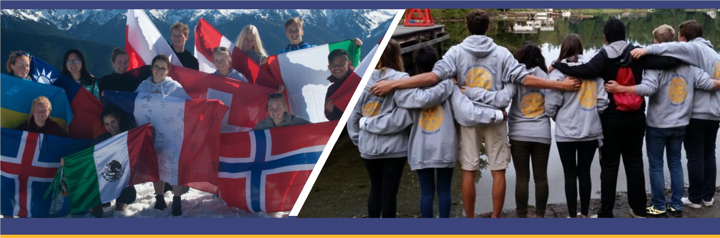
THE YOUTH EXCHANGE
SCHOLARSHIP
Have you always dreamed of…
Traveling the World? ▪ Living in another Country?
▪ Being fluent in another language? ▪
Valued at over $25,000:
YOUR LOCAL ROTARY CLUB:

The Youth Exchange scholarships are made possible by the generosity of our overseas partners and local Rotary Clubs in Rotary District 5050 (NW Washington State and Fraser Valley, BC). Qualified applicants must be ages 15 -18 years old at the time of departure. The scholarships cover room, board, tuition, and a monthly stipend for one academic year. The student/family pays for the airfare, insurance, optional trips and some other fees.
District 5050 information www.youthexchange5050.org Rotary International information www.studyabroad.rotarywessex.org
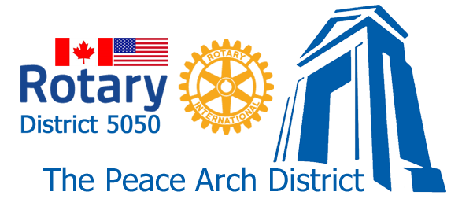
Room, board, tuition, and monthly stipend for a high school year abroad.

THE ROTARY YOUTH EXCHANGE SCHOLARSHIP

Rotary District 5050’s Youth Exchange Program, with the help of our local Rotary clubs and our overseas partners, has made a number of Rotary Youth Exchange Scholarships available for the next academic year. Valued at over $25,000, each scholarship covers room (homestay), board, tuition, and a monthly stipend while overseas.
The Rotary Scholars travel to their host countries in approximately late July to mid September, and return in approximately late June of the following year. They’ll attend high school in their host countries and are expected to act as goodwill ambassadors representing Rotary and their home country (Canada or USA).
Minimum Requirements to apply:
- Between 15 and 18½ on Departure (may currently be in 9th, 10th, or 11th grade)
- Good academic standing
- Open-minded individuals who demonstrate leadership qualities
Applicants are not required to be involved with Rotary in any way before applying. Children of Rotarians are welcome to participate but are not given any preference. Home-schooled and private school students, and students with disabilities are encouraged to apply. We are an all-inclusive program

You will be scheduled for an informational interview to discuss details, and to determine your suitability for the program.

Important Dates:
Deadline for submission of the Preliminary Application is ______________
(this date may vary by Club– Contact your local Rotary Club)

The Preliminary Application must be made online at this link:
https://yehub.net/W05-obpre

ROTARY YOUTH EXCHANGE

LETTER OF INTENT AND INITIAL APPLICATION

(Students Please Note: If your application to your local Rotary Club is successful and you are selected by the club as a prospective Youth Exchange Student, you will receive a link to complete the necessary application forms which you will have to complete and submit to the District Committee for approval and placement. APPROVAL BY THE LOCAL CLUB OF YOUR CANDIDACY IS NOT A GUARANTEE OF APPROVAL OR PLACEMENT BY THE DISTRICT COMMITTEE.)

To Apply :
https://yehub.net/cgi-bin/W05_get.cgi?pgid=apob0
or
youthexchange5050.org and click on the “Apply Here” hyperlink.

RULES AND CONDITIONS OF EXCHANGE
