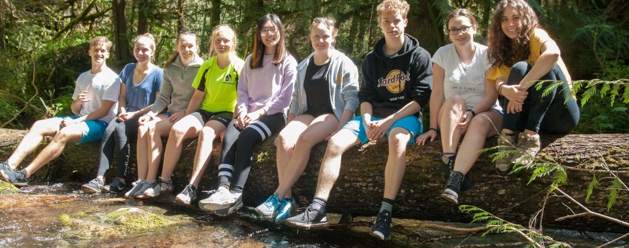
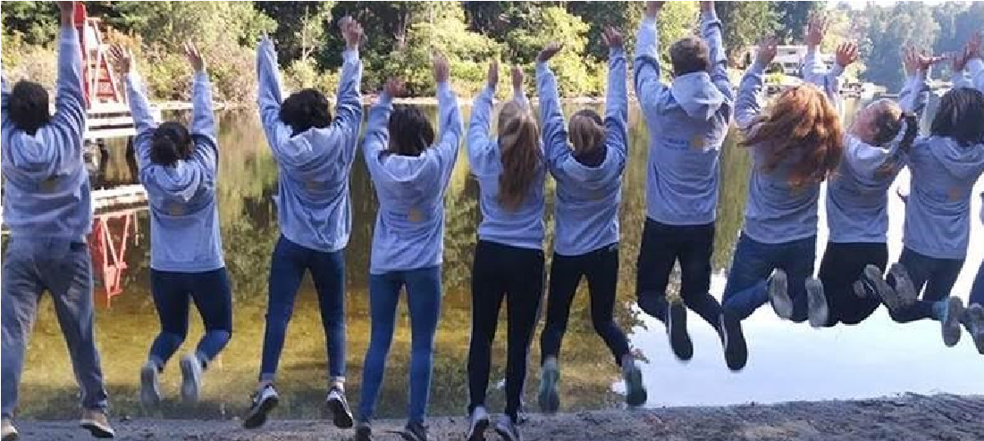
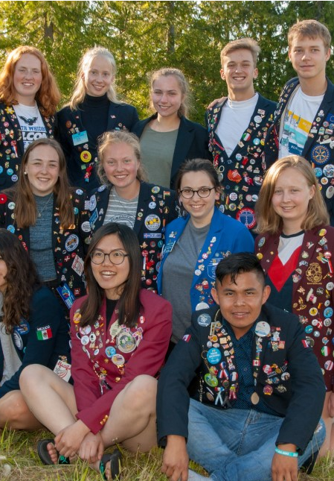
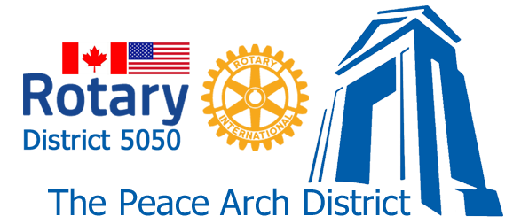
Thinking of hosting an
exchange student?

Hosting may be
a great
opportunity for
your family!

The Rotary Youth Exchange Program
depends on people just like you to make
this program a success. Think about the
impact you could have
-

for life!

Reach out to our [club name] Youth
Exchange Coordinators to learn more or

take the next step:

[contact name]

[contact phone]

[contact email]

[contact name]

[contact phone]

[contact email]
https://www.youthexchange5050.org

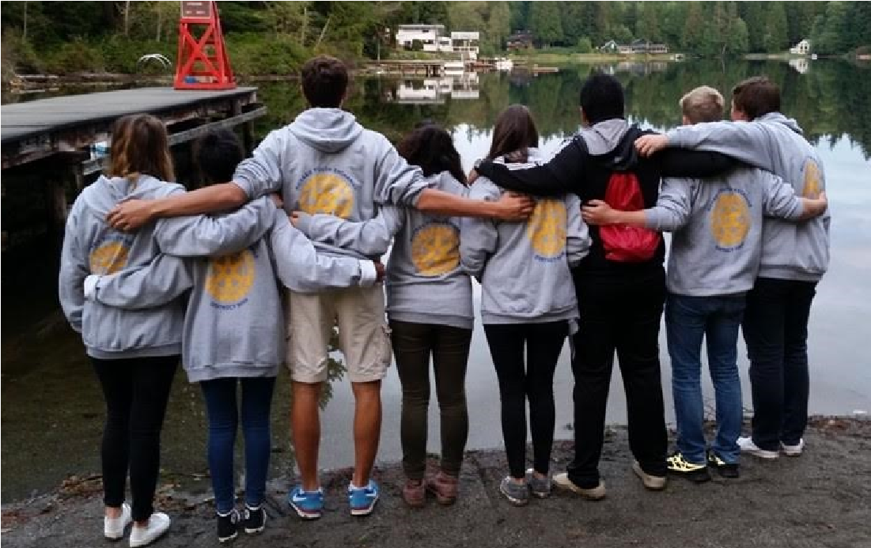
WE SUPPORT YOU EVERY STEP OF THE WAY:
Hosting a Rotary international high school exchange student is a life-enhancing experience for your whole family. It’s a unique opportunity to get new perspectives, explore new customs, and share North American culture and your community with others. Most of all, you’ll build special friendships and connections that often last a lifetime.
WHAT CAN I EXPECT?

Rotary has been successfully
hosting international students
since 1929.

LOCAL SUPPORT
Our experienced local coordinators live in your community, so you always have someone to turn to for immediate guidance. Your local
Rotary Club is comprised of many community leaders who will provide assistance to ensure a positive exchange experience.

PEACE OF MIND
All Rotary exchange students are thoroughly screened prior to acceptance, and arrive with
spending money and full insurance so you can be confident they’re ready to become part of
your family. Students are provided a monthly stipend from Rotary. Host families are
responsible for the basics - room, board, and school transportation - no surprises!

EXCEPTIONAL STUDENTS
Rotary has clubs in over 200 countries. Local Rotary clubs select the best students for participation in the program. The students are smart, engaged, and excited to share their country’s unique cultures, traditions, and languages.An
- An Exchange Student from overseas lives in your home, as a member of your family, for approximately 3-4 months. They are involved with your family, in school, with new friends, and are also active in Rotary events such as conferences and meetings.
- They are 15-18 years old and they are here for 11 months. While the exchange students are here they live with 2 or 3 families to give them a broader understanding of our culture.
- You have extensive support from the local Rotary Club and over 3,000 Rotarians in the local district (District 5050).
- We have had students from Brazil, Italy, Germany, Argentina, Peru, Denmark, Bolivia, Sweden, Belgium, France, Switzerland, Japan and many others. They are wonderful young people.
- We promise you that the experience will enrich your family.

