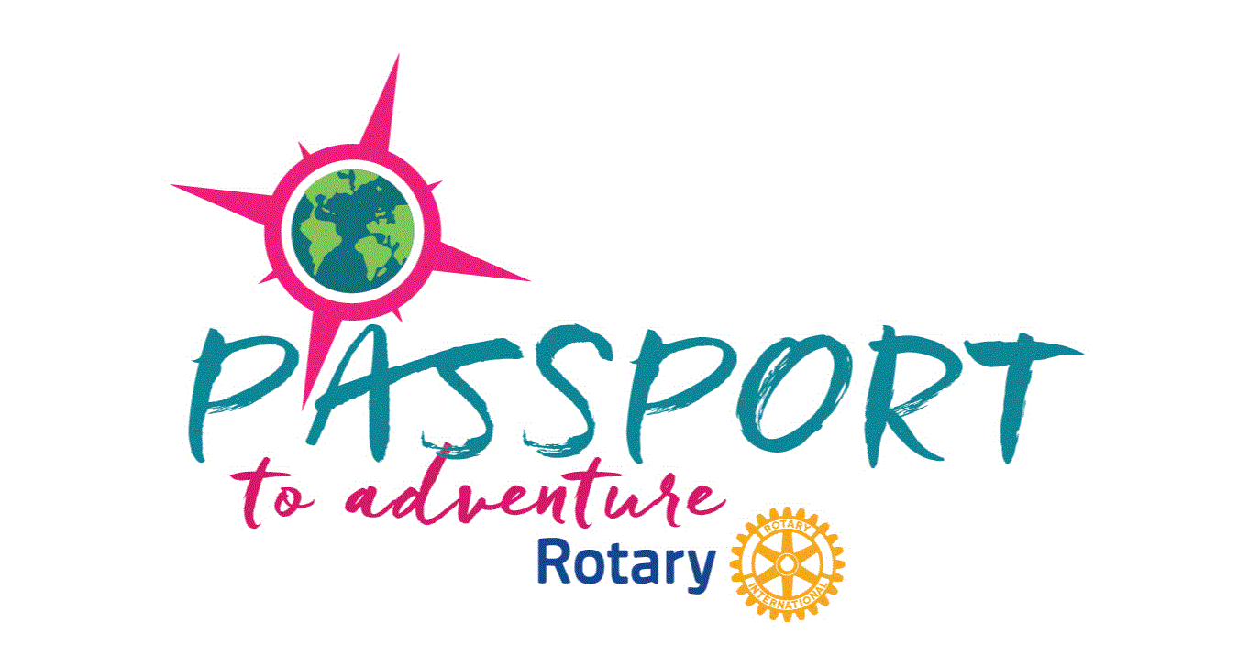

Dear Rotarians,
The District 5160 “Passport to Adventure” Conference will be held in Redding, CA Sheraton Hotel, May 1-3, 2020
We would like to invite you to participate in the Passport to Adventure’s House of Friendship. This is a unique opportunity to showcase what your clubs have accomplished, as well as recruit potential project partners. The House of Friendship will be centrally located to ensure maximum exposure for those participating.
Rotary Fellowships and Action Groups are welcome and encouraged to participate. The House of Friendship will provide an opportunity for clubs to highlight specific projects, fundraise, and seek out partnerships for developing projects. Vendors selling Rotary related products and services are also welcome.
Table fees are $30.00 per table for Vendors. Tables for Clubs are Free.
Please complete the attached application by _________, and return it along with a check for the applicable fees to the team member indicated on the form.
We are so excited about the Passport to Adventure and hope that you will join us. Best Regards,

_______________________________________

