**Membership Application / Renewal Form**

**Company Address**

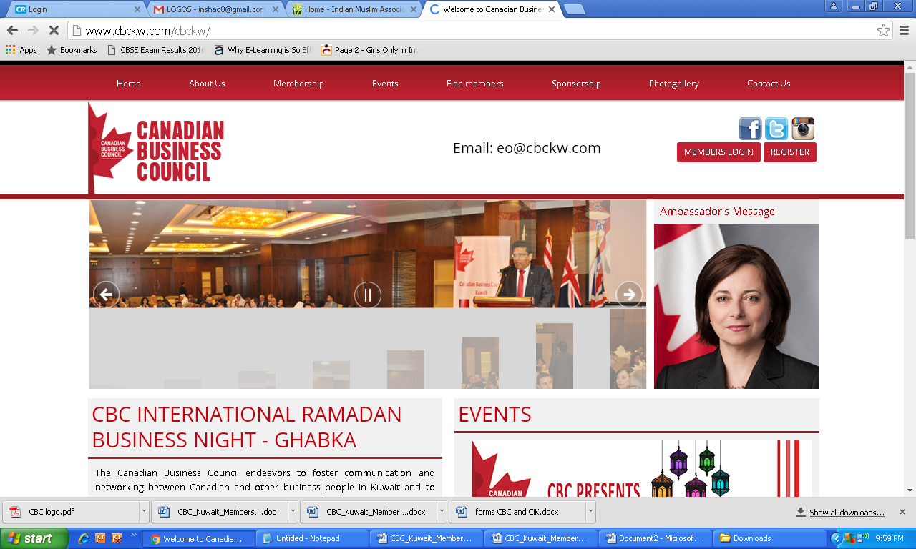

**Given names**

**Surname**

**Gender**

**FEMALE**

**MALE**

**Nationality**

**Position in Company**

**Company**

**Website:**

**Nature of Business**

**Years in Kuwait**

**Mobile:**

**Email**

**Alternate:**

**Primary:**

**Office:**

**Fax:**

**Telephone**

**Reason for your Interest in the CBC Membership**

**Date:**

**Applicant Sign**

**Healthcare**

**Education & Training**

**Construction & Eng.**

**Banking & Finance**

**Other**

**Computers & IT**

**Military & Security**

**Oil & Gas**

**SPOUSE DETAILS: (if applicable)**

**Forename**

**Surname**

**Telephone**

**Nationality**

**For Office Use Only:**

**Email**

**Position in Company**

**Company**

**Date:**

**Recd. by**

**Previous Member**

**YES**

**Email Sent**

**Date Paid**

**Receipt No.**

**Couple (KD.50/-)**

**Single (KD.40/-)**

**Date approved**

**NO**

**Membership No.:**

**Membership Type:**