The following instructions are intended to be a very simple guide to creating an Event using ClubRunner Event Planner functionality for a Bearbrass Probus event convenor with an appropriate ClubRunner access level.
By EXACTLY following these instructions an Event will be created, scheduled into the club calendar, registrations will be enabled and an invitation email sent out allowing members to accept or decline.
For any issues or comments please contact the author, Mel Gray on 0407787117 or mgra2929@bigpond.net.au
- Go to the Bearbrass Probus home page
2. Click on “Member Area” at the top right hand side of the screen
3. If the logon screen on the right pops up enter your “Username” and “Password” and you will see another screen as below. If you don’t see the logon screen you’ll see a screen with text as follows at the top right hand side  (It just won’t say “Mel Gray”- it will have your name!) | 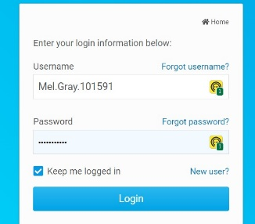
4. At the top of this screen there will be a list of menu options in white writing against a blue background. Click on “Events”. | ….
5. “Events” will now be in black text on a white background. The line below is black text on a grey background showing sub-menu options for “Events”. Click on “Event Planner”. | ……..
6. This screen has a title “Events” on the left side and “Create A New Event” on the right side. Click on “Create A New Event”.
7. This screen allows entry of detail about the event.  - Enter the “Event Name” label  - Ignore “Event Code”  - Set the “Status” “Active” radio button as shown  - Click on the downward arrow head on the “Event Type” line and select “Event”  - Set “Start Date & Time” by clicking on the calendar icon and the diamond icon  - Set “End Date & Time” by clicking on the calendar icon and the diamond icon  - Enter details of the event in “Description” | 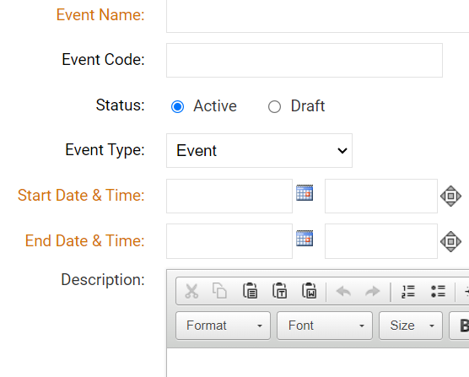
8. Continue entering Event detail  - Set the “Would you like to enable registration now?” “Yes” radio button as shown  - Ignore image  - Select “Event Chair” name from the pick list (“Email” will populate automatically)  - Enter “Location” of the Event  - Complete the rest of the address details as necessary  - Ignore “Map Override” | 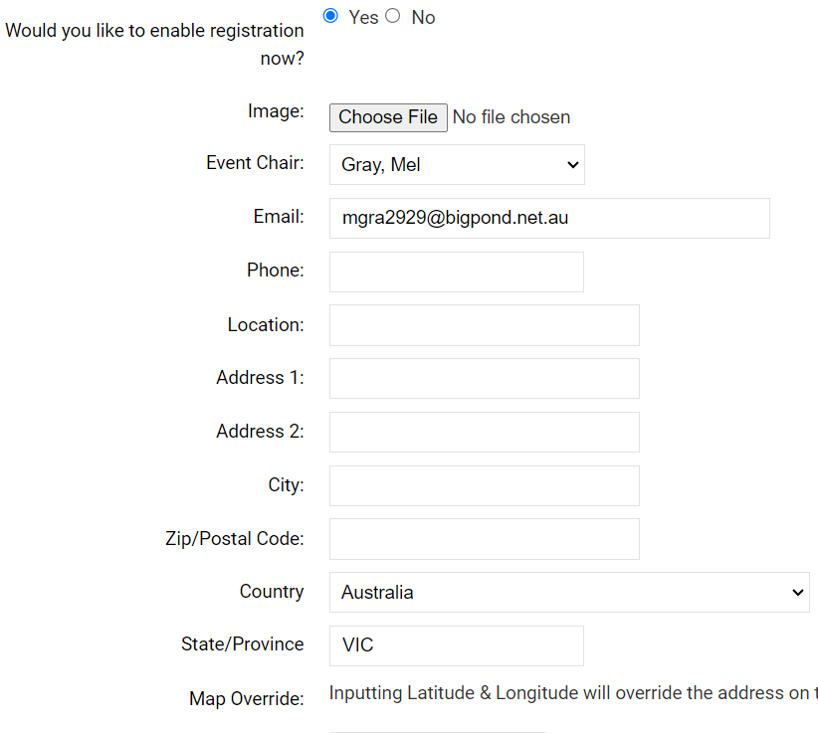
9. Continue entering Event detail  - Ignore “Latitude”  - Ignore “Longitude”  - Set the radio buttons exactly as shown | 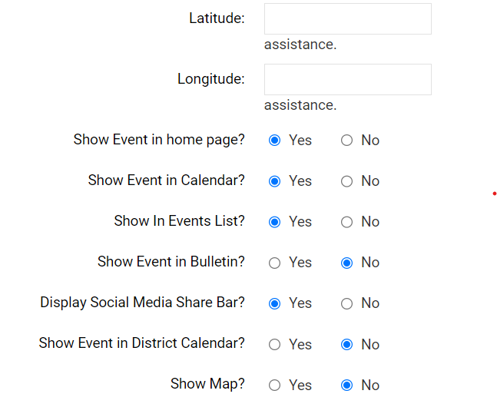
10. Click on “Save” on the bottom right of the screen
11. This screen will be headed with the name of the Event which you created.  Enter Event Registration Options exactly as shown  - Tick box for “Open this event for registration”  - Set “Start Date & Time” (for registration) by clicking on the calendar icon and the diamond icon  - Set “End Date & Time” (for registration) by clicking on the calendar icon and the diamond icon  - Ignore “Is there a fee to attend this event”  - Ignore “Allow public registration”  - Only tick “Allow members to register guests” for events where there is not a restriction to the numbers that can attend (members have first priority)  - Tick box for “Copy event chair on new registration emails”  - Ignore “Enable comments on registration page”  - Ignore “Enable Custom Email Message”  - Ignore “Custom Email Message” | 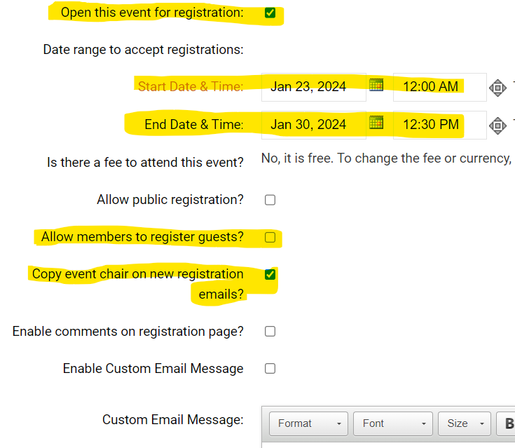
12. Click on “Save” on the bottom right of the screen
13. This screen will be headed with the name of the Event which you created.
Ignore headings:
- Registration, Reports, Register, Volunteers, Payment Settings
14. To the right hand side of the heading “Emails” click on “New Invitation”
15. This screen will be headed “Send Invitation for …” whatever your event is called. | 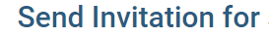
16. Follow the Five Steps on this screen to send a test Invitation email to yourself. When you are happy with what the invitation contains (after viewing it in your email system and seeing that there are no errors) send the email to the member audience.
17. Step 1:  - Tick box for “Active and Honorary Members” to send the invitation to all club members  - Tick the box “Other Users” if you wish to send the invitation to Prospective Members | 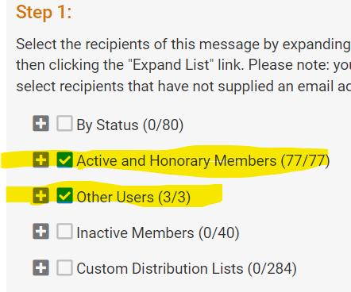
18. Step 2 (part 1):  - Type in the word “Bearbrass” into the “Subject” line  - Ignore all “Template and Merge Fields” | 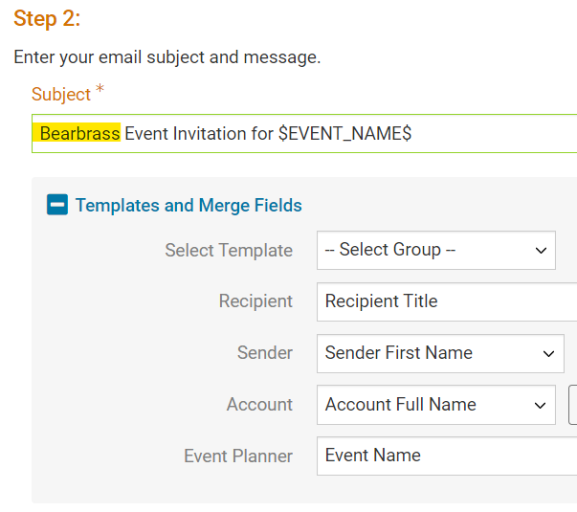
19. Step 2 (part 2) make the following specific changes in the email template:  - Remove “$LAST_NAME$,”  - Ignore “Event”, “Date”, “Fee”, “Location” and “Details”  - Ignore “$EVENT_ATTEND_DECLINE_LINK_MEMBERS$”  - Remove all the text with the red cross through it  - Ignore “Thank you” and the next line | 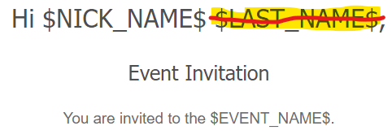  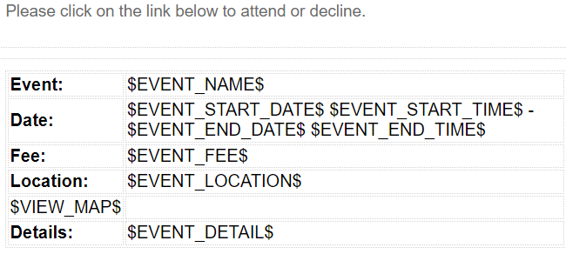  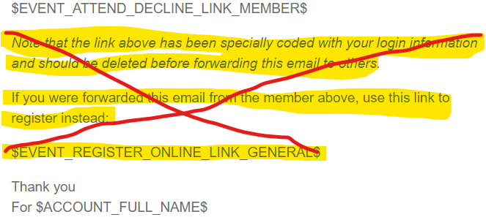
20. Step 3 – ignore step 3 | 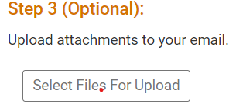
21. Step 4:  - Tick box for “include link to list of recipients”  - Tick box for “Send me a copy of this email” | 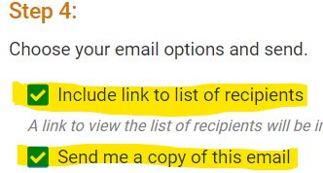
22. Step 5 (part 1):  - The radio button “Send right now” is automatically set (don’t change)  - Click on “Send to Myself”. This will send a copy of the Invitation (a test email) to your email address, so you can check it before sending to all the recipients  - Go to your email system and retrieve the Invitation email  - Review the email in the shoes of someone who is learning about the event for the first time. If you have followed the instructions exactly the only thing that might need to be changed is the Event Description.  - If you wish to send the test email out exactly as the one sent to yourself, go to paragraph 23 of these instructions.  - If you do need to change the Event Description go to the top of the page and click on “Back to Event Details”  - This screen will be headed with the name of the Event which you created.  - Click on “Edit Details” on the right hand side of the screen.  - This screen will be headed with the name of the Event which you created.  - Scroll down to the “Description” of the event and make whatever changes are necessary  - Scroll down to “Cancel” and “Save” on the lower right hand side and click on “Save”  - This screen will be headed with the name of the Event which you created.  - Scroll down to the bottom of the page to the section headed “Emails”  - Ignore “New Invitation” and “New Email”  - Click on “Open” on the right hand side of the draft email  - Go back to the start of this paragraph 22 and repeat the steps until “you wish to send the test email out exactly as the one sent to yourself” then go to paragraph 23 of these instructions | 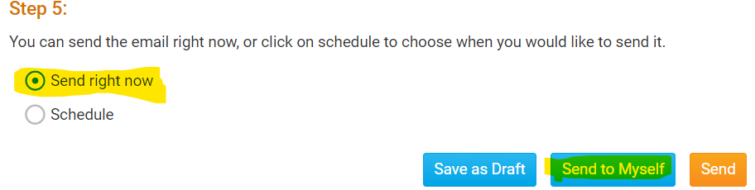  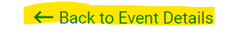  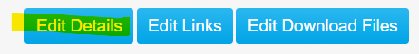  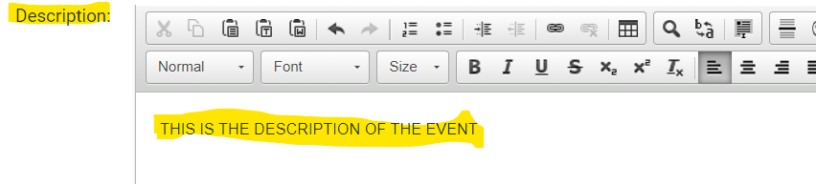  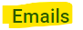  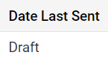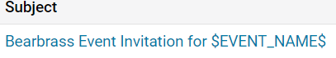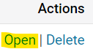
23. Step 5 (part 2):  - Scroll to the bottom of the page and click on “Send” | 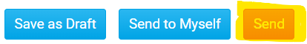

…..and that’s all folks!
If you have followed the instructions exactly you will have created an Event, scheduled it into the club calendar, enabled registrations and sent out an invitation email allowing members to accept or decline.

