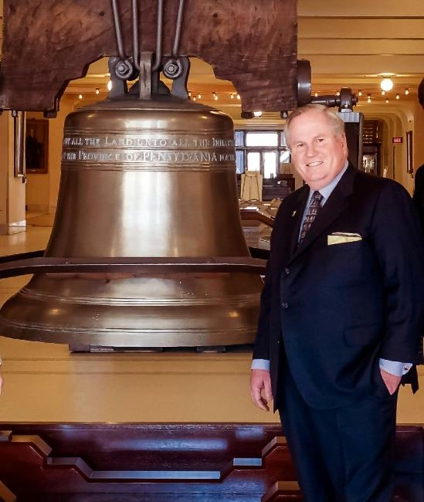
PLENARY SESSION III
PDG Kelly C. Atkinson
Rotary District 5420
Rotary Club of West Jordan, Utah

Kelly C. Atkinson is a native of Utah and
has lived in the Salt Lake City Valley his
entire life.
In 1986, he became the first member of
his party elected to the Utah House of
Representatives from his area since the
Great Depression. He served in the Utah
Legislature from 1990 to 1996.

During his tenure in office, the Deseret News named Kelly as
"one of the most effective legislators" on Capitol Hill for each term he
served. That same year, Kelly was approached by Bob Ladenberger,
a hospital administrator, to help form a new Rotary Club in West
Jordan, Utah. Kelly became a charter member of the club, established
in 1987.

In the centennial year of Rotary, Kelly was the District Governor for
Utah. He was the chairman of the House of Friendship for the 2007
Rotary International Convention held in Salt Lake City. Kelly also
served as Zone 27 Rotary Coordinator from 2016-2019. He and his wife
Penny are both Arch Klumph Society Members as well as members of
the Paul Harris Society.
In 2010, Penny, Kelly's wife of 53 years, was elected as the first
woman Governor in the history of District 5420. Kelly and Penny are
among just a handful of Rotarian couples in the world that have both
served as District Governors and the first and only couple to do so in
Utah. Together, the Atkinsons have hosted 31 Exchange Students from
all over the world. The Atkinson’s have two sons. three grandsons, and
one great granddaughter!

