PLENARY SESSION I

Martha (Marty) Peak Helman, TRF Trustee
RC of Boothbay Harbor, Maine
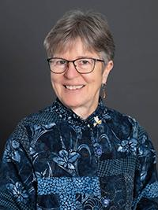

Marty Helman spent her career as a writer for
business executives and as a magazine editor at McGraw-Hill and the American Management
Association. Later, she served as president of
the Otto and Fran Walter Foundation, a nonprofit
that has helped build schools in developing nations, provided scholarships for at-risk youth, and
supplied humanitarian aid to Holocaust survivors, among other initiatives.
The Walter Foundation partnered with The Rotary Foundation to fund
the new Rotary Peace Center that will be located at Bahçeşehir
University in Istanbul.

Helman and her late spouse, Frank, joined the Rotary Club of Boothbay
Harbor in 2003. She has served Rotary as chair of the Peace Major
Gifts Initiative and on the working group to select a site for the new
peace center. A keen fundraiser for The Rotary Foundation, Helman
initiated an effort to support the Sakuji Tanaka Rotary Peace Fellowship,
which raised $1 million for the Rotary Peace Centers.

Helman is an Arch Klumph Society member, and she chooses to support
Rotary as a member of the Paul Harris Society and PolioPlus Society.
She and Frank were charter members of the Legacy Society of The
Rotary Foundation.

