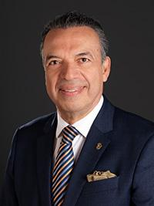

PLENARY SESSION II
SALVADOR RIZZO TAVARES
Director 2024-2026
Rotary Club of Monterrey Carlos Canseco
Nuevo León, Mexico

Salvador Rizzo Tavares is CEO of Grupo Rizzo,
which he established in 1987 as an office equipment wholesaler. The group
now has four companies and
specializes in supplying hardware and software for private companies,
educational institutions, and governments. Among his professional
accomplishments is the creation of Aula Inteligente technology that has
been used to equip more than 120,000 classrooms in public elementary
schools in Mexico.

Rizzo Tavares joined Rotary in 1989 at age 27. He focuses on connecting
Rotary members, engaging young professionals, and enhancing members’
understanding of the organization. He has served RI as a Rotary
Coordinator, member of the New Generations Committee, and training
leader. He also established the Rotary Leadership Institute in 11 countries and
led them for 10 years, training more than 5,000 Rotary members.

Rizzo Tavares has also led global grant projects to address eating
disorders, resolve environmental problems, and provide equipment to
detect prostate cancer, among others. He has also served his community
in the metropolitan area of Monterrey as a member of an arts organization
that combats pediatric cancer. He volunteered for Acciones en Cadena
(“Chain Reactions”), which runs programs to protect at-risk youth from
alcoholism, tobacco, drugs, and eating disorders.

He and his partner, Esmeralda, are Rotary Foundation Major Donors,
Benefactors, Paul Harris Fellows, and Bequest Society members.

Rizzo Tavares has three children, Anna María, Salvador, and Paulina, and
three grandchildren, Enrique, Regina, and Santiago.

