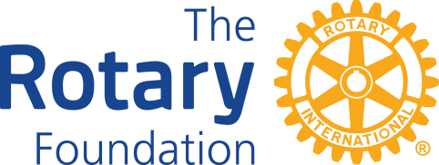

ARIZONA ROTARY LEADERSHIP ACADEMY

“UNDERSTANDING AMD UTILIZING THE ROTARY FOUNDATION”

CHAPTER TWO: Structure of the District Rotary Foundation Committee

The material in this chapter is extracted from the online course entitled “Get Ready: District Rotary Foundation Committee.” Go online to learn more about the DRFC.

The District Rotary Foundation Committee supports clubs and the District Governor.
The chair and the committee are responsible for:
- Coordinating and promoting all district Foundation fundraising and program participation
- Working with the district training committee to promote Foundation-related training events
- Encouraging clubs to offer at least two programs about the Foundation each year, including one in November for Rotary Foundation Month
- Soliciting annual and major gifts to the Foundation
- Deciding together how to distribute District Designated Funds and working with the governor and governor-elect to authorize the use of those funds
- Encouraging clubs to set fundraising goals in Rotary Club Central
- Qualifying the district to participate in global grants and implementing the district memorandum of understanding
- Facilitating grant management seminars and qualifying clubs to participate in Foundation grants
- Serving as the primary contact for district grants, providing grant resources, reviewing applications, and overseeing project funding approvals
- Helping choose qualified recipients for Foundation awards

Rotary International recommends these subcommittees for the District Rotary Foundation Committee. Each subcommittee may include additional subcommittees. For example, the Grants Subcommittee may include a Global Grants Subcommittee and a District Grants Subcommittee.
- Grants. The district grants subcommittee manages and promotes Rotary Foundation grants.
- Stewardship. This subcommittee ensures the careful management of Rotary grant funds and trains Rotary members to manage grants effectively.
- PolioPlus. This subcommittee promotes the Foundation's polio eradication efforts to Rotarians and the wider community and organizes fundraisers to help end polio. It can also encourage club presidents to appoint a club PolioPlus committee.
- Rotary Peace Fellowships. This subcommittee encourages clubs to participate in the Rotary Peace Centers program and manages the required district endorsement process. Governors appoint a district Rotary Peace Fellowship subcommittee chair to serve as the main contact for the fellowship.
- Fundraising. This subcommittee strengthens and monitors Foundation fundraising and recognition in the district.

District Rotary Foundation Committee Chair

To be effective, the district Rotary Foundation committee must have continuity of leadership. For this reason, the committee chair is appointed for a three-year term.

Under the district governor’s leadership, the committee chair works with the committee to plan, coordinate, and evaluate district Foundation activities.

Additional details on the responsibilities and function of the DRFC can be found in the online course.

