Downtown Neighborhoods Association Newsletter
April 2024
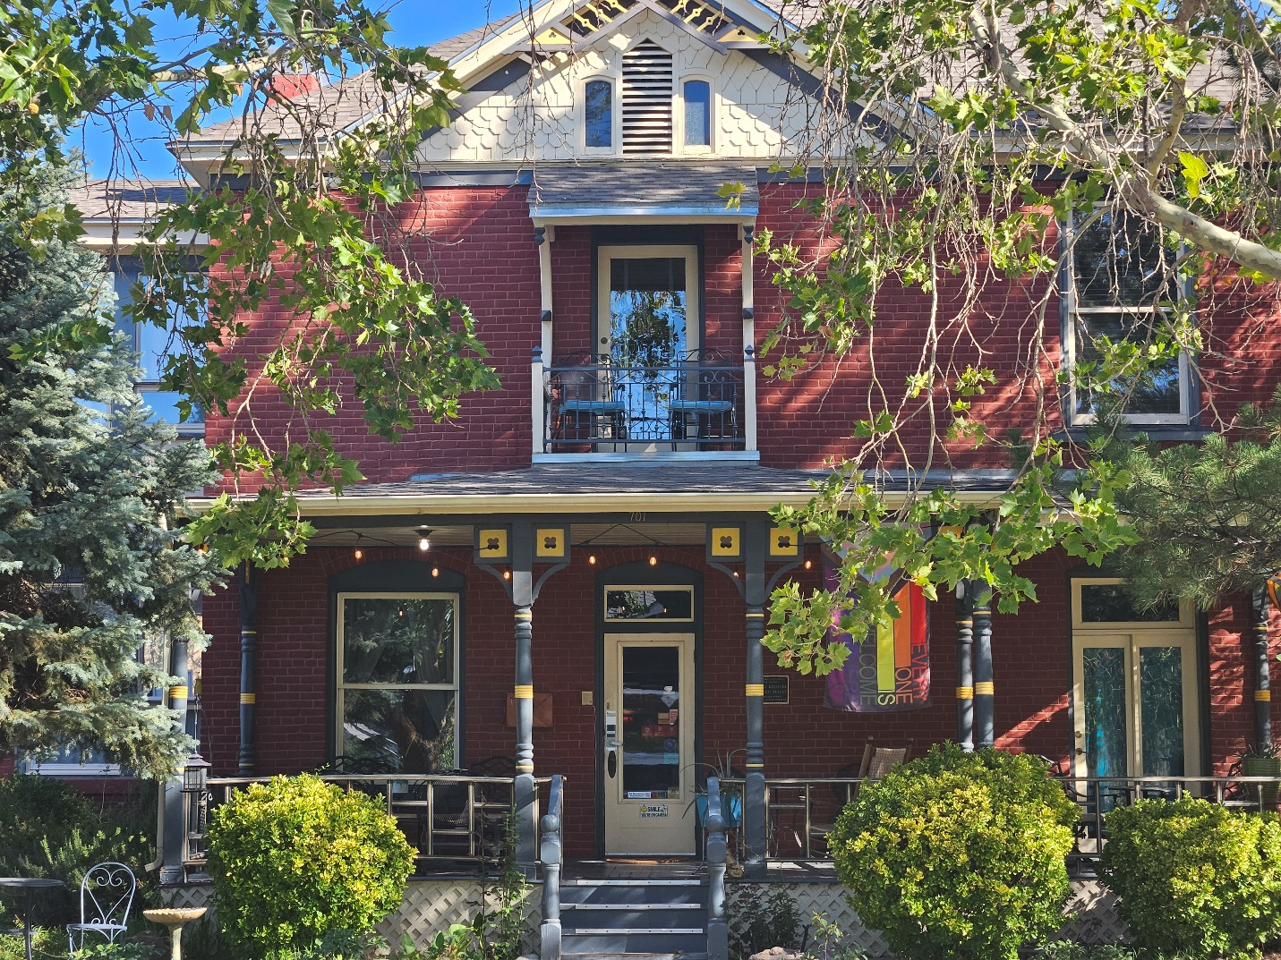
Mother’s Day Historic House and Garden Tour.
It’s almost here. Sunday, May 12, 11:00–3:00. This is the 50th anniversary of the tour, and promises to be very special. The tour starts at Lew Wallace School, and all houses are within blocks of one another. Please note that this is a walking tour, so plan accordingly. Buy your tickets online now HERE Price of tickets $15.00/person online; $20.00 at the door.
Docents are still needed for the tour. Volunteer to be a docent, and you will receive a free ticket to view the other homes on the tour in the two hours before or after your docent duty. Docents answer questions about that particular home and guide participants through the home or garden. If interested, please contact the DNA at abqdna@abqdna.com.

April Board meeting: The Downtown Neighborhoods Association Board will meet Monday, April 1, 2024 (no fooling!) from 5:30 – 7:00 p.m., at Lew Wallace Elementary School, 513 6th Street, room #104.
New Board Members Elected. At the annual meeting on March 6, two new Board members were elected—Eric Carson and Barbara Saville—bringing to eleven the number of members on the Board. Below is the complete roster. Officers for next year will be selected at the April Board meeting.
Eric Carson
Karen Foss
Sylvia Holguin
Kelly Hogeland
Corine Leger
Nancy Magnusson
Beverly Salas
Glen Salas
Barbara Saville
Danny Senn
Trudi Wieduwilt

Celebrating Downtown. Beginning with this month, we are adding a new feature in the DNA newsletter—a haiku that reminds us of the beauty, potential, adventure, and sometimes challenges that come with living downtown.

Historic houses
Blooms and birds and trees say Spring
Heart of the City
—Stephen Littlejohn

There are many ways to be active in your neighborhood:
· Come to monthly DNA Board meetings
· Become a DNA member. There are no set membership amounts. Give what you can to support the projects of the DNA.
· Support the DNA by purchasing one or both books we have for sale about downtown Albuquerque: McClellan Park and DNA History Project. $10.00 each. Order yours at https://abqdna.tidyhq.com/public/shop/products
· Share this newsletter with your neighbors: Pass this newsletter along and encourage those you share it with to sign up themselves. To sign up for the newsletter list, send your email to: abqdna@abqdna.com.

