August Newsletter
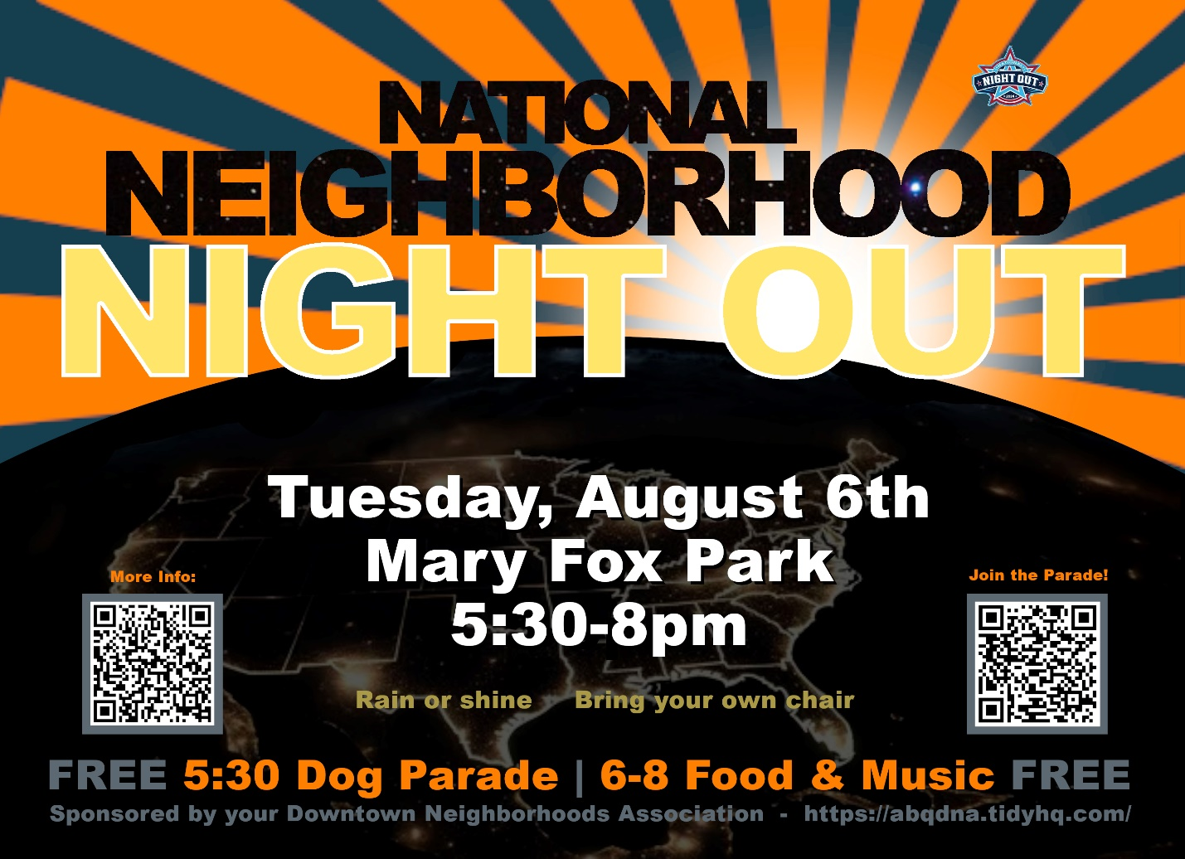

Live Music, Food & Games – 6 – 8 pm
The NNNO will kick off with the first annual Dog Parade to celebrate the dogs and humans that love to walk in our downtown neighborhood. All DNA Doggies are invited to participate and the first 50 to sign up using the QR code on the flier will receive a handmade gift! Following the parade, you will have time to take your dog home for a well-deserved rest before joining in the remainder of the activities.
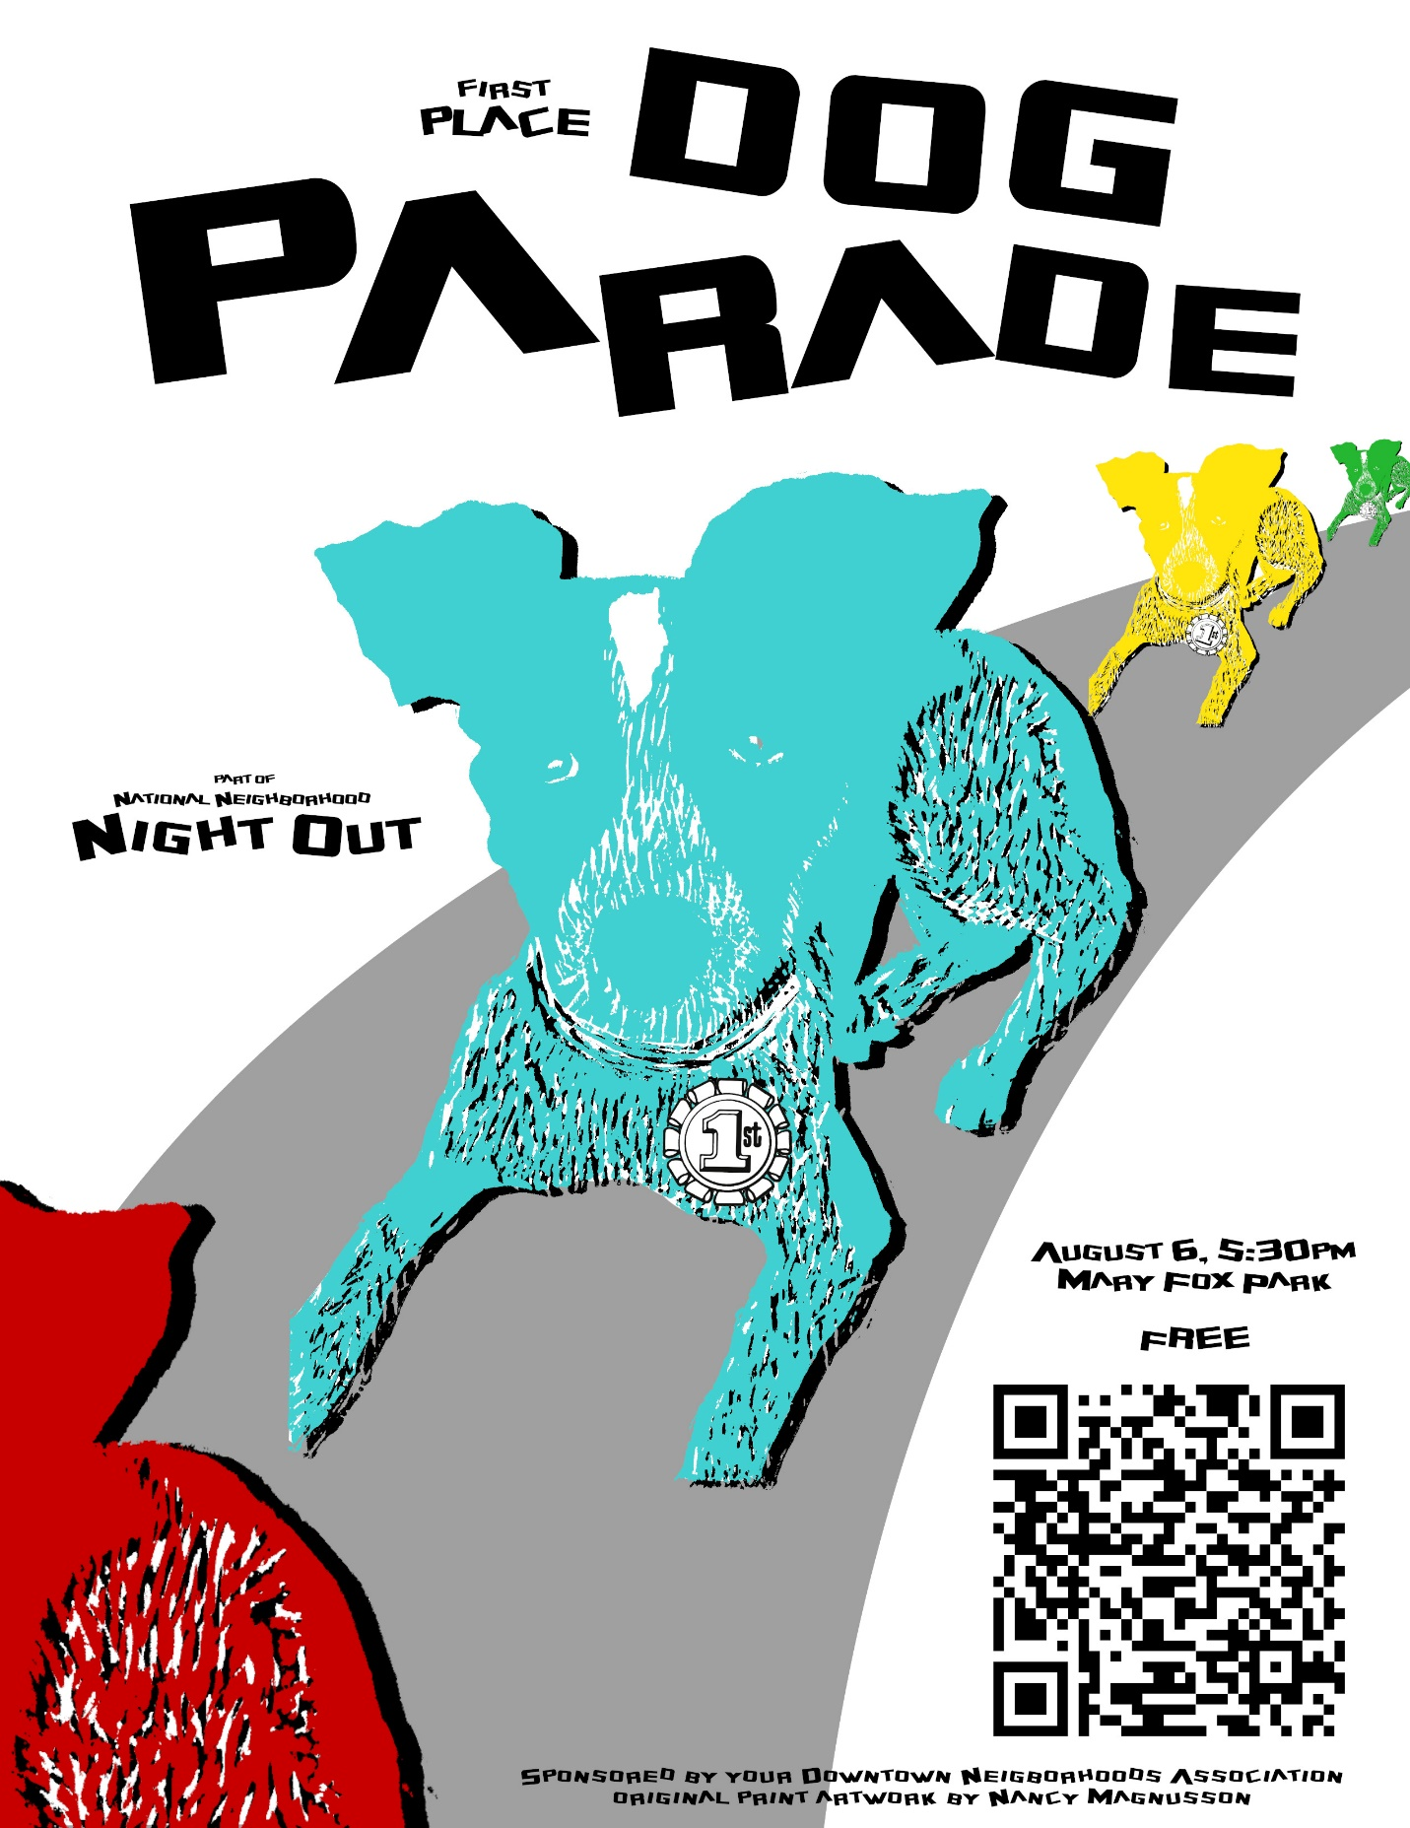

Lew Wallace News:
Lew Wallace Elementary School is excited to welcome back our 1st through 5th grade students on Wednesday, August 7. Our Kindergarten students will begin school on Friday, August 9. School starts at 8:40am and ends at 4:10pm. We have before and after school care on site.
Join us for Teacher Meet & Greet on Tuesday, August 6, 3-4pm. We have many exciting family events and enriching opportunities for students coming up this year, including Open House, August 28, 5-6:30pm. We can't wait to get started with the new school year!
We love volunteers and donations of all kinds -- please contact Lew Wallace Community School Coordinator, Melanie Lewis, at melanie.lewis@aps.edu or 505-563-0648 for more information. Information on APS Volunteer Background Clearance https://www.aps.edu/community/volunteer-with-aps

Old Walls Gallery is hosting NEIGHBORS 2.
The second annual community exhibition showcasing artists of the Downtown Albuquerque Neighborhood.
Opening Celebration
Friday, August 2nd 5-8 pm
On view August 2 – September 30
Open on Saturdays with the Grower’s Market.
Next scheduled Downtown Neighborhoods Association Board Meeting
Monday, August 5, 2024. 5:30 pm at Fusion/The Cell, 700 1st Street NW, Albuquerque NM 87102
Agenda Items:
· finalize National Night Out Plans
o Committee updates
· Arts and Culture Guest Speaker
· What do we want to accomplish as a board over the next year?
· Budget for the next year
· No September DNA meeting
If you are sharing this newsletter with fellow neighbors, please encourage each one to join the Downtown Neighborhoods Association. It’s free and easy to join! https://abqdna.tidyhq.com

