December 2024
The DNA Bulletin

Holiday Spirit
The air sparkling with good cheer
Friends, Family draw near
New Website Arriving Soon
The Downtown Neighborhoods Association is preparing to launch a new website! Your DNA board has been working behind the scenes to research websites, learn the new system and transfer information. Watch for email updates on the new website as we move forward into the new year.
CommUnity Tree Project
Spreading roots…creating community. One of the many projects the DNA spearheads involves community building by decorating trees at schools and in neighborhoods across town with hand-made tree bark ornaments that display positive words (respect, love, joy) and images. The act of creating the ornaments, and decorating the trees begins with a conversation that leads to a shared community experience. Board members Nancy Magnusson and Beverly Salas engaged the third grade students at Lew Wallace Elementary in conversations and directed their art project. (for more photos and details, see the Dec. 3, 2024 issue of the Downtown Albuquerque News online newspaper)
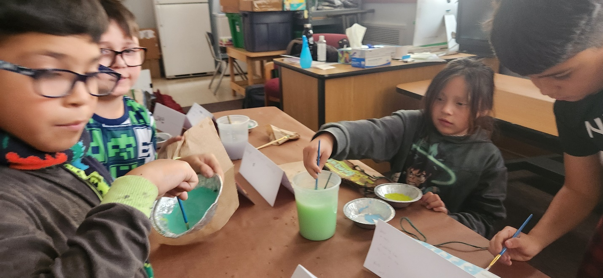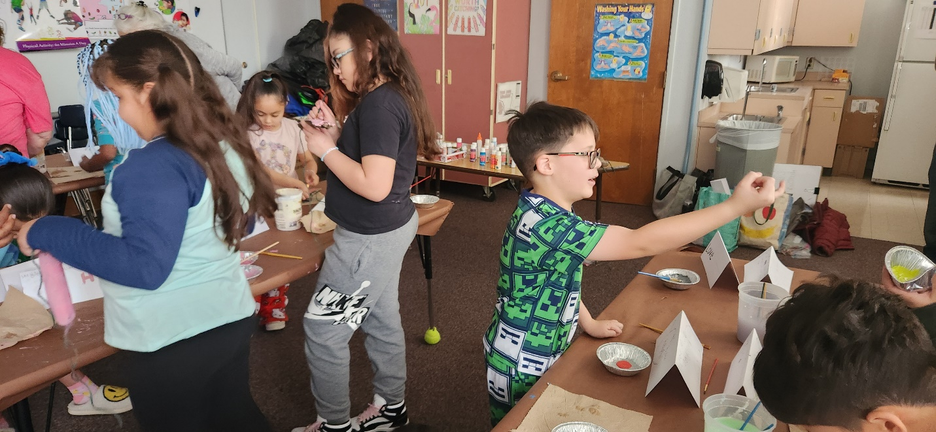
Neighborhood Yard Waste Fall Clean-up
The trees have been dropping those leaves!
Yard waste can be collected for pick-up by the city every fall and spring. Fall pickup is scheduled December 2 – 13 on your regularly scheduled trash day.
Green Waste Collection Event Tips:
During collection events, please follow these guidelines:
- Green Waste must be 5 feet away from trash/recycling containers.
- Green Waste must be placed in trash bags.
- Trash bags must not weigh more than 40 lbs.
- Cut branches to four-foot lengths and bundle them securely.
- Dirt, debris, gravel, construction material or tree stumps will not be picked up.
- Do NOT place green waste in your recycling cart.
Lew Wallace Elementary School News
The students and staff enjoyed a wonderful Thanksgiving lunch with our families on November 21!
We will host a Winter Make & Take Craft Night on December 18, 4:30-6pm.
Ms. Cook’s class & Mr. Chacon’s classes will have a special performance of their National Institute of Dance — New Mexico at the end of the year on December 19. There will be a performance for the students and another performance for parents and community members, 3-4pm.
If you want to donate presents or give in another way to students & families, reach out to Melanie Lewis
Community School Coordinator
c (505) 563-0648 melanie.lewis@aps.edu
DNA Meetings
New Members Wanted: We currently have a wonderful group of people who work together very well and our meetings are always fun and informative. If you have any interest in joining our board and becoming more active in your community, contact chair@abqdna.com. Membership in our board is not overly exacting, steady attendance for the monthly meetings is required, not all 12 but as many as you can. We also ask that you participate in our major events: The Historic Home tour, the Annual Meeting, and Neighborhood Night Out. If you’d like to go a little deeper, each event has committees that start some long-range planning. Our Historic Home Tour, for example, is held every even number year and we start planning a year in advance. We will be sharing any other necessary information during the meeting. Thank you for being good neighbors!
Next scheduled Board Meeting: Monthly Meetings are now scheduled for the 2nd Monday of each month. The next meeting will be Monday, December 9, 2024. 5:30 pm at Fusion/The Cell, 700 1st Street NW, Albuquerque NM 87102
Share this with your neighbors: Pass this newsletter along and encourage those you share it with to sign up themselves. To get on the email list, send your email to: abqdna@abqdna.com

