January 2024
New Meeting Place for the DNA: Beginning with the January board meeting, the DNA has a new meeting place: Lew Wallace Elementary School, 513 6th Street, room #104. Please use the 6th Street main entrance to the school; the room is easy to find once you enter. A big thanks to Harwood Art Center for providing the DNA with meeting space over the last year.
January Board meeting: The Downtown Neighborhoods Association Board will meet Monday, January 8, 2024, 5:30 – 7:00 p.m., at Lew Wallace Elementary School, room #104.
Agenda
1. Update on Home Tour tasks
2. Establish dates for 2024 meetings
3. Establish date and location for annual meeting in March
4. TidyHQ system
5. Recruitment of new board members
6. Buttons update
7. Facebook/Instagram Update
8. Update on book sales
Neighbors who wish to add an agenda item: please contact Danny Senn (abqdna@abqdna.com) at least 24 hours before the scheduled meeting time. Presenters will be limited to 5 minutes each to ensure that the board’s business can be completed in a timely fashion.

Save the Date! Mother's Day, Sunday, May 12th, 2024 (11 AM - 3 PM)
50th Anniversary Home Tour: Your Downtown Neighborhoods Association will once again offer the Historic Neighborhood Home Tour.
Volunteer to be a docent for the home tour. Give two hours at one of the featured homes or gardens on the tour, and you will receive a free ticket to view the other homes on the tour in the two hours before or after your docent duty. Docents answer questions about that particular home and guide participants through the home or garden. If interested, please contact the DNA at abqdna@abqdna.com

Learn more about your neighborhood and its history:
McClellan Park: The Life and Death of an Urban Green Space, by Jeffrey C. Sanders 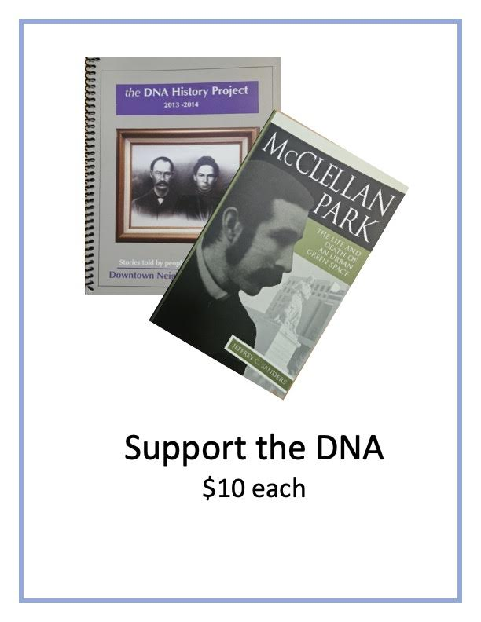
Order yours at https://abqdna.tidyhq.com/public/shop/products

News from Lew Wallace Elementary
By Tanya Silva
At Lew Wallace, our dedication to cultivating an arts-integrated environment remains steadfast. On December 6, we orchestrated an enchanting day that allowed our students to delve into the captivating world of the circus. The students were immersed in a spectrum of arts-integrated workstations led by the LWES staff and the talented instructors from Wise Fool Circus Arts (visit them at https://wisefoolnewmexico.org/). These sessions seamlessly wove together literacy, arts, music, community, and the mesmerizing artistry of the circus. Under the guidance of the Wise Fool Circus artists, our students explored diverse skills from acrobatics to games to movement to juggling.
The afternoon was a spectacle as the students were treated to a mesmerizing circus performance that featured a remarkable aerialist. As the day drew to a close our students transformed into performers themselves. Led by music teacher Alex Flores, students showcased their newfound talents from the music and literacy workstations to an audience of families and esteemed guests.
The resounding success of this event has inspired us immensely, igniting our eagerness to commence planning for next year. We envision building upon this incredible experience, continuing to ignite the spark of creativity and artistic discovery in the hearts of our students.

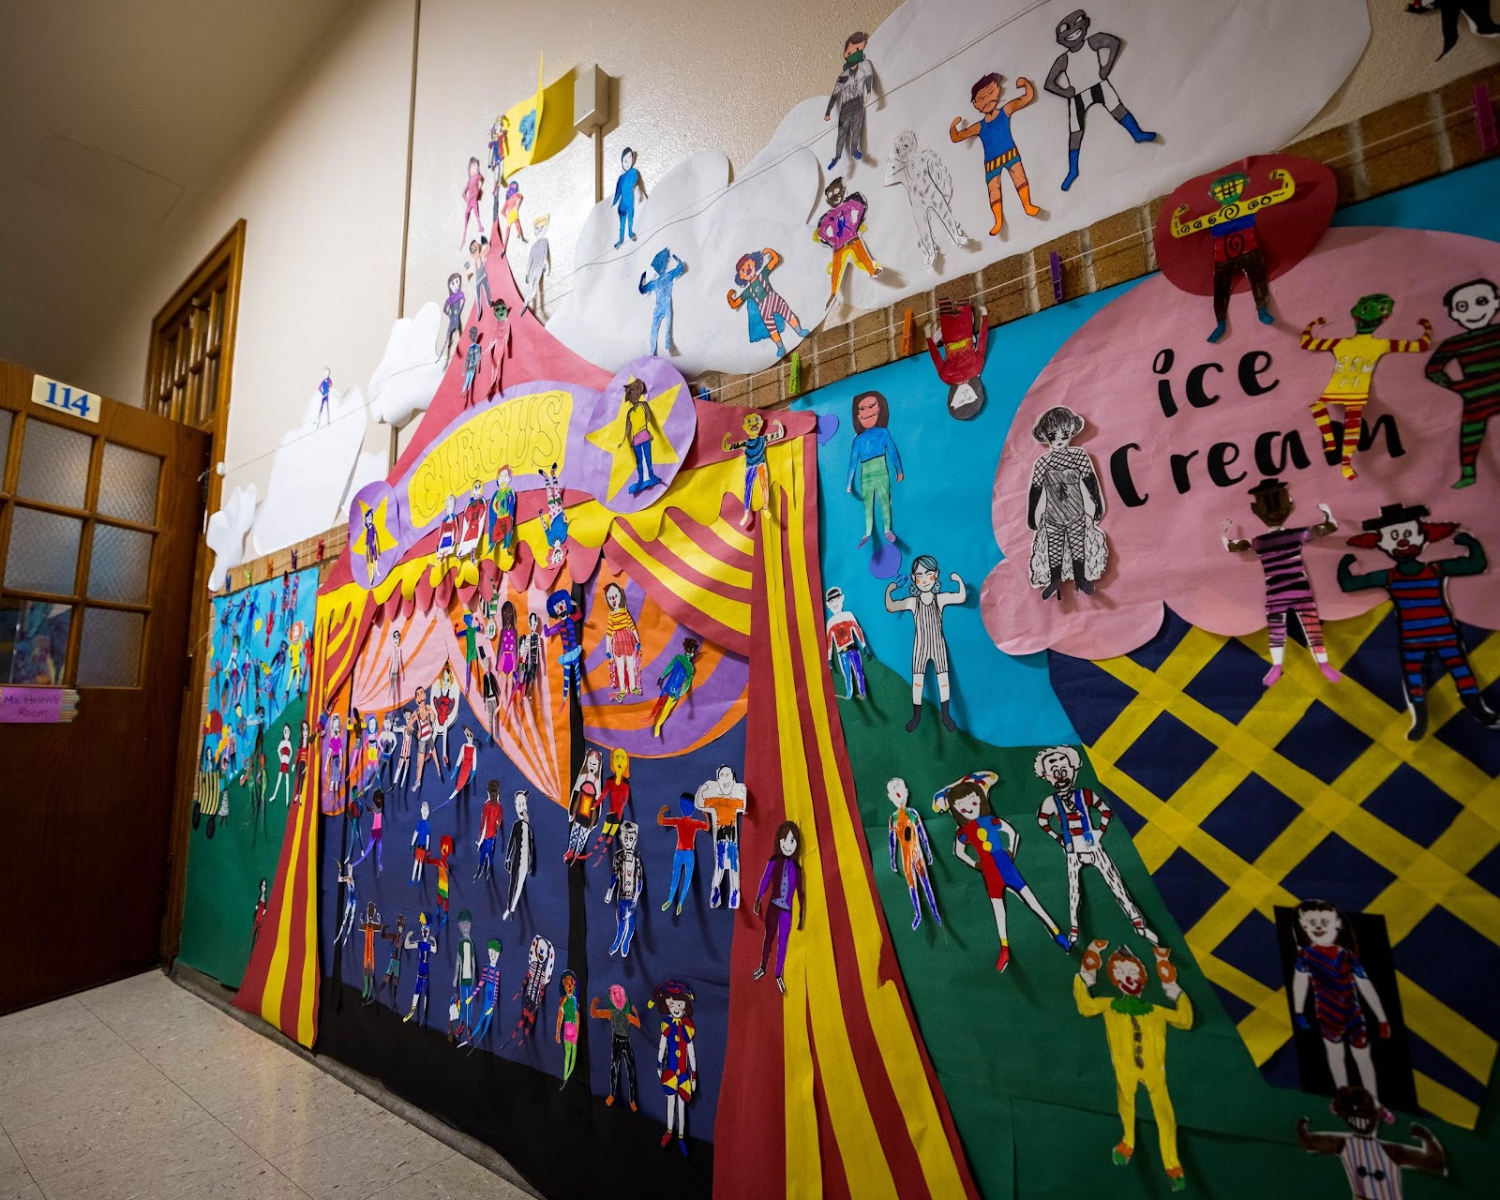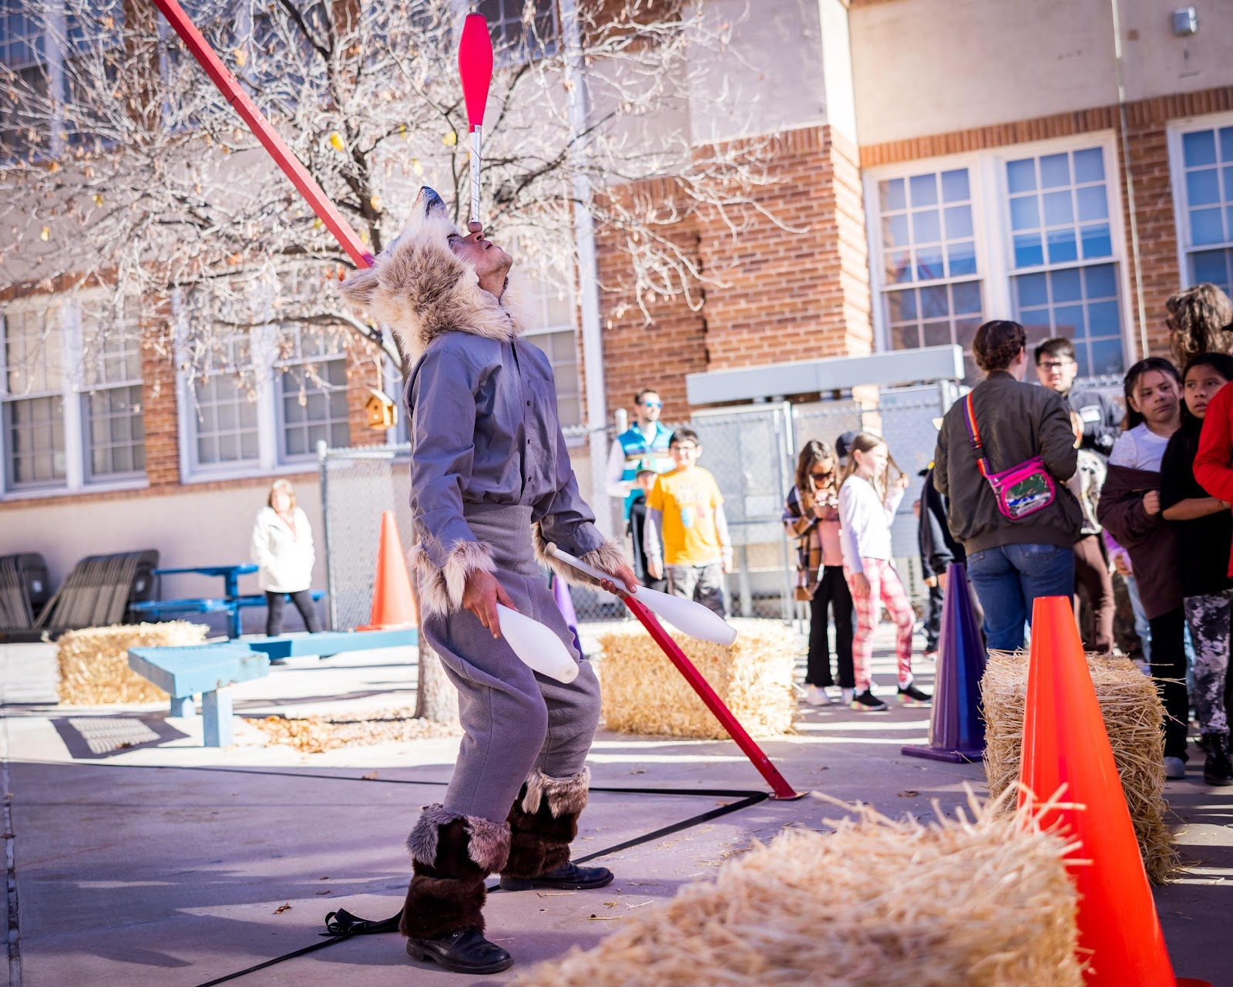

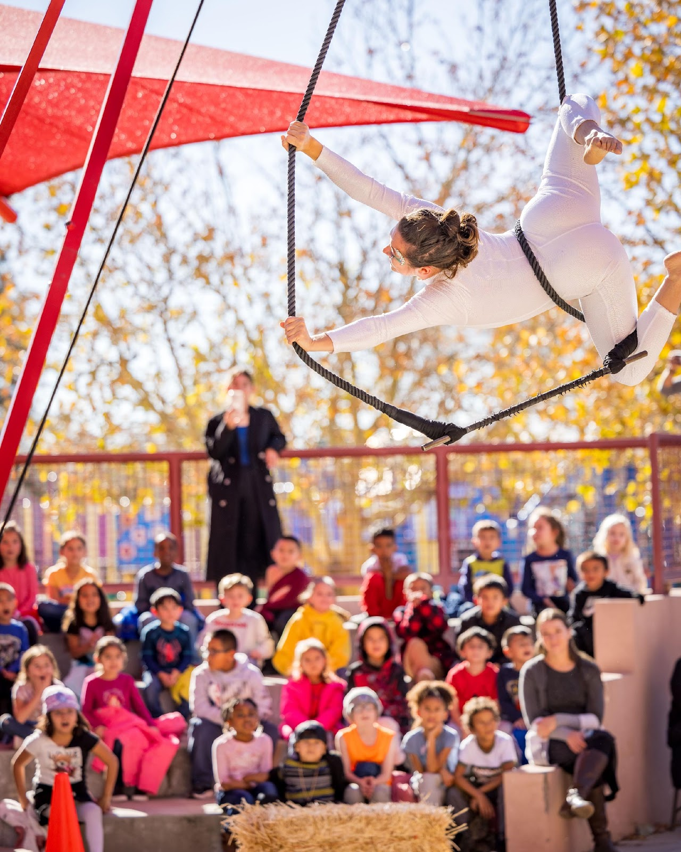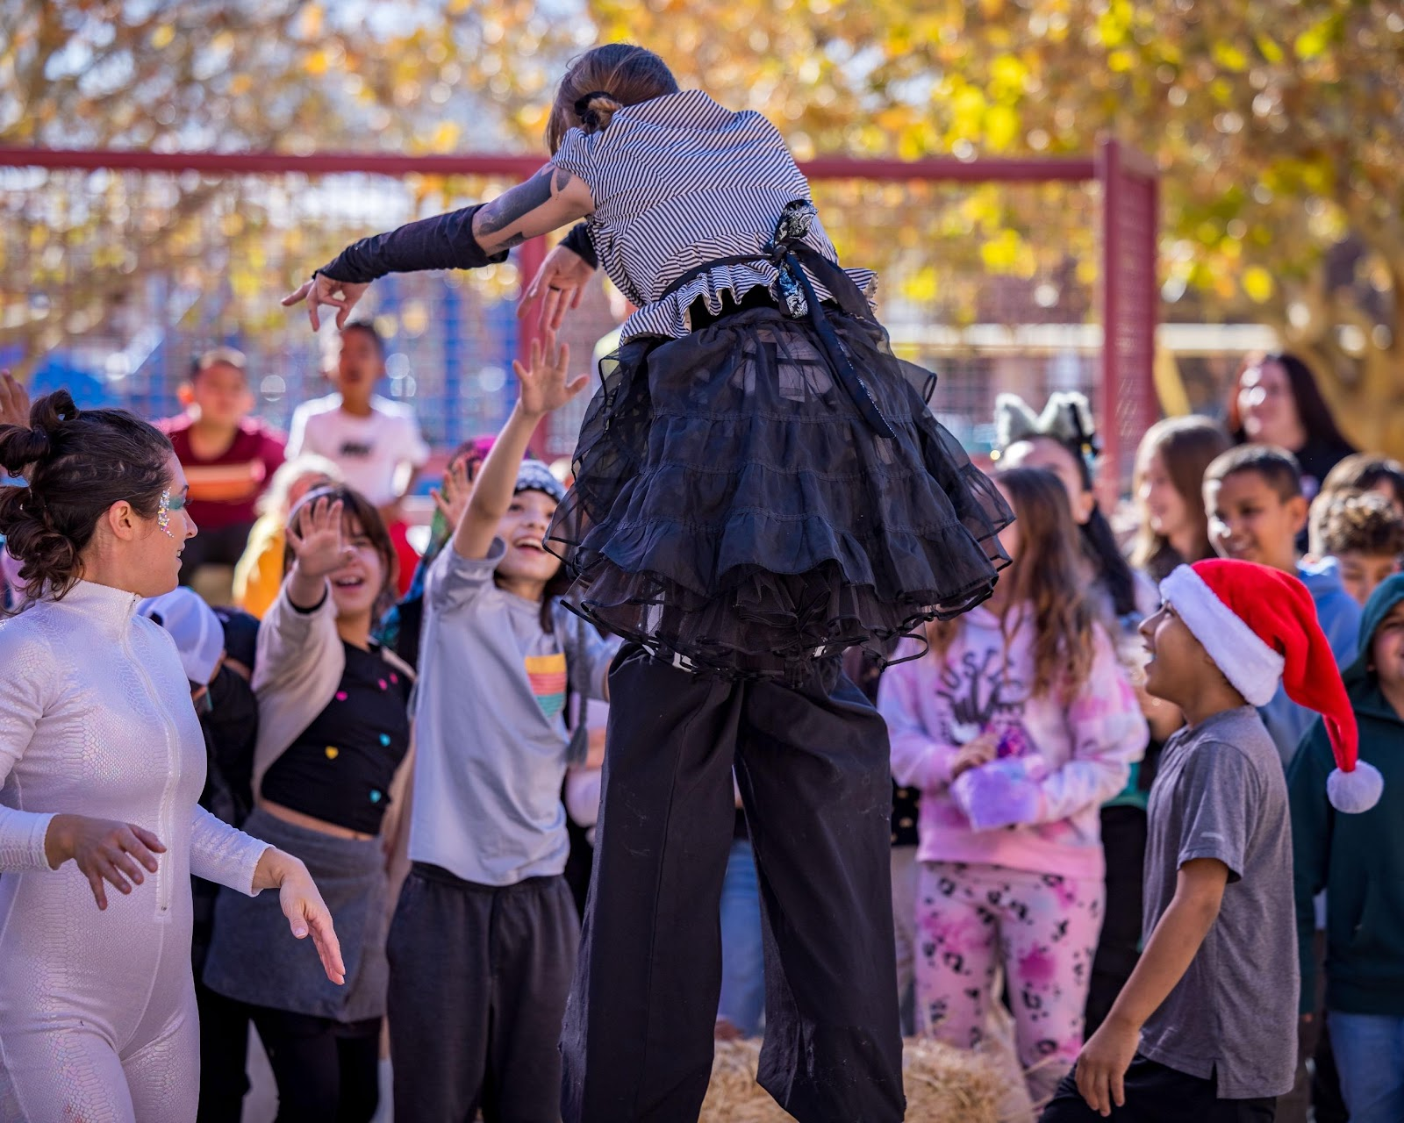
Photographs by Patrick Beare, APS Fine Arts Department
Share this newsletter with your neighbors: Pass this newsletter along and encourage those you share it with to sign up themselves. To get on the newsletter list, send your email to: abqdna@abqdna.com

