July Newsletter
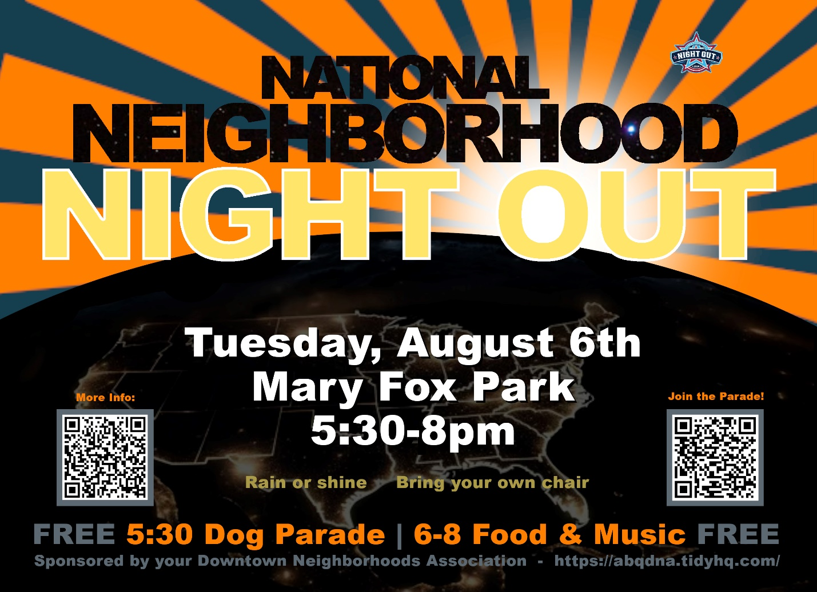

Plans are in full swing to gather as a neighborhood!
Tuesday, August 6, 2024
Mary Fox Park
Dog Parade – 5:30 – 6 pm
Live Music, Food & Games – 6 – 8 pm
The NNNO will kick off with the First Annual Dog Parade to celebrate the dogs and humans that love to walk in our downtown neighborhood. All DNA Doggies are invited to participate and the first 50 to sign up using the QR code will receive a handmade gift! Following the parade, you will have time to take your dog home for a well-deserved rest before joining in the remainder of the activities.
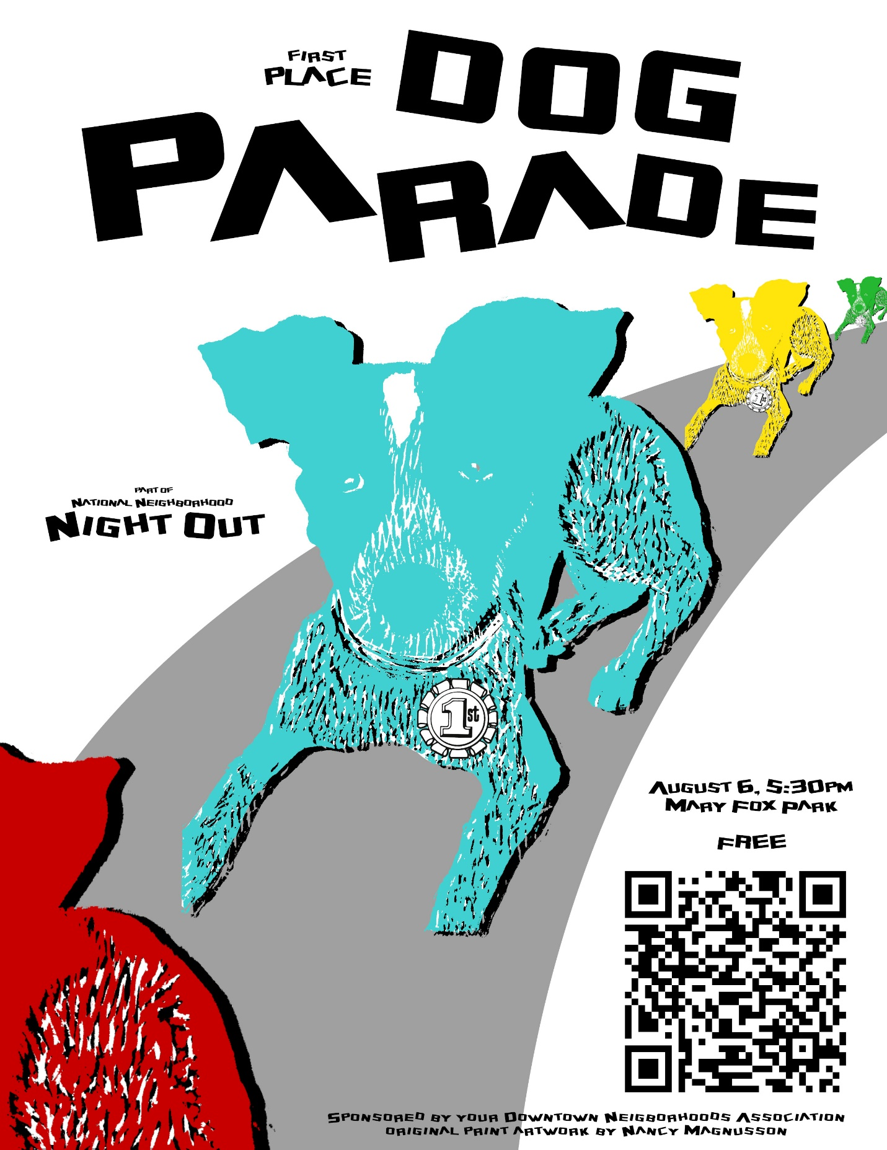
Lew Wallace News:
Lew Wallace is welcoming Renee Gallegos, as the new principal for the 2024/2025 school year. Ms. Gallegos comes to Lew Wallace with 29 years of APS district experience and 21 years of administrative experience. She has dedicated herself to the future of Albuquerque Public Schools using her training and experience to serve our students.
Next Scheduled Downtown Neighborhoods Association Board Meeting:
Monday, July 1, 2024. 5:30 - 6:30 pm at Fusion/The Cell, 700 1st Street NW, Albuquerque NM 87102
Agenda Items:
- Discuss National Night Out Plans
  - Committee updates
- Introduction of the new Principal of Lew Wallace Elementary
- Confirm Board meeting on August 5, and no meeting for September
- Quick Trip zoom meeting review
Haiku
July's hot weather
Picnics, families gather
Independence Day!
If you are sharing this newsletter with fellow neighbors, please encourage each one to join the Downtown Neighborhoods Association. It’s free and easy to join! https://abqdna.tidyhq.com

