June 2024 Newsletter
Beautiful Day in the Neighborhood!
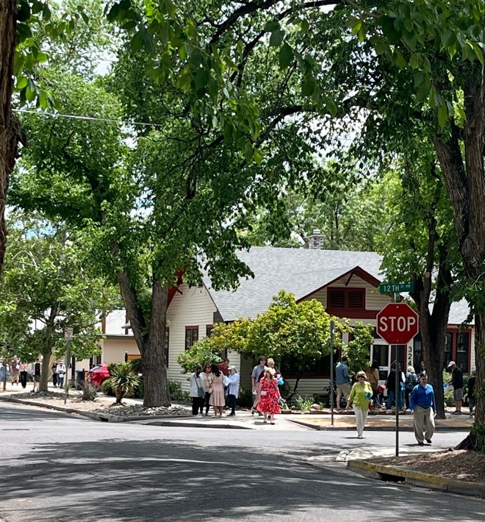
The Mother’s Day Historic Home and Garden Tour was a HUGE success,
attracting 900 visitors to the eight featured homes and five gardens on Sunday, May 12, 2024.
Homeowners and docents shared information about the homes and gardens as people strolled through the featured historic homes many with contemporary renovations. Homeowners were delighted to see that the gardens and back yards offered the visitors a place to relax and reflect on the gorgeous weather and event’s ambiance.
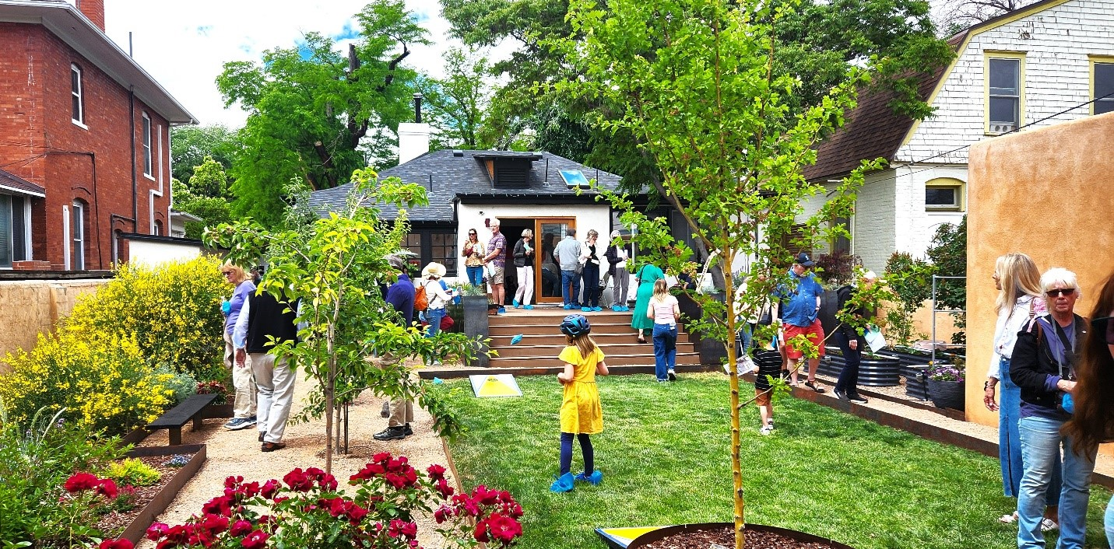
Throughout the home tour positive comments were shared with homeowners and docents.
“I work in this neighborhood and have always dreamed of seeing the inside of these houses. This is a wonderful event.”
“These houses are beautiful and so much more unique than anywhere else in the city. It is such a treat to see them.”
“The home looks small from the outside, but it feels so spacious inside.”
“Lew Wallace felt so warm and inviting.”
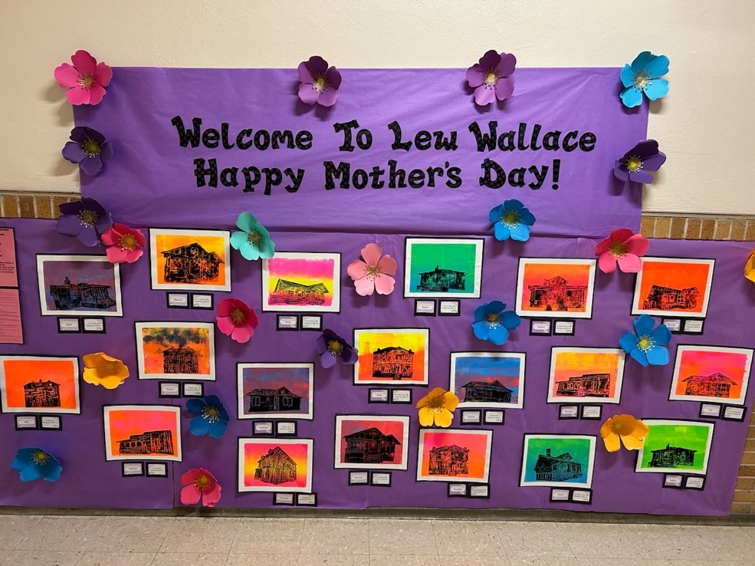
The historic Lew Wallace Elementary School put out the welcome mat for ticket holders to begin the walking tour. Visitors could learn about this amazing neighborhood school and enjoy the prints done by Mrs. Edward’s 2nd grade class that featured the homes on the tour. Printmaking techniques were taught to the students by APS Fine Arts Instructor, Tanya Silva.
The Downtown Neighborhood Association would like to give a huge Thank You to the homeowners who graciously opened their homes, to the docents who welcomed visitors into each home, and to the many sponsors that helped fund the printing of the booklets for the event. Sponsors: Old Walls Gallery, Remarque Print Workshop, the Art of Angus Macpherson, High Noon Restaurant & Saloon, Cafe Lush, F & H Markets, Cloudwalker Farm, and Seared Bistro.
Haiku by Jeremiah Jones:
A rousing success
Historic homes and gardens
Bloomed for Mother’s Day

Lew Wallace Elementary School Event:
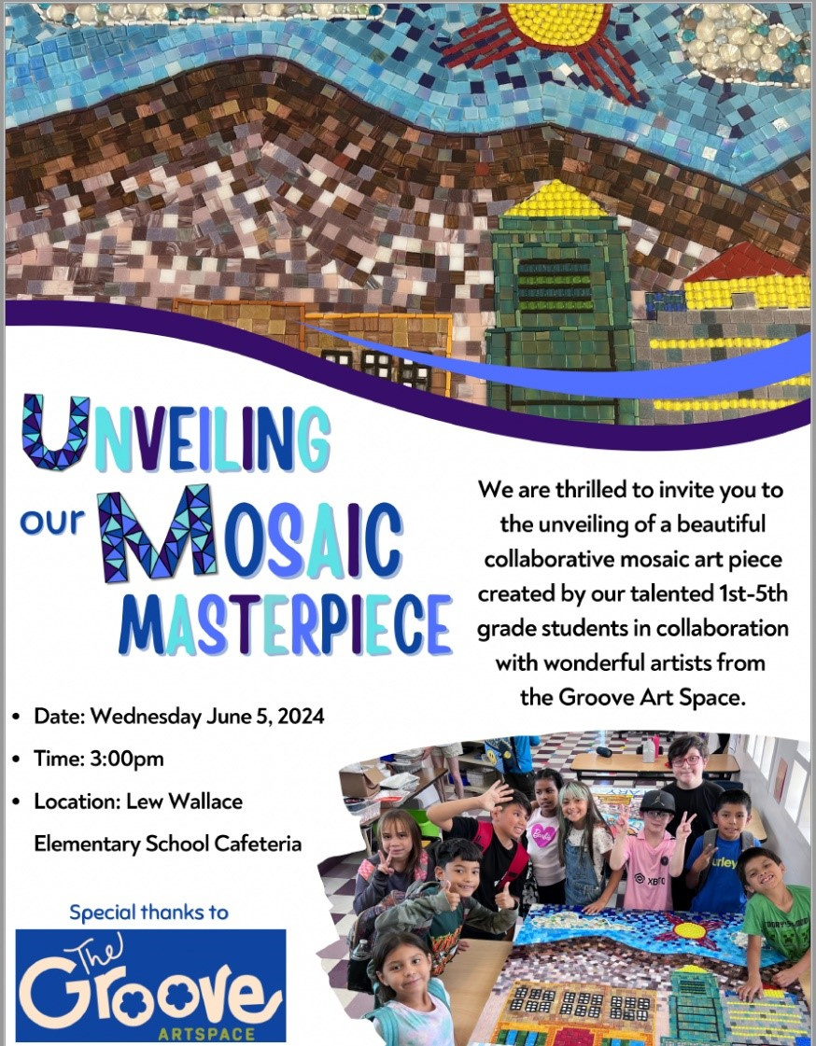
Next board meeting: Monday, June 3rd 5:30 -7 pm at Fusion/The Cell east side of First Street between Lomas and Roma. Signs will direct you to the gathering place.
Agenda:
- Recap the Historic Home Tour
- Next steps for National Night Out
- Jessica Carr – community member

Next Up: National Night Out (brought to you by your Downtown Neighborhoods Association) will be celebrated in our neighborhood at Mary Fox Park. Tuesday, August 6, 2024, 5PM–8PM. Come meet your neighbors…join us for live music, food and games!

