May Newsletter 2024
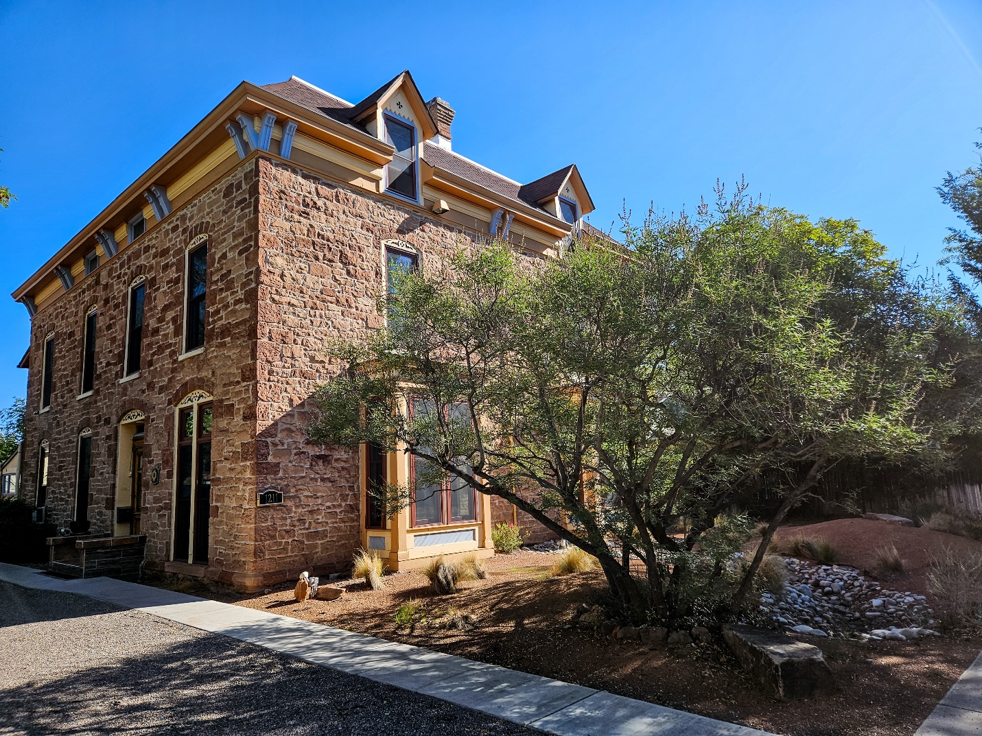
Mother’s Day Historic Home and Garden Tour
It’s almost here. Sunday, May 12, 11:00–3:00.
Enjoy the neighborhood on the 50th Anniversary of the tour!
The walking tour begins at Lew Wallace Elementary School,
where you will receive a map to guide you through the Historic 4th Ward.
Visit eight vintage homes and lush gardens while strolling on the tree-lined streets.
Buy your tickets online now HERE Price of tickets $15.00/person online;
$20.00 at the door.

Save the Date!
Neighborhood National Night Out
Tuesday, August 6, 2024. 6-8 pm. Mary Fox Park. 401 13th Street NW Featuring live music, food, and games. Free!
Can’t wait to meet you there!
Celebrating Downtown
Haiku
Downtown is psyched up
Filled with anticipation
The house tour is nigh.
By Annie Shively

Next scheduled Downtown Neighborhood Board Meeting:
Monday, April 29, 2024. 5:30 pm at Lew Wallace Elementary School. 513 6th Street NW
Agenda Items:
· Finalize Historic Home Tour Plans
· Neighborhood National Night Out discussion
· Support letter for Washtub Laundromat discussion
· Pearl project appeal update
· ONC annual meeting compliance update

