November
Welcome Fall to our beautiful Downtown Neighborhood
October Haiku
by Debbie G.
The hauntings begin
Subtle winds, Wobbly shadows
A lovely witch laughs

DNA News:
Trick or Treat on Forrester Street and the surrounding neighborhood was a BOO-tiful event! The neighborhood welcomed hundreds of trick-or-treaters. DNA is proud to help sponsor this community-wide event.

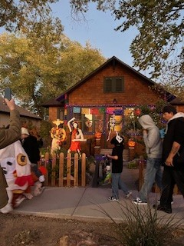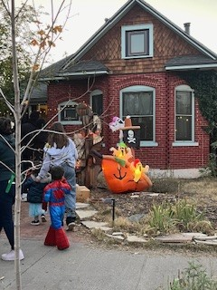
Albuquerque Department of Senior Affairs will provide spring and fall yard clean up and also swamp cooler winterization (although these slots may be full for this year). They'll install grab bars in bathrooms, or ramps and a multitude of other useful things. One must be 60 to be eligible for services.
Here's the link: https://www.cabq.gov/seniors/senior-services/home-services
Fall Clean-up:
Yard waste can be collected for pick-up by the city every fall and spring. The dates for the fall pick-up are not set yet.
Green Waste Collection Event Tips:
During collection events, please follow these guidelines:
- Green Waste must be 5 feet away from trash/recycling containers.
- Green Waste must be placed in trash bags.
- Trash bags must not weigh more than 40 lbs.
- Cut branches to four-foot lengths and bundle them securely.
- Dirt, debris, gravel, construction material or tree stumps will not be picked up.
- Do NOT place green waste in your recycling cart
Lew Wallace News:
Lew Wallace has a new principal! Melanie Misquez-Telles, the current Assistant Principal at Alamosa Elementary, will serve as Lew Wallace Elementary’s principal.
Principal Telles shares….I am excited to step into the role of principal at Lew Wallace Elementary and look forward to the journey ahead; thank you to the district staff and our wonderful community for believing in me and supporting the creation of a shared vision for our school. Together, I am confident we will create an environment where every student can thrive. I have 18 years of seasoned experience in APS; I am from Albuquerque, NM, the Land of Enhancement, and attended Griegos Elementary, San Felipe de Neri, St. Pius X High School, and ten years as a Lobo. I have dedicated my life to inspiring students and the school community to make a difference to thrive through academic excellence; I can’t wait to get started and work alongside all of you to make this school year exceptional!
Lew Wallace hosted a successful Fall Festival on October 25. The families that attended were having a great time gathering with the staff for food and games. Thanks to the PTO and all the dedicated staff and volunteers.
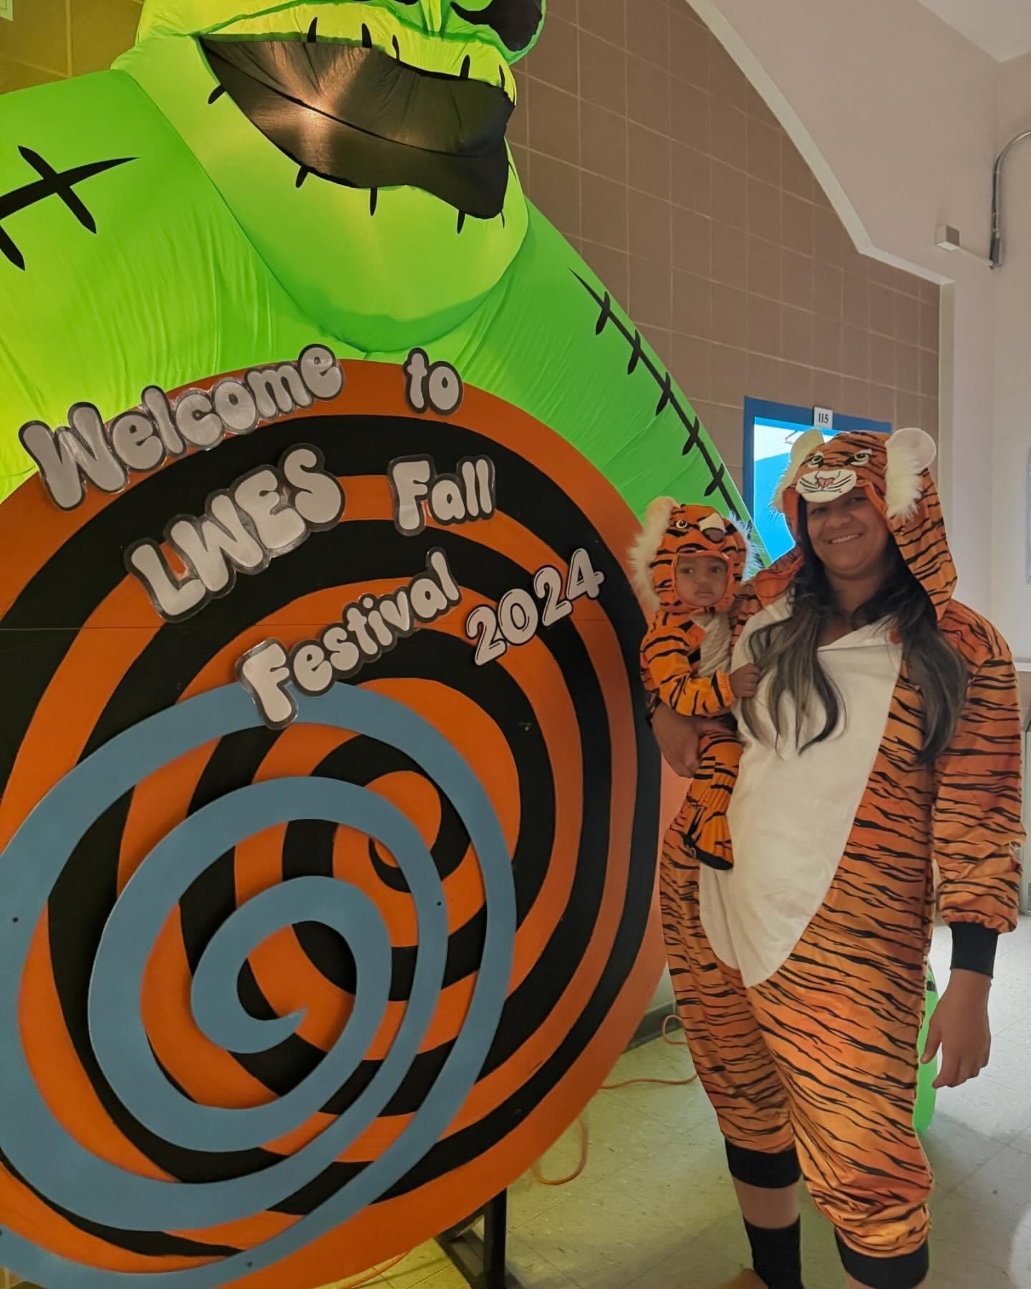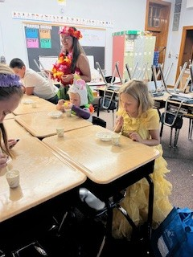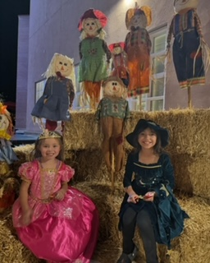
We love volunteers and donations of all kinds -- please contact Lew Wallace Community School Coordinator, Melanie Lewis, at melanie.lewis@aps.edu or 505-563-0648 for more information.
Information on APS Volunteer Background Clearance https://www.aps.edu/community/volunteer-with-aps
Next scheduled Downtown Neighborhoods Association Board Meeting:
NOTE: Regular Monthly Meetings are now being held on the second Monday of each month from 5:30 – 6:30.
Next Meeting will be Monday, November 11th, 2024, 5:30- 6:30 pm at Fusion/The Cell, 700 1st Street NW, Albuquerque NM 87102
If you are sharing this newsletter with fellow neighbors, please encourage each one to join the Downtown Neighborhoods Association. It’s free and easy to join! https://abqdna.tidyhq.com

