October Newsletter
DNA News:
The Downtown Neighborhood Association would like to thank everyone who attended the National Neighborhood Night Out held in Mary Fox Park on August 6th. A good time was had by all who attended! Thank you to a fine neighborhood band, Otis B. Goode and the Honky Tonk Heretics for their engaging music. We also enjoyed many visits by neighborhood officials.
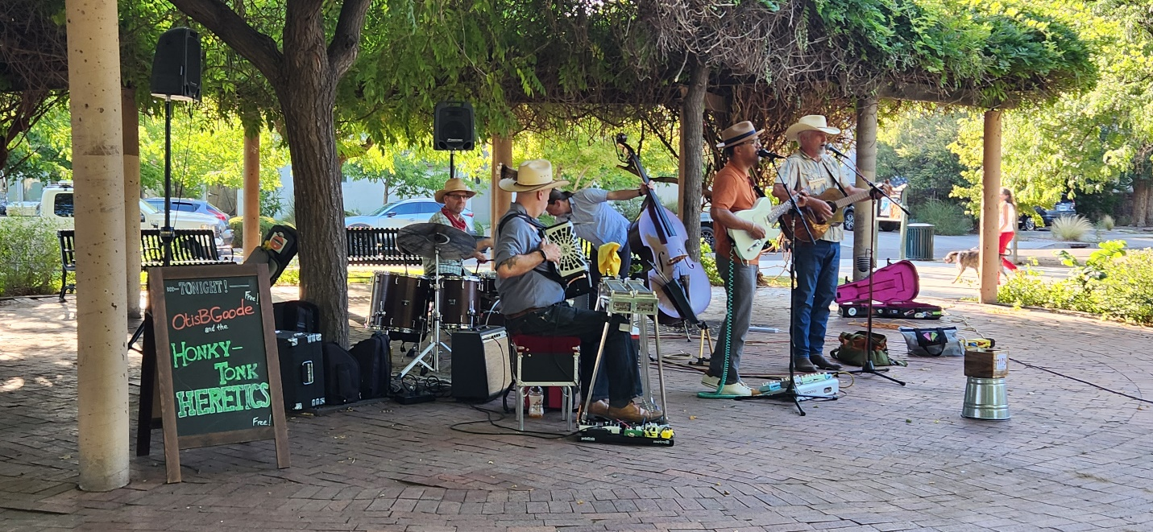
The evening started with the first annual Dog Parade accompanied by a bagpipe player! What a howl!
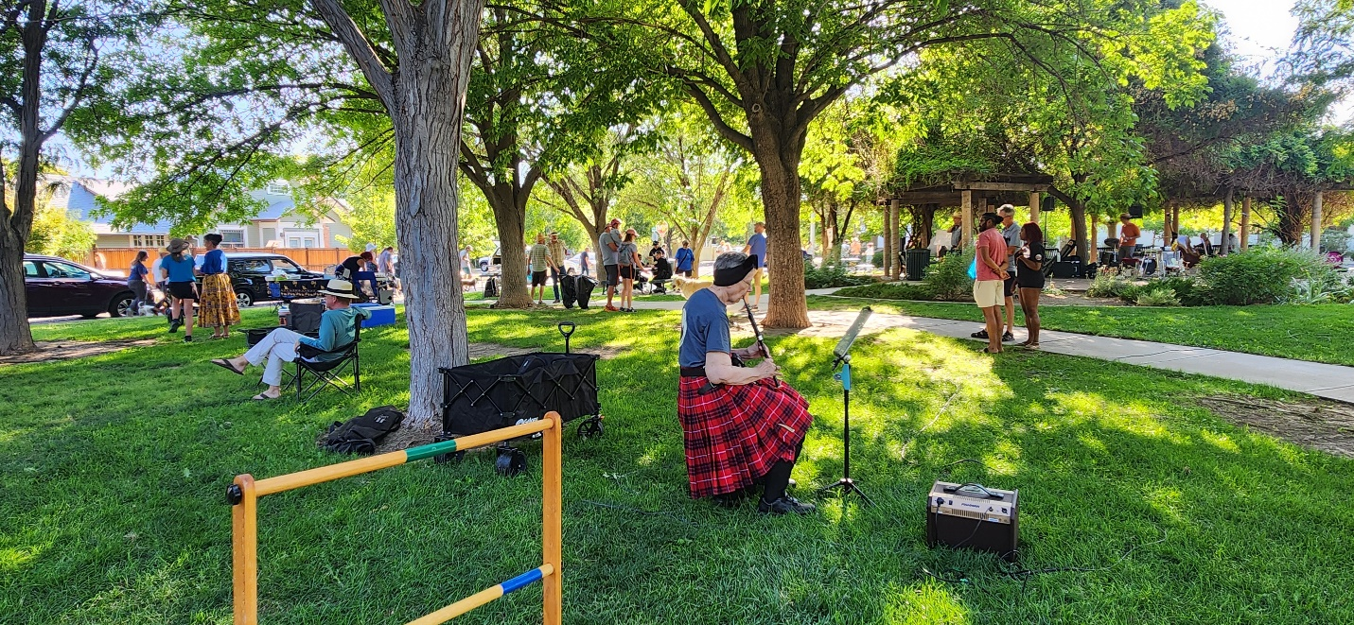
Be sure and check out photos on our website, in the events section https://abqdna.tidyhq.com
On Saturday, September 28 th at 9 am your board members met at Mary Fox Park to conduct a neighborhood clean-up, part of the city-wide event: Keep Albuquerque Beautiful. Plan to join us next year at Mary Fox Park where we will received wonderful all-weather hats, gloves, trash bags, and trash grabbers.
October 31st plan to Trick or Treat on Forrester Street with your children, or just go to see the decorations. The neighborhood works together to create a street of lights and bonfires, with plenty of treats to hand out. The street fills with music, spooky sounds and laughter! DNA is proud to help sponsor this event.
Next scheduled Downtown Neighborhoods Association Board Meeting
Monday, October 7, 2024. 5:30 pm at Fusion/The Cell, 700 1st Street NW, Albuquerque NM 87102
Agenda items:
- What do we want to accomplish for our neighborhood over the next year?
- Set budget for next year.
- Secretarial housekeeping and updating.
Lew Wallace News:
Lew Wallace Elementary School will host a Globito remote control balloon launch on October 4 th, approximately 7:30-8:40.
The school's Fall Festival is planned for November 1st, 5:30 – 7:30 pm. The school is looking for volunteers and donations, especially Day of the Dead themed.
A committee is being formed to replace Principal, Ms. Gallegos who recently retired. The committee will
consist of staff, families, and community members and will be choosing from numerous candidates.
The whole school is participating in the One School One Book program. Everyone is reading the book,
Fish in A Tree, by Lynda Mullaly Hunt. The students are enjoying the book and the discussions.
Click on this link to see a collaborative art project that Lew Wallace students are participating
in: https://news.unm.edu/news/unm-student-collaborates-on-art-project-with-local-elementary-school-city-
of-albuquerque.
We at Lew Wallace love volunteers and donations of all kinds -- please contact Lew Wallace Community School Coordinator, Melanie Lewis, at melanie.lewis@aps.edu or 505-563-0648 for more information.
Information on APS Volunteer Background Clearance https://www.aps.edu/community/volunteer-with-
aps

If you are sharing this newsletter with fellow neighbors, please encourage each one to join the
Downtown Neighborhoods Association. It’s free and easy to join! https://abqdna.tidyhq.com

