
ABN 80 294 124 571
Website: www.camberwellprobus.org.au
President Secretary Treasurer
Judy Nancarrow David Turner Barbara Grufas
camprobpres@gmail.com camprobsec@gmail.com camprobtrea@gmail.com

PROBUS CLUB of CAMBERWELL INC.

NEWSLETTER APRIL 2026

Next meeting Tuesday 28 April at CBC at 10 am.
Speaker - Alan Hall
Subject - The RAAF First Fatal Mission
President’s Thoughts
Hi to all, I hope you are enjoying Melbourne’s beautiful autumn weather. The highlights for April were The Sound of Music which was enjoyed by 20 guests, and the regular and Bay walks which attracted 14 and 13 walkers respectively. Glenferrie Probus Club has invited us to join them on the Greenline walk in May, refer to details in the Newsletter. Two new activities will commence this month, Cinema and Garden Appreciation.
I understand there are a number of members who, due to transport issues, are unable to attend meetings or activities. If you would like assistance with transport or you are happy to provide transport please record your name and contact details on a form at the next meeting.
Unfortunately there was insufficient support for the Tasmanian Tour which has been cancelled and replaced by a 7 day bus tour to the Sapphire Coast 9th – 15th November. Information will be available at the April meeting.
It is with much sadness that I inform you of the death of our fellow member and friend Judi Burmeister. Judi died suddenly last Sunday shortly after enjoying lunch with her family. Many of us will have great memories of Judi and her enthusiastic participation in our activities and tours. May she rest in peace.
Judy Nancarrow, President
Coming Events
Sunday 26 April Malvern Theatre
Tuesday 28 April General Meeting at CBC 10 am
Monday 4 May Garden Appreciation Group to Olinda
Tuesday 5 May Walk
Wednesday 6 May Cinema at Palace Balwyn 1 pm.
Monday 11 May Coffee & Chat
Wednesday 13 May GYT Metro stations
Wednesday 20 May Train to pub lunch at Pakenham
Thursday 21 May Greenline Walk with Glenferrie Probus
Friday 22 May Happy Hour at Amora Hotel
Tuesday 26 May General Meeting
Sunday 7 June 42nd Street at The Round

Morning Tea Roster for April
Bronwyn Woolcock, June Strickland, Julie Roncon, Julie-Anne Kerger- Barry.

An important morning tea message from Judy Golomb

I am encouraging members to volunteer, not only to ensure that your morning teas are available in a timely manner but also to share the morning tea duty throughout the club.
Five helpers per month is ideal.
Please arrive by 9.30am to help with the set up.

If you have any questions regarding volunteering or if you can’t do your nominated day please don’t hesitate to contact me.
,
Judy Golomb
Morning Tea Convener 0412 844 056.
Get Yourself There Activities

Coffee & Chat
Monday 11 May at Bugiardo’s, 970 Toorak Rd, Glen Iris 10.30 am.

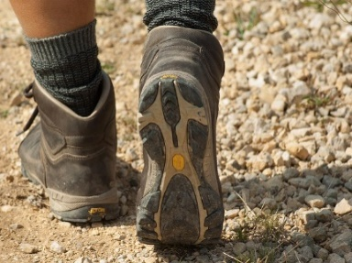
Happy Walkers
Tuesday May 5. 10.00am
Meet in car park in Ferndale Park. Glen Iris Rd
Coffee at The Pantry after walk.
Leader : Judy Golomb

.

Wednesday 13 May
Come and explore the new Metro Tunnel stations. Meet at Town Hall Station (cnr. Swanston & Collins St) at 10.15 am. Names and/or apologies to Barbara Timcke.
And it’s free travel!
Cinema
Wednesday 6 May at Palace Balwyn.
1 pm. ‘Pike River’ based on a true story. Tickets $12/10 for senior/member

All payments for Club activities by EFTPOS into account:
BSB: 633-000, Account: 170611610 or
pay with Credit Card at monthly meeting.


Amora Hotel
649 Bridge Road Richmond
Friday 22 May 5.00pm
Contact: Jennifer Mariott
Route 75 Tram, Stop 22
Street Parking or at Office Works

Garden Appreciation Group

Monday 4 May Phillip Johnson Garden, Olinda.
﻿Approx 80 min drive from Camberwell to Parks Victoria Dandenong Ranges Botanic Gardens
Rhododendron gardens. Meet in the entrance at 10:15. The garden covers 50 hectares.
Tour in the gardens booked at 11am. Cost of train through gardens $10. But cash only please.
It is only 250 metres from the entrance and gift shop to the Phillip Johnson garden.
Phillip Johnson’s 2013 entry into the Chelsea show won Best in Show. The judges said ‘how beautiful it was to see a garden with soul again, not just another take on an outdoor kitchen.’ This has been recreated in the Botanical Gardens.
Entrance to the garden is free. Bring your own morning tea and picnic lunch or eat in a cafe in Olinda.
Enquiries to Dianne Weston 0413937307
Train to Pub Lunch
Wednesday 20 May at Railway Hotel, Pakenham
Meet at Richmond Station at the bottom of the ramp leading to platform 6 at 10.15 am.
The 70 tram goes past Richmond Station.

For Your Information
Many of the emails you receive from committee executives may have, to you, unidentifiable names and addresses and may end up in your Spam folder.
campropres This comes from the President, Judy Nancarrow
camprosec This is from the secretary, David Turner
camprotreas This is from the treasurer, Barbara Grufas

Thursday May 21 A Walk to discover the Greenline Project
Join Glenferrie Probus walkers on a walk to enjoy and learn about the Greenline Project – along the north side of the Yarra.
Have you heard about the City of Melbourne Greenline Project?
Come with us to walk part of The Greenline and meet the award-winning design team.
Meet Leonda carpark, 2 Wallen St Hawthorn at 10 am. The 70 tram goes past Leonda.
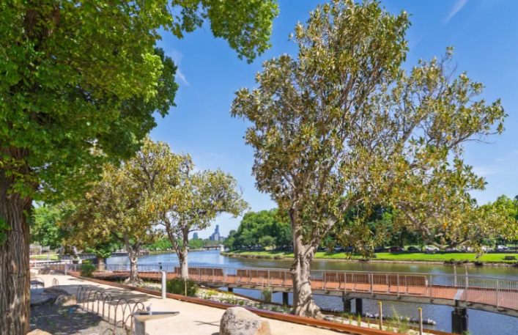
The Greenline Project is a transformational project that presents a new vision for the north bank of the Yarra River - Birrarung. It will create 4km of interconnected promenades, parks, open spaces and environmental renewal in 5 stages between Birrarung Marr and the Bolte Bridge. Stage 1 at Federation Square is complete.
- A tram ride and a short 1.5 k interesting walk along the river will take us to the start of the Greenline on the north bank of the Yarra.
- We’ll explore the completed Stage 1 section [Birrarung Marr, 500m]
- Stop for coffee in the Gallery coffee shop in The Atrium at Fed Square
- Then walk the uncompleted Stage 2 section [500 m], and return
- to meet Designer Skye Haldane at the Greenline Project Hub, Princes Walk, Melbourne for a talk about the project.
Organiser – Kay Edwards 0400128690

Something to look forward to

Bring a Friend
You are all invited to bring a friend to the July meeting and look forward to a very interesting speaker.
Friday 24 July - Christmas in July at The Glasshouse, Caulfield Racecourse
Plenty of parking and close to Caulfield Station. Traditional Christmas menu $50 per head.
Wednesday 23 September
Coach trip to ‘Duneira’, Mt Macedon. Details to come.
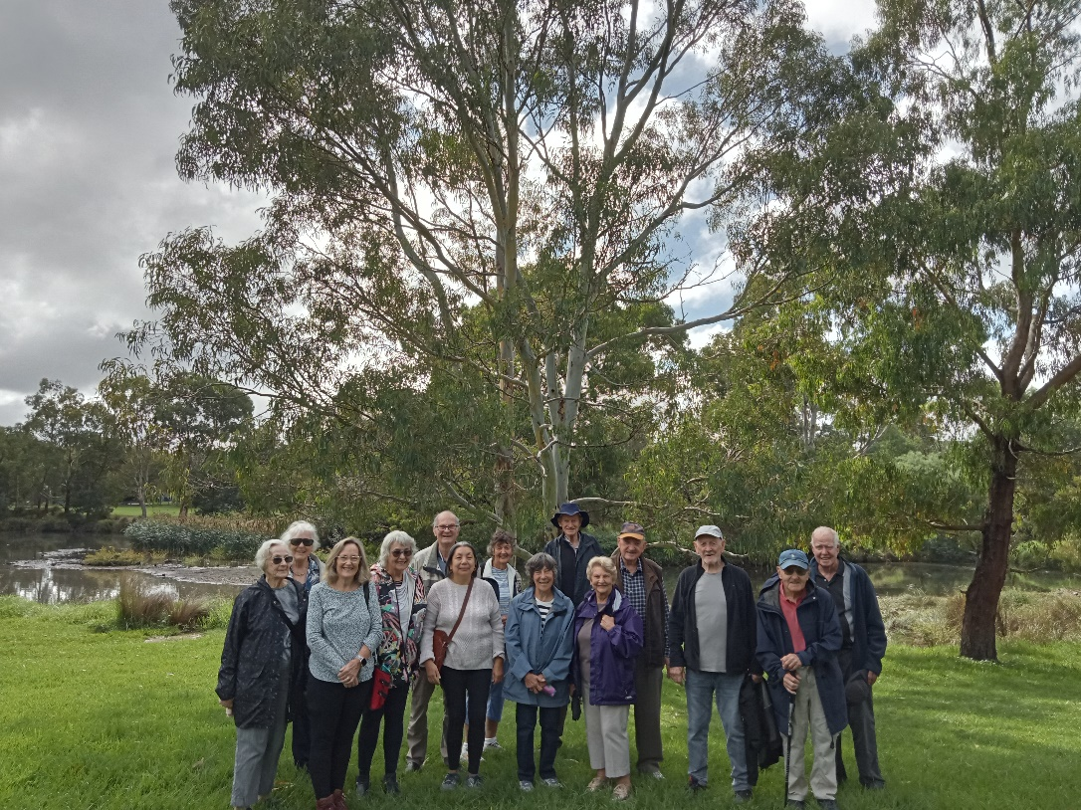
April walkers in Glen Iris

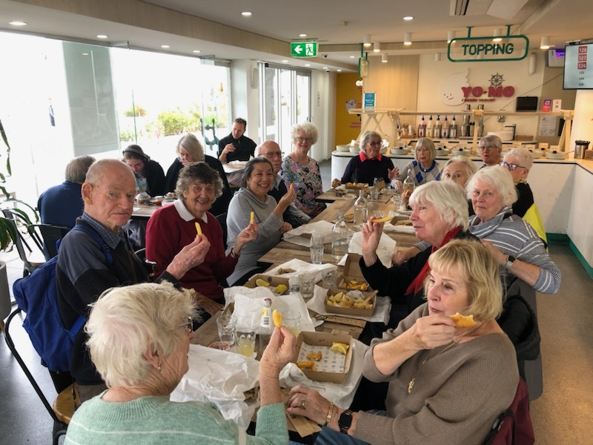
Great fish and chips at Port Melbourne

Theatre and Entertainment
Malvern Theatre Company 2026, 29 Burke Road, Malvern East, 3145

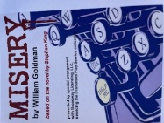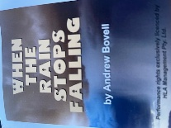
Sunday 28th June, 2 pm Sunday 30th August, 2pm Sunday 1st November, 2pm
Payment for each play separately $29 five weeks before performance.


42nd Street
The Round
379 Whitehorse Road, Nunawading

Sunday 7th June at 1:30 pm

Cost: $58

Ticket purchases are non-refundable after payment by the club. Closing payment: 28th April 2026. Any enquiries please contact Julie Telfer

The Princess Theatre
163 Spring Street, Melbourne

Wednesday 7th October 1:00 pm

Cost: $160

Closing Payment: 23rd June 2026 Any enquiries please contact: Julie Telfer



