
ABN 80 294 124 571
Website: www.probusclubcamberwell.org.au
President Secretary Treasurer
Judy Nancarrow David Turner Barbara Grufas
camprobpres@gmail.com camprobsec@gmail.com camprobtrea@gmail.com

PROBUS CLUB of CAMBERWELL INC.

NEWSLETTER AUGUST 2026

Next meeting Tuesday 25 August at CBC at 10 am.
Speaker – Campbell Martin
Subject - Wildlife Conservation

President’s Thoughts
By the time you receive this newsletter I will be travelling through the Canadian Rocky Mountains, hopefully the bushfires have not caused too much damage.
You would all have received information about the proposed tour in February 2027 which includes a 4 night cruise on the Murray Princess and 2 nights at the Monarto Safari Park. I’m sure you would all agree the itinerary is exciting with many inclusions in the price. The tour is costly, particularly with the single supplement, and this may well be a deterrent for some. However I think it is good value.
Murray Princess cruises are very popular and apart from a vacancy in June, this is the only date available in 2027. We have a short turn around to confirm our booking. We need at least 15 guests for this tour to be viable. To confirm the booking we are required to provide a preliminary rooming list by 17th September, and the deposit by 15th October.
If you would like to join us on this tour, please register your interest on the list at the August Members’ Meeting. Any enquiries please contact Barbara Grufus.
There are still members who have not logged onto our new website. You need to do this before you can download the Club Runner app. The Club Runner app, once downloaded, is easy to us, and also provides access to the website. If you are having trouble or are hesitant in logging on to the new website or downloading the mobile app on your phone/iPad, please contact Barbara Grufas.
I look forward to catching up with you at the September meeting or at one of our September activities.
Judy Nancarrow, President.

Coming Events
Tuesday 25 August Meeting
Friday 28 August Happy Hour cancelled
Sunday 30 August Malvern Theatre
Wednesday 2 September Cinema Balwyn TBA
Tuesday 8 September Walk
Friday 11 September Coffee & Chat
Thursday 17 September GYT Parliament House
Sunday 20 September Theatre Hello Dolly
Wednesday 23 September Bus trip to Duneira
Friday 25 September Happy Hour
Tuesday 29 September Lunch at Amora

Morning Tea Roster for August
Gwen McBeth, Diane Emery, June Strickland, Patricia MacLaren, Manette Durup

Coffee & Chat
Friday 11 September at Miss Frank, 200 Through Rd, Camberwell. (Cnr Riversdale & Through Rds) at 10.30 am.

Cinema
Wednesday 2 September at Palace Balwyn. Details to be advised at next meeting and also on ClubRunner. Feel free to book your ticket online prior to the screening.


Happy Walkers
Tuesday 8 September 10.00am
Leader June Strickland
Meet at Highbury Rd in front of café Bells and Whistles where there is a carpark. Highbury road. Mel 60 K7


Amora Hotel
649 Bridge Road Richmond
Friday 25 September 5.00pm
Contact: Jennifer Mariott
Route 75 Tram, Stop 22
Street Parking or at Office Works

Lunch Thursday 29 September
Amora Hotel,649 Bridge Rd, Richmond
It is imperative that you let Julie Roncon know if you are intending to come and notify her if you are unable to attend.

Wednesday 23 September
Coach trip to ‘Duneira’, Mt Macedon. $50 payment due now. Waitlist available.

Get Yourself There
Thursday 17 September
Public tour to visit to Parliament House. 2 pm. No charge. 45 min tour.
Please note that spots are allocated on arrival so be there early to ensure admission.
Make sure your name is on the list and notify Barbara Timcke if you can’t come.

Tour Sapphire Coast
Payment due before Tuesday’s meeting (25 August)

Possible Tour on Murray Princess
See President’s earlier message.

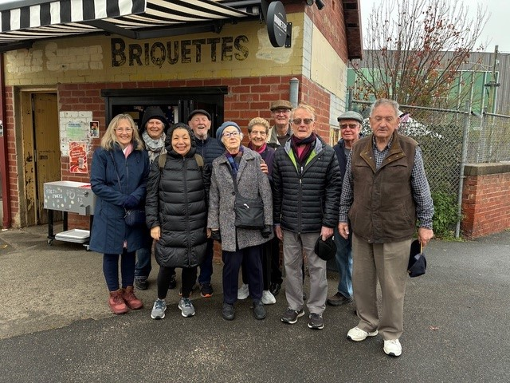

July walkers

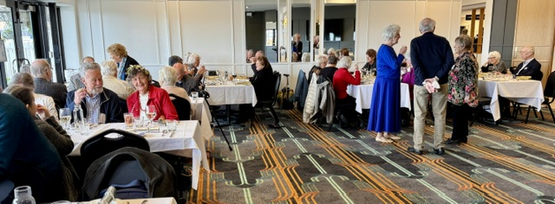

Christmas in July at The Glasshouse
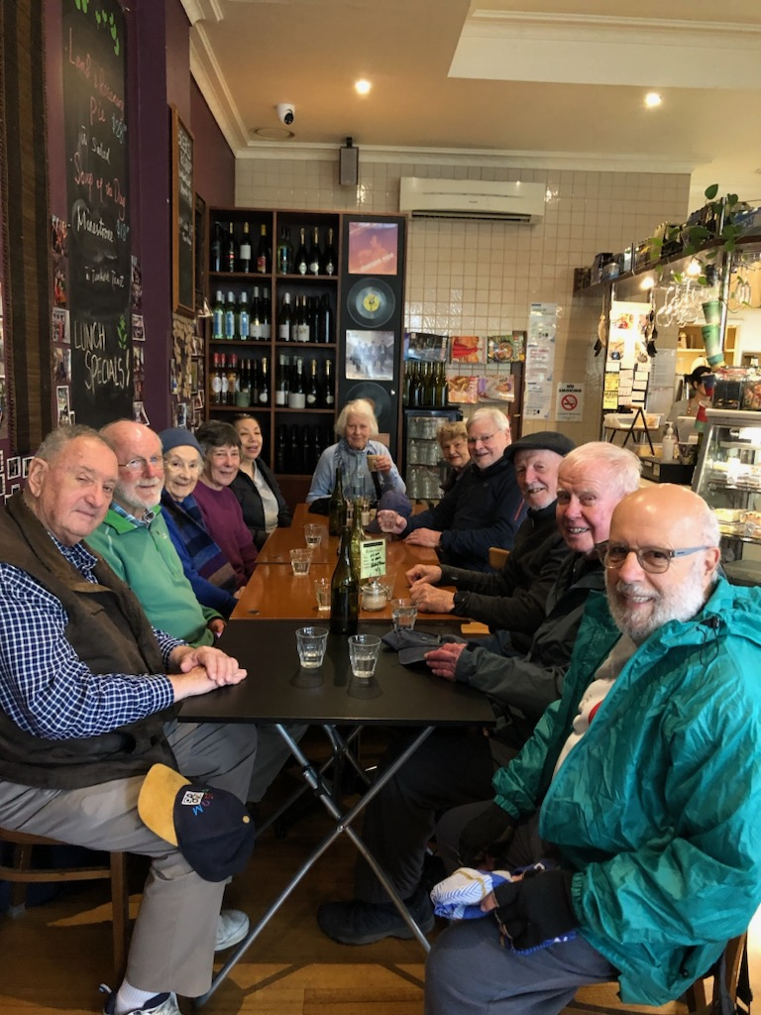

August walkers

All payments for Club activities by EFTPOS into account: BSB: 633-000, Account: 170611610 or pay with Credit Card at monthly meeting.

Theatre and Entertainment
Malvern Theatre Company 2026, 29 Burke Road, Malvern East, 3145

Sunday 1st November, 2pm

Final payment 22 September


The Princess Theatre
163 Spring Street, Melbourne

Wednesday 7th October 1:00 pm

Cost: $160

Fully booked.


The Round
379 Whitehorse Road, Nunawading

Sunday 20th September at 1:30 pm
Cost: $47

Ticket purchases are non-refundable after payment by the club.
Closing payment: 25th August 2026
Any enquiries please contact: Julie Telfer

Ian Potter State Theatre
St Kilda Road

Wednesday 23rd December 2 pm

Cost: $72



Payment by EFTPOS into account: BSB: 633-000, Account: 170611610 or pay with Credit Card/cash at monthly meeting. Ticket purchases are non-refundable after payment by the club. Closing payment: 27th October 2026


Any enquiries please contact: Julie-Anne Kerger-Barry (Contact details on ClubRunner)

