
ABN 80 294 124 571
Website: www.camberwellprobus.org.au
President Secretary Treasurer
Judy Nancarrow David Turner Barbara Grufas
camprobpres@gmail.com camprobsec@gmail.com camprobtrea@gmail.com

PROBUS CLUB of CAMBERWELL INC.

NEWSLETTER FEBRUARY 2026

Next meeting Tuesday 24 February at CBC at 10 am.
Speaker – Julie Dyer
Subject - Downsizing and Relocating
President’s Thoughts
Welcome back to a year packed with opportunities to mix with fellow member in a range of old and new activities and events.
We are introducing 3 new activities: Garden Appreciation, Happy Hour and Cinema groups.
Arrangements for an 11 day tour of Tasmania in November are being finalised.
Details of these activities/events will be provided at the February meeting following the Special Meeting to approve the revised Constitution and Standing Resolutions for our Club.
A reminder that booking and payment ($35) for our AGM and a Marvellous Morning Tea on Tuesday 24th March, at the Box Hill Golf Club, must be finalised before or at the upcoming meeting on Tuesday 24 February. Please note that attendance at the AGM is free.
It is with sadness that I inform you of the recent death of Jill Williams and offer our condolences to Peter and her family. Both Jill and Peter are long term members of our Club, Jill has been a member since 2009 and Peter since 2006. Rest in Peace Jill.
Judy Nancarrow, President

Coming Events
Sunday 22 February Malvern Theatre
Tuesday 24 February General meeting at CBC at 10 am
Friday 26 February Coffee & Chat 10,30 am.
Friday 26 February Happy Hour at Abora Hotel, Richmond
Tuesday 3 March Walking group
Friday 13-19 March SA tour
Tuesday 24 March AGM Marvellous Morning Tea at Box Hill Golf Club
Thursday 26 March Lunch at Malvern Vale Hotel
Sunday 29 March Sound of Music at The Round
Tuesday 31 March GYT The Metro Tunnel

Morning Tea Roster for February 2026
Julie Telfer, Julie-Anne Kerger-Barry, Julie Clarke
Get Yourself There Activities

Coffee & Chat
At Bugiardo, 970 Toorak Rd, Glen Iris. 10.30 am.

Happy Walkers
Tuesday March 3. 10.00am
Walk: Central Park & Hedgeley Dene Gardens
Park: Kensington Street
Meet: Cnr of Kensington St & Wattletree Roads.
Leader. Don James



ANNUAL GENERAL MEETINM
Tuesday 24 March at Box Hill Golf Club

10.00 am. Meeting
Marvellous Morning Tea to follow at a cost of $35 a head

Speaker – Winston March “Lies your mother told you”
Musical entertainment – Mario Miranda

You are welcome to attend just the Annual General Meeting but the following morning tea is $35 a head

Cottage By the Sea
Supporters of the Cottage will be pleased to hear the fantastic result of the annual January Fair. $108,000!!!
The best ever. This will enable the Cottage to give even more needy children the opportunity of a holiday.
Supporters can also buy a brick for $200 for the newly developed adjacent building which replaces an old motel.


Amora Hotel
649 Bridge Road Richmond
Thursday 26th February 5.30pm
Contact: Jennifer Mariott
Route 75 Tram, Stop 22
Street Parking or at Office Works

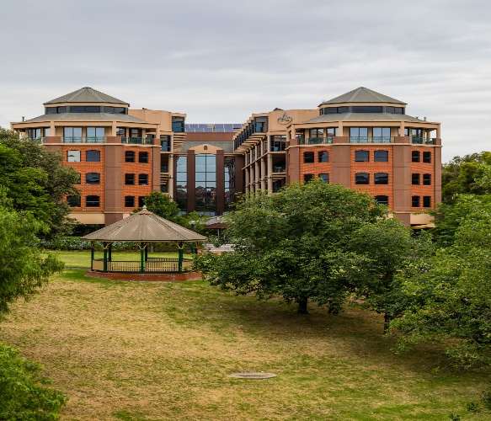

Tuesday 31 March
A visit to the Metro Tunnel stations. Details to come.

Forthcoming Events in 2026
Wednesday 23 September Coach trip to ‘Duneira’, Mt Macedon.
Tasmania 11 days in November. Planning in progress.

Garden Appreciation Group
This is a new introduction to the Club’s program. There will be three garden visits in the year, during Autumn, Winter & Spring.
The first is in May this year to Olinda.

Theatre and Entertainment
Malvern Theatre Company 2026
29 Burke Road, Malvern East, 3145






22nd February 22nd April 28th June 30th August 1st November

Payment for each play separately $29 five weeks before performance.

The Round
379 Whitehorse Road, Nunawading

Sunday 29th March at 1:30 pm
Closing Payment 24th February
$52



All payments for Club activities by EFTPOS into account:
BSB: 633-000, Account: 170611610 or
pay with Credit Card at monthly meeting.

The Princess Theatre
163 Spring Street, Melbourne
Wednesday 7th October at 1:00 pm
Cost: $160



Closing Payment: 23rd June 2026
Any enquiries please contact: Julie Telfer

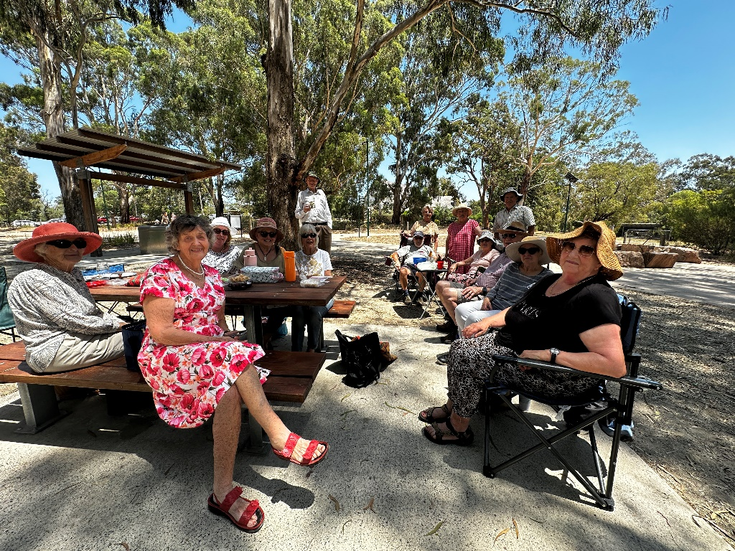
January Picnic in Wattle Park


Camberwell Probus Club Tour | Tasmania

11 Day Tour Tasmania
Monday 9 November – Thursday November 2026
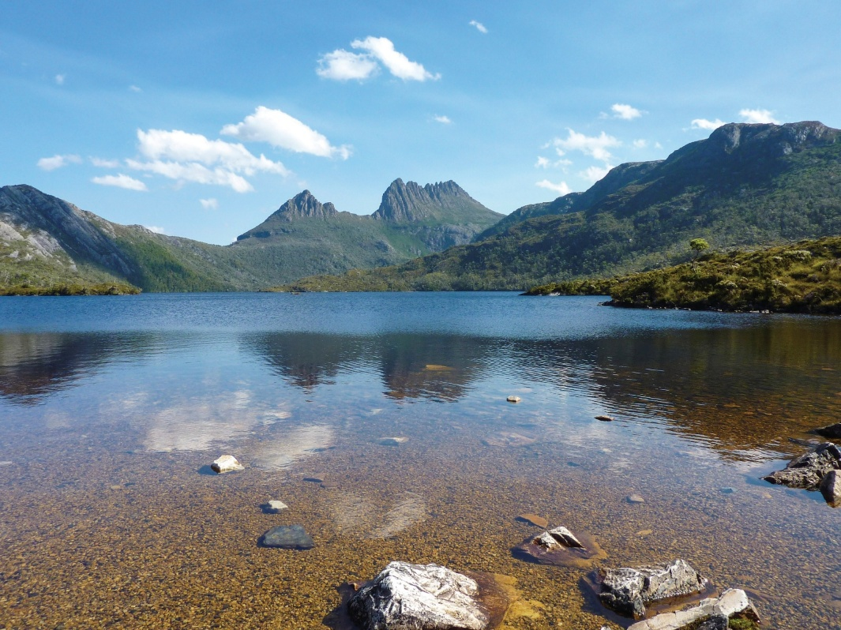

A place of wild beauty and spectacular scenery.
Journey into pristine wilderness by land and uncover compelling convict heritage set deep within historic towns.

Highlights include:
- Guided tour of Launceston
- Discovery Cruise on the Tamar River
- Overnight stay in Bicheno, with visits to Freycinet National Park & Richmond on the way to Hobart.
- Special Dinner at the Point Revolving Restaurant
- 3 night stay in Hobart – Salamanca Markets, Tahune Forest Walk, Bruny Island tour
- 2 nights in Queenstown – Cruise on the Gordon River, Sarah Island & Cradle Mountain
- Burnie
- 8 guided tours
- All breakfasts, dinners and lunches.
More information at February Meeting

