ABN 80 294 124 571
Website: www.camberwellprobus.org.au
President Secretary Treasurer
Judy Nancarrow David Turner Barbara Grufas
camprobpres@gmail.com camprobsec@gmail.com camprobtrea@gmail.com


PROBUS CLUB of CAMBERWELL INC.

NEWSLETTER JANUARY 2026

Next meeting Tuesday 24 February 2026 at CBC at 10 am.
President’s Thoughts January 2026.
I hope you all enjoyed the festive season celebrations with family and friends and also managed some time to recharge your batteries. Planning is well in hand for providing many opportunities for you, our members, to enjoy in 2026. We are planning to introduce some new activities in 2026, details of which will be unveiled at the February meeting.
The February Meeting will commence with a Special Meeting to approve the revised Constitution and Standing Resolutions for our Club. Details of this meeting will be circulated to all members by email on February 1.
Hoping to see some of you at the Picnic in the Park on Tuesday 20th January, and all of you at our first meeting for the year on Tuesday 24th February.
Best Wishes for 2026, may it provide you many opportunities to smile.
Judy Nancarrow, President.
Coming Events
Tuesday 20 January 2026 Picnic in the Park at Wattle Park 12.30 pm. BYO everything
Tuesday 3 February Walk
Wednesday 11 February 2006 Lunch at Young & Jacksons 12.30 pm.
First meeting in 2026 Tuesday 24 February 2026 at CBC at 10 am
Vote on new Constitution & Standing Resolutions will be held.
Happy Walkers
Leader: Daryl Wayland: 0439 632 223
Meet: 10 am at second car park cnr Burke & Belmore Roads
Walk: Hays Paddock and back.
Coffee: Café in Burke Rd

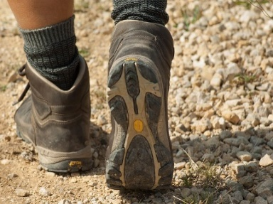

Lunch at Young & Jacksons
A reminder to those who have registered for the lunch on Tuesday 11 February.
If you are not sure if you have put your name down please contact Julie Roncon by email.

Annual General Meeting 24 March 2026
At Box Hill Golf Course. 10 am. for meeting followed by morning tea. Cost to be advised.
Speaker Winston Marsh. “Lies our mothers told us”

All payments for Club activities by EFTPOS into account:
BSB: 633-000, Account: 170611610 or pay with Credit Card at monthly meeting.

Theatre and Entertainment

Malvern Theatre Company 2026
29 Burke Road, Malvern East, 3145






Ticket purchases are non-refundable after payment by the club.
Any enquiries please contact: Julie Telfer

22nd February 22nd April 28th June 30th August 1st November

Payment for each play separately $29 five weeks before performance. Payment for all five plays $135 by 10th January 2026


The Round
379 Whitehorse Road, Nunawading

Sunday 29th March at 1:30 pm
Closing Payment 24th February
$52

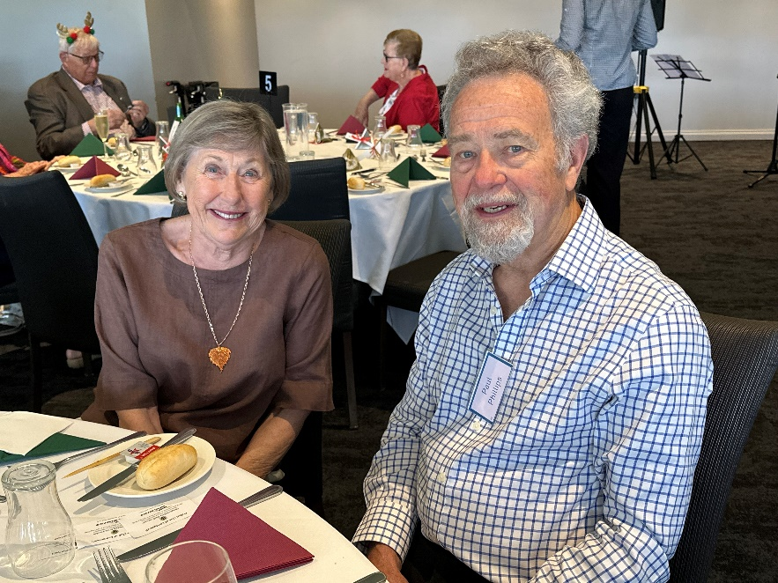
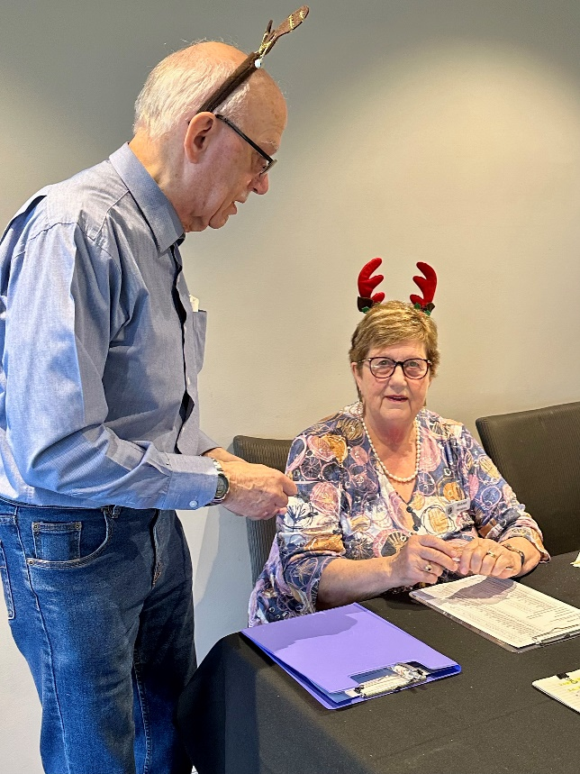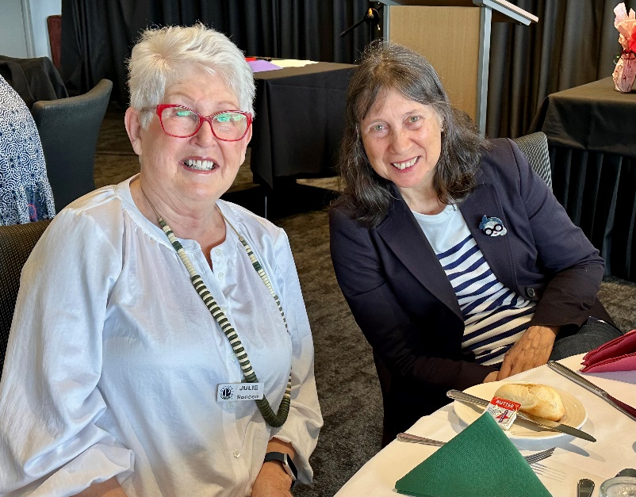
Happy Probians at Christmas Lunch 2025



