PROBUS CLUB of CAMBERWELL INC.


ABN 80 294 124 571
Website: www.camberwellprobus.org.au
President Secretary Treasurer
Judy Nancarrow David Turner Barbara Grufas
camprobpres@gmail.com camprobsec@gmail.com camprobtrea@gmail.com

NEWSLETTER MARCH 2026

Next meeting Tuesday 24 March at Box Hill Golf Club. AGM at 10 am.
Speaker – Winston Marsh
Subject - ‘Lies our mothers told us’
President’s Thoughts
Hi from a weary but happy traveller. We arrived home late on Thursday evening after 7 days and 1,251 kms, exploring, Clare, Port Augusta, Whyalla, Hawker and the Flinders Ranges. Unfortunately for us, but a blessing for the locals, we experienced 3 days of steady rain which required a change of plans once the rivers started to flow. Thanks to our coach driver Justin and Expanding Horizons alternative accommodation and activities were arranged. We all had a great time, and seeing the Flinder’s Ranges in the wet was a bonus.
I urge you all to consider joining us in November when we explore Tasmania. Overnight tours provide a great opportunity to get to know and appreciate our fellow members.
I look forward to seeing you all at the AGM next Tuesday.
Judy Nancarrow, President
Coming Events
Tuesday 24 March AGM Marvellous Morning Tea at Box Hill Golf Club
Friday 27 March Happy Hour at Amora Hotel, Richmond. 5 pm.
Sunday 29 March Sound of Music at The Round
Tuesday 31 March Lunch Malvern Vale Hotel 12 noon.
Tuesday 7 April Walk
Friday 10 April Coffee & Chat
Monday 13 April GYT Bay Walk
Thursday 16 April Pub lunch at The Palace, Camberwell 12.00
Friday 24 April Happy Hour at Amora Hotel, Richmond
Sunday 26 April Malvern Theatre
Sunday 7 June 42nd Street at The Round

Your Probus fees are due now! Please pay $65 by 31 March 2026.

Morning Tea Roster for April
Lorna Johnson, Dick Johnson, Bronwyn Woolcock, June Strickland
Get Yourself There Activities

Bay Walk
Monday 13 April
Meet under the clocks at Flinders St Station at 10.15 am. We will catch No 1 tram to South Melbourne Beach, a flat walk about 3 km to Port Melbourne, look at the old Princes Pier and Station Pier and yummy fish and chips for lunch before returning on tram 109 to the city.
Don’t forget to bring your water bottle and wear comfortable walking footwear and be prepared for weather – sunny or cold. Ring Barbara Timcke if in doubt as to weather that day.

Coffee & Chat
Friday 10 April at Bugiardo’s, 970 Toorak Rd, Glen Iris 10.30 am.

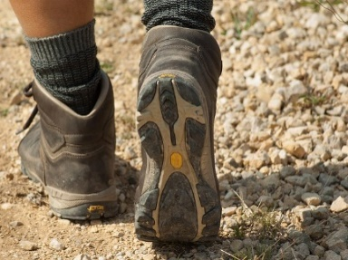
Happy Walkers
Tuesday April 7. 10.00am
Leader Julie Telfer
Meet bottom of Estella st Glen Iris
Park in cricket club car park
Coffee afterwards

.

ANNUAL GENERAL MEETING
Tuesday 24 March at Box Hill Golf Club

10.00 am. Meeting
Marvellous Morning Tea to follow at a cost of $35 a head

Speaker – Winston March “Lies your mother told you”
Musical entertainment – Mario Miranda

You are welcome to attend just the Annual General Meeting but the following morning tea is $35 a head.


Amora Hotel
649 Bridge Road Richmond
Friday 27 March 5.00pm
Contact: Jennifer Mariott
Route 75 Tram, Stop 22
Street Parking or at Office Works

Forthcoming Events in 2026
Friday 24 July - Christmas in July at The Glasshouse, Caulfield Racecourse
Plenty of parking and close to Caulfield Station. Traditional Christmas menu $50 per head.

Wednesday 23 September Coach trip to ‘Duneira’, Mt Macedon.
Tasmania 11 days in November. Planning in progress.

Garden Appreciation Group
This is a new introduction to the Club’s program. There will be three garden visits in the year, during Autumn, Winter & Spring.
The first is on 4 May this year to the Dandenong Ranges Botanical Gardens, Olinda.

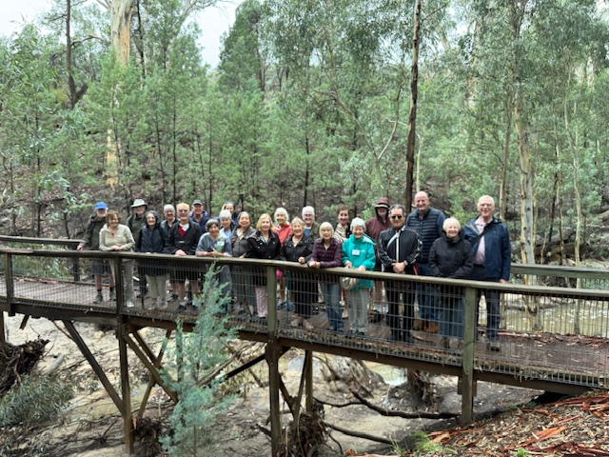
Wet weather in Wilpena Pound
Theatre and Entertainment
Malvern Theatre Company 2026
29 Burke Road, Malvern East, 3145



‘The Visit’ Sunday 26th April 2 pm

‘Misery’ Sunday 28th June, 2 pm

‘When the Rain Stops Falling’: Sunday 30th August, 2pm

‘Dirty Rotten Scoundrels’: Sunday 1st November, 2pm
Payment for each play separately $29 five weeks before performance.

The Round, Nunawading
42nd Street - Sunday 7th June at 1:30 pm

Cost: $55 Payment by 28 April



The Princess Theatre
163 Spring Street, Melbourne
Wednesday 7th October at 1:00 pm
Cost: $160



Closing Payment: 23rd June 2026
Any enquiries please contact: Julie Telfer
All payments for Club activities by EFTPOS into account:
BSB: 633-000, Account: 170611610 or
pay with Credit Card at monthly meeting.
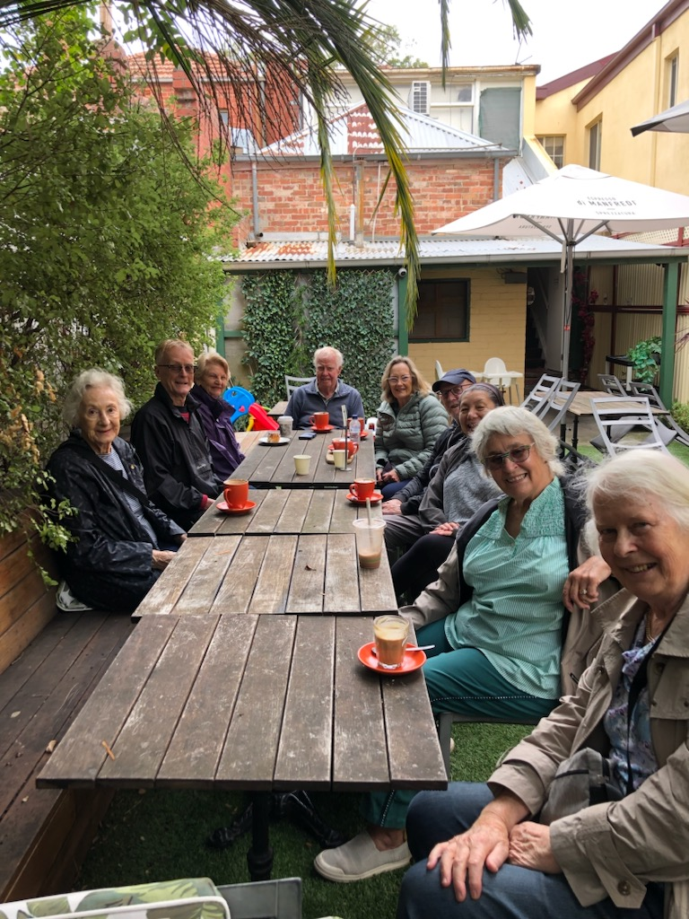

March walking group

Cl11 Day Tour Tasmania
Monday 9 November – Thursday 19November 2026
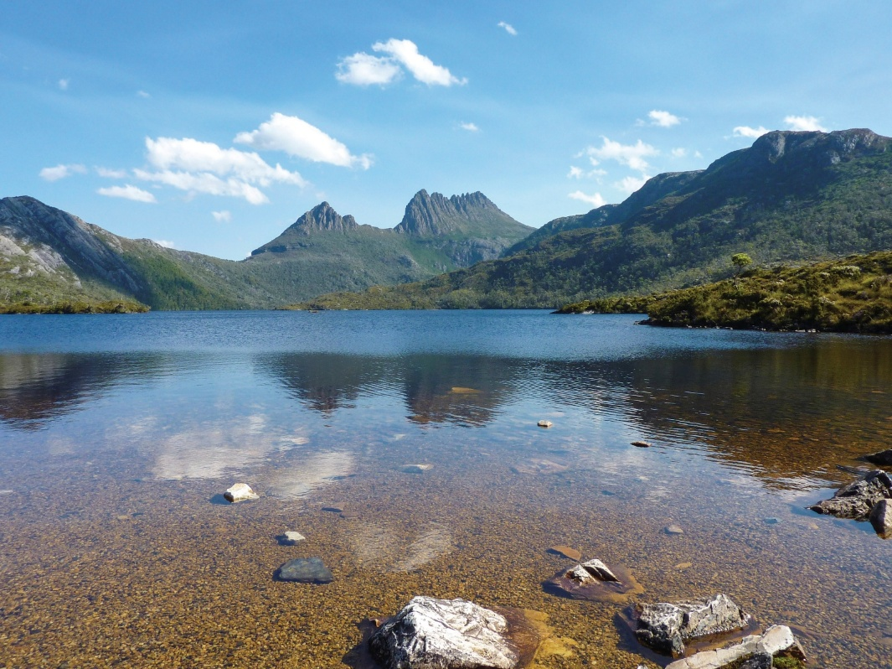
A place of wild beauty and spectacular scenery.

Journey into pristine wilderness by land and uncover compelling convict heritage set deep within historic towns.

Highlights include:
- Guided tour of Launceston
- Discovery Cruise on the Tamar River
- Overnight stay in Bicheno, with visits to Freycinet National Park & Richmond on the way to Hobart.
- Special Dinner at the Point Revolving Restaurant
- 3 night stay in Hobart – Salamanca Markets, Tahune Forest Walk, Bruny Island tour
- 2 nights in Queenstown – Cruise on the Gordon River, Sarah Island & Cradle Mountain
- Burnie
- 8 guided tours
- All breakfasts, dinners and lunches.
Contact Judy Nancarrow for more information


