
ABN 80 294 124 571
Website: www.probusclubcamberwell.org.au
President Secretary Treasurer
Judy Nancarrow David Turner Barbara Grufas
camprobpres@gmail.com camprobsec@gmail.com camprobtrea@gmail.com

PROBUS CLUB of CAMBERWELL INC.

NEWSLETTER JUNE 2026

Next meeting Tuesday 23 June at CBC at 10 am.
Speaker – Roman Fida
Subject - End of Life Planning (Wills, Trusts, Power of Attorney etc)

President’s Thoughts
Hope you are all keeping warm and enjoying winter food and activities. The highlights for June include a wonderful production of 42nd Street at The Round, a visit to the State Library, the Cinema and a Lunch at the Arbory. Thanks to the organisers and the members who supported these activities.
Our new Website and the ClubRunner App are now available to all members. Many of you have logged onto the new Website and have downloaded the the Mobile App on their phone and I urge those who haven’t to do so. If you need assistance please contact Barbara Grufas or myself.
I would like to take this opportunity to thank Dick Johnson for being our Web Master, and for managing Membership Database for many years. Dick implemented our initial Website in 2008. The ‘old’ website will be decommissioned shortly. The Club owes Dick a great deal of thanks for his commitment and many hours of volunteering, managing and maintaining our website and Membership database. These functions will now be provided through ClubRunner.
Payment for Christmas in July and the deposit for the Sapphire Coast Tour are due on or before our June meeting. Please refer to the details below. As we are still waiting for news from the Bendigo Bank re the success of our grant application for our day tour to Duneira, the cost has not been finalised.
Judy Nancarrow, President
Coming Events
Tuesday 23 June General meeting
Friday 26 June Coffee and Chat at Our Little Secret
Happy Hour
Sunday 28 June Malvern Theatre
Wednesday 1 July Garden Appreciation outing
Tuesday 7 July Walk
Wednesday 8 July Cinema
Friday 10 July Train to Pub Lunch
Monday 13 July Coffee and Chat at Goodness Gracious Café
Friday 24 July Christmas in July
Friday 31 July Happy Hour

Morning Tea Roster for June
Wendy Glass, Yvonne Phillips, Wendy Vestergaard, John Vestergaard

Reminder – More helpers always needed for morning tea roster.

Coffee & Chat
Friday 26 June at Our Little Secret, 722 Riversdale Rd at 10.30 am.
On the deck if weather is fine.

Monday 13 July at Goodness Gracious, 744 Riversdale Rd, Camberwell.

Cinema
Wednesday 8 July at Palace Balwyn. Details to be advised.
Tickets $12/10 for senior/member
Note: Change of week for this month only.

Get Yourself There Activities

Happy Walkers
Tuesday 7 July. 10.00am
Part of the Outer Circle Trail
Meet at Cnr. Gordon and Wills Streets, Balwyn
Parking - In Wills Street
Melway 45 K6
Leader Marjorie Birrell
Coffee at Adeney Ave, Café

FFEE

.




Amora Hotel
649 Bridge Road Richmond
Friday 26 June 5.00pm
Contact: Jennifer Mariott
Route 75 Tram, Stop 22
Street Parking or at Office Works

Garden Appreciation Group

Wednesday 1 July – Garden World
﻿Our second Garden Appreciation outing is to Gardenworld, 810 Springvale Road, Braeside, on Wednesday July 1st. It is a Get Yourself There but if transport is required contact Dianne Weston.
Meet at the entrance at 11.00am, café booked for 12:15. This is a large indoor nursery with a wide selection of orchids, bromeliads, cacti, succulents and bonsai. There is also a wonderful mineral display. There may be a short talk and an opportunity to ask questions.


Friday 24 July - Christmas in July – Last chance!

Help us celebrate Christmas in July on Friday 24 July 12.00 pm. at the Glass house, 31 Station St, Caulfield East.
Plenty of parking and close to Caulfield Station.
Traditional Christmas menu and entertainment
$50 per head to be paid by June meeting.

Tour Sapphire Coast
Deposit $500 due by June meeting.

Train to Pub Lunch Friday 10 July
At Hotel Brighton, 286 Bay St, Brighton. 12 noon.
Close to the North Brighton railway station.
Further information from Diane Hristov.

For Your Information
Many of the emails you receive from committee executives may have, to you, unidentifiable names and addresses and may end up in your Spam folder.
camprobpres This comes from the President, Judy Nancarrow
camprobsec This is from the secretary, David Turner
camprobtrea This is from the treasurer, Barbara Grufas

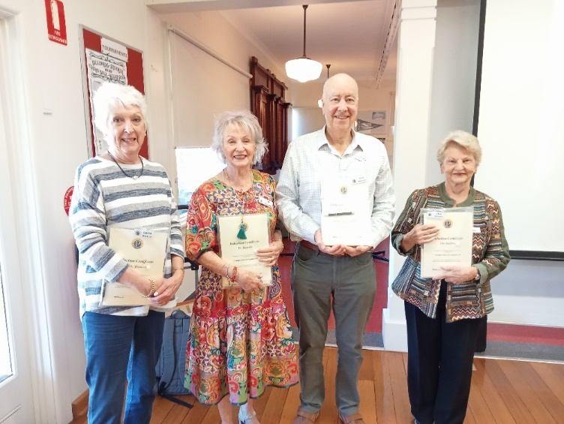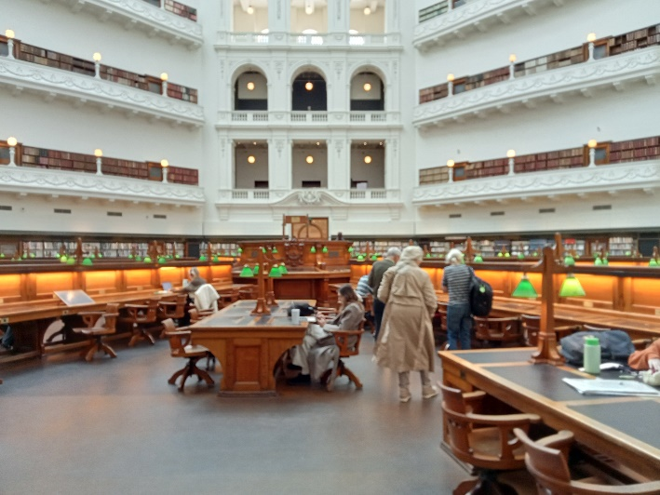
Apology to last month’s new Probus members – June visit to State Library
Di Harrold, Edith & Rick Westcott, Lila Scicluna

Glenferrie Probus Club Greenline Walk
This is now being held on Thursday 23 July. Enquires to Lila Scicluna.

Bring a Friend to the July meeting
You are all invited to bring a friend to the July meeting and look forward to a very interesting speaker.

Wednesday 23 September
Coach trip to ‘Duneira’, Mt Macedon. Details to come.

Theatre and Entertainment
Malvern Theatre Company 2026, 29 Burke Road, Malvern East, 3145


Sunday 30th August, 2pm Sunday 1st November, 2pm

Final payment 28 July Final payment 22 September


The Princess Theatre
163 Spring Street, Melbourne

Wednesday 7th October 1:00 pm

Cost: $160

Note: Closing Payment: 23rd June 2026 Any enquiries please contact: Julie Telfer


The Round
379 Whitehorse Road, Nunawading

Sunday 20th September at 1:30 pm

Cost: $47

Ticket purchases are non-refundable after payment by the club. Closing payment: 25th August 2026
Any enquiries please contact: Julie Telfer

All payments for Club activities by EFTPOS into account: BSB: 633-000, Account: 170611610 or pay with Credit Card at monthly meeting.

Cottage By the Sea
A reminder that packets of Rice Bubbles, Cornflakes or Nutrigrain are needed for the children at The Cottage. No Weetbix please. If you are willing to donate in this way it would be greatly appreciated.



